The process for clinical assessment and dispensing of antivirals needs to be completed within 48 hours of onset of symptoms in the last case (36 hours if zanamivir is used).

Initial UKHSA response
- UK Health Security Agency (UKHSA) receive information regarding possible localised outbreak e.g., care home
- UKHSA to warn stakeholders as per the chart below who will:
- Confirm that the Care Home provider is registered with a NHS Hampshire and IOW GP practice and which AV provider they link to
- Confirm whether in season or out of season (if flu season not yet declared please see out of season plan)
- start to identify stock of antivirals and warn the relevant pharmacy see appendix A
- support the care home provider to gather the information (Best interest, staff vaccination, swallow, eGFR) See appendix B
- UKHSA conduct thorough written risk assessment, including:
  - number of symptomatic residents & timescales
  - number of exposed residents
  - number of unvaccinated staff in a high-risk group
  - Arrange swabbing (where appropriate)
- A UKHSA Consultant in Health Protection will make a recommendation regarding prophylaxis for residents +/- staff in high
- UKHSA inform the appropriate stakeholders See appendix C & D:
Prescriber of prophylaxis and treatment
- Provider undertaking the prescribing of the Antivirals to contact the relevant pharmacy (appendix A) to ask for stock to made available and ordered where required.
  - Prescriber organisation and pharmacy to agree how the process of sending the patients details will be shared with the pharmacy
  - In the event of unused Antiviral medication ordered specifically for the outbreak the ICB Medicine Optimisation Team and local prescribing provider should be made aware so that the stock can be used at the earliest opportunity.
- Clinician conducts clinical assessment of exposed persons (staff and patients/residents) for possible prophylaxis as per the UKHSA Guidance: Influenza: treatment and prophylaxis using anti-viral agents Influenza: treatment and prophylaxis using anti-viral agents - GOV.UK (www.gov.uk).
  - For prescribing of antivirals for those with no recent renal function test (in previous 6 months) please see Appendix E page 33 of the Guidelines for PHE Health Protection Teams on the management of outbreaks of influenza-like illness (ILI) in care homes (publishing.service.gov.uk)
  - Please see Page 26 section 3.1.2 of the Guidance on use of antiviral agents for the treatment and prophylaxis of seasonal influenza (publishing.service.gov.uk)
  - Vaccinated staff members (defined as those who have received a vaccine ≥ 2weeks prior to exposure) do not need prophylaxis
- Clinician determines if antivirals are appropriate see appendix B for UKHSA form which can be sent to the Care home for completion (if not already sent to them by UKHSA).
  - Prophylaxis is not a medical emergency and needs to be prioritised in conjunction with other activity but within 48 hours),
    - Priority 1: Residents in an at-risk group
    - Priority 2: Staff members in a high-risk group who have not had the vaccine ≥ 2 weeks prior to exposure
- If they are not appropriate, the clinician informs the relevant ICB Place. Appropriate reasons for not providing prophylaxis:
  - Patient is now symptomatic and requires treatment dose
  - Person refuses consent
  - Clinical contraindication please see page Guidance on use of antiviral agents for the treatment and prophylaxis of seasonal influenza (publishing.service.gov.uk)
  - Outside timeframe (i.e., over 48-36 hrs since last contact with symptomatic case)
  - System priority (e.g., OPEL 4) – see guidance below on outbreaks during critical incidents see appendix F
  - Insufficient information from UKHSA
- Clinician to inform care home of direct contact details in the event of any issues.
- In Season FP10’s can be used for both treatment and prophylaxis
  - PGD’s should be used by a non-prescriber clinician who meets the competency requirements set out in the PGD when assessing patients prior to supplying prophylaxis and treatment. Influenza post exposure prophylaxis and treatment: PGD templates - GOV.UK (www.gov.uk)
  - Where a PGD is used a FP10 should still be issued unless a variation is discussed and agreed with the community pharmacy
- Clinician to inform patient’s GPs of antiviral treatment and prophylaxis
- Pharmacy to dispense antivirals for named patients in labelled boxes
  - The care home is responsible for collecting, distributing and administering antivirals
  - Care home providers are to be encouraged to arrange collection where possible, however in the event of a large outbreak with high levels of staff sickness or deteriorating residents’ delivery may need to be arranged
  - Provider to identify if the Care home will need support in arranging the delivery of antivirals, where support is required the ICB is to be informed and support will be agreed on a case-by-case basis.
- If any exposed person on prophylaxis becomes symptomatic, clinician to be contacted and antiviral dose changed to treatment dose through an additional FP10
- Clinician to inform UKHSA and the ICB of number of individuals assessed, given antiviral treatment or prophylaxis.
Links to National and local Guidance:
- 2024/25 South East winter-readiness (infection prevention) information for care homes pack
UKHSA Winter readiness (infection prevention) information for care homes in South East England Winter 2024/25
- Guidelines for PHE Health Protection Teams on the management of outbreaks of influenza like illness (ILI) in care homes Guidelines for PHE Health Protection Teams on the management of outbreaks of influenza-like illness (ILI) in care homes (publishing.service.gov.uk)
- Guidance of use of antiviral agents for the treatment and prophylaxis of seasonal influenza Guidance on use of antiviral agents for the treatment and prophylaxis of seasonal influenza (publishing.service.gov.uk)
- Influenza post exposure prophylaxis and treatment: PGD templates Influenza post exposure prophylaxis and treatment: PGD templates - GOV.UK (www.gov.uk)

Appendix A: Guidance on accessing Antiviral Stock from Community Pharmacies
NOTE:
- In season Antiviral stock can be accessed from community pharmacies. In the first instance please contact the community pharmacy which links with the care home.
- Please check that the pharmacy is local, and the Antivirals would arrive with the Care home within the 48hr timeline.
- The majority of Community Pharmacies will need to order in stock of Antivirals, please ensure they are aware of the 48hr deadline
- Boxes of Antivirals can be split to provide all patients with an initial 1–3-day course to allow time for more stock to be ordered
- Where the care homes usual pharmacy is not able supply within the required timeline, please contact other local pharmacies and the NHS Hampshire and IOW Medicine Optimisation Team for support.

Appendix B
2024/25 South East winter-readiness (infection prevention) information for care homes pack
UKHSA Winter readiness (infection prevention) information for care homes in South East England Winter 2024/25

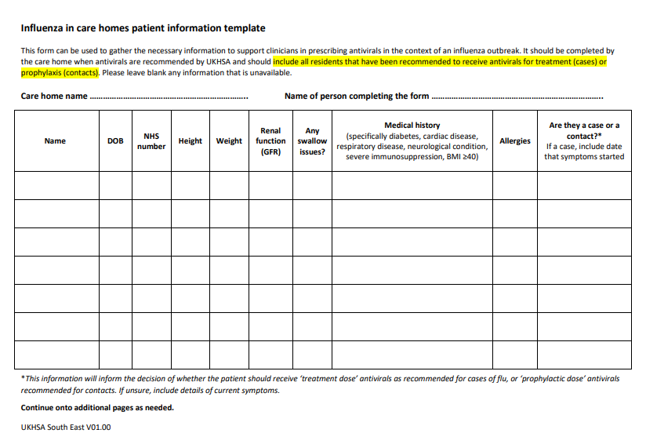

Appendix C: IN HOURS contacts (Weekdays 9am-5pm unless otherwise specified)
Place | Process
Isle of Wight | - UKHSA to contact ICB IPC practitioner on 08703156601 and email a copy of the email sent to the home and a summary of actions being taken hiowicb-hsi.infectionprevention@nhs.net ICB IPC practitioner  - ICB IPC Practitioner to contact the Quality team 03005612561 (option 4, then option 1) / hiowicb-hsi.iw.quality@nhs.net (No PID)  - Medicines Optimisation Team: (In hours only) MOT will provide informal signposting when needed to antivirals in community pharmacies please email: hiowicb-hsi.mot@nhs.net  - Quality team arrange for GP practice to send a clinician to assess exposed persons for antiviral treatment or prophylaxis.  - IPC practitioner to support care home provider
North Hampshire | - UKHSA to call NHUC (provider) Executive on call directly on 01252 915303 to assess exposed persons for antiviral treatment or prophylaxis  - UKHSA to contact ICB IPC practitioner on 08703156601 and email a copy of the email sent to the home and a summary of actions being taken hiowicb-hsi.infectionprevention@nhs.net ICB  - IPC practitioner to Support the care home provider
Rest of Hampshire  - Mid  - South Eastern  - South West | - UKHSA to call PHL (provider) 03333 210 942 ask for shift manager to assess exposed persons for antiviral treatment or prophylaxis and email pohl.hdocs-referrals@nhs.net  - UKHSA to contact ICB IPC practitioner on 08703156601 and email a copy of the email sent to the home and a summary of actions being taken hiowicb-hsi.infectionprevention@nhs.net ICB  - IPC practitioner to Support the care home provider
Southampton City | - UKHSA to call SPCL (provider) 023 8017 0610  - UKHSA to contact ICB IPC practitioner on 08703156601 and email a copy of the email sent to the home and a summary of actions being taken hiowicb-hsi.infectionprevention@nhs.net ICB IPC practitioner to support the home  - IPC practitioner to support care home provider
Portsmouth City  08.00 to 22.00 | - UKHSA to call tactical on call Manager to activate service 0845 852 0013  - Manager on call advises Medicines Management team  - PPCA (provider) on 0845 891 0431  - Email (No PID) to pccg.safeguardingteam@nhs.net; simon.cooper3@nhs.net  - UKHSA to contact ICB IPC practitioner on 08703156601 and email a copy of the email sent to the home and a summary of actions being taken hiowicb-hsi.infectionprevention@nhs.net ICB IPC practitioner to support the home

Appendix D: OUT OF HOURS (Weekdays from 5pm-9am unless otherwise specified, and weekends)

Isle of Wight | - UKHSA to call GP OOH/Urgent Treatment Centre directly on 01983 534730  - Informs ICB on tactical call manager on 0845 852 0013  - Email hiowicb-hsi.infectionprevention@nhs.net
North Hampshire | - UKHSA to call NHUC (provider) Executive on call directly on 01252 915303  - Informs ICB tactical on call manager on 0845 852 0018  - Email hiowicb-hsi.infectionprevention@nhs.net
Rest of Hampshire  - Mid  - South Eastern  - South West | - UKHSA to call PHL (provider) 03333 210 942 ask for shift manager to assess exposed persons for antiviral treatment or prophylaxis and email pohl.hdocs-referrals@nhs.net  - Informs ICB on tactical call manager on 0845 852 0013  - Email hiowicb-hsi.infectionprevention@nhs.net
Southampton | - UKHSA to call SPCL (provider) directly on 023 8017 0610  - Informs ICB tactical on call manager on 0845 852 0018  - Email hiowicb-hsi.infectionprevention@nhs.net
Portsmouth City  22.00 to 08.00 | - Informs ICB on tactical call manager on 0845 852 0013  - UKHSA to call PHL (provider) 03333 210 942 ask for shift manager to assess exposed persons for antiviral treatment or prophylaxis and email pohl.hdocs-referrals@nhs.net  - Email hiowicb-hsi.infectionprevention@nhs.net

Appendix E – Prescribing based on Renal function
British Geriatric Society advice on antiviral prescribing (November 2017)
If an individual has a documented renal function within the last 6 months, which does not indicate renal impairment, the standard dose of antivirals can be prescribed.
For individuals with a known renal impairment and where the prescriber has access to their renal function during an emergency outbreak, they can be prescribed an adjusted dose according to the guidelines.
However, in an emergency outbreak response, where there is no information about the presence or absence of renal impairment (or lack of available routine renal function results from the past 6 months), there is a high likelihood of abnormal renal function in care home residents, so we would recommend a reduced daily dose of oseltamivir in all care home residents.
This would be for a dose appropriate to CrCl of 31-60 mL/min.
We would not recommend routine measurement of renal function prior to treatment due to the logistical challenges of collecting bloods en masse in care home populations and the likely delays introduced by waiting for lab results to return in the community.
Where time permits, checking renal function in specific patients at high risk of significant renal impairment, for example those on high dose diuretics, may be useful.

Appendix F - Management of Flu A outbreaks in care home during healthcare critical incidents.
Management of Flu A outbreaks in care home during healthcare critical incidents.
- At the time of referral by UKHSA a discussion between UKHSA and the provider of the prophylaxis (PHL, NHUC, SPCL and medicine optimisation team) may take place in relation to competing demands on the provider regarding treatment/prophylaxis and likelihood of the prophylaxis being arranged and delivered with in the 48hrs window.
- Priority must be given to the treatment of symptomatic individuals over those requiring prophylaxis. See below a list of conditions which would make the home a priority for prophylaxis or may reverse the decision by UKHSA to not provide prophylaxis:
- New cases continue to be identified
- Symptoms in residents causing admissions
- Deaths due to Flu A
- Where a home cannot be provided with prophylaxis within the 48hrs window the home and UKHSA and the ICB IPC team should be made aware so that the home can be regularly reviewed and supported
- In the event of unused Antiviral medication ordered specifically for the outbreak the ICB Medicine Optimisation Team and local prescribing provider should be made aware so that the stock can be used at the earliest opportunity.

Appendix G Patient Specific Direction (PSD) template

<Prescriber Address>
FOR URGENT ATTENTION
<Pharmacy Address> <insert date>
Please arrange for the supply of:
<Insert influenza antiviral name>
For the following patients:
<Patient name> <DOB> <NHS Number> <Dosage> <Duration>
eGFR: <…ml/min>
These medicines are required as part of the urgent management of an influenza outbreak at:
<Insert care home name and address>
As declared by the UKHSA South East:
<Insert PHE Centre details>
This PSD is signed by
<Insert prescriber name>
<Registration number>

Appendix H Antiviral request form (signed order) to be sent to the hospital pharmacy
Practice logo
A copy should be kept by the prescriber organisation and Care home provider.
Name of Home |  | Date/time of Antiviral request |  |  |  | Name and qualification of prescriber
First Name | Last name | DOB |  | NHS number | eGFR ml/min | Antiviral Prophylaxis or Treatment? | Medication, Dose, frequency and course length
 |  |  | Signature of prescriber:

