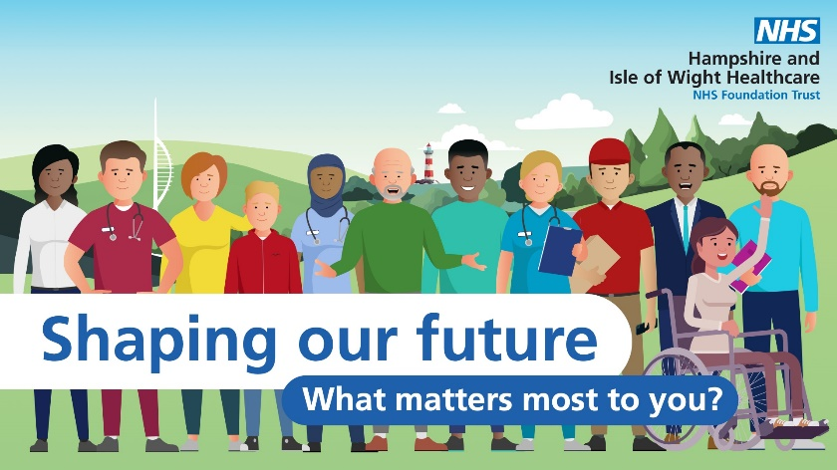

**Shaping our Future – tell us what matters most to you**

At the beginning of October, Hampshire and Isle of Wight Healthcare NHS Foundation Trust was launched to provide community, mental health and learning disability services across the area.

Now we are looking for your help to continue shaping our future and developing our plan and priorities for the next five years.

There are several ways that you can get involved:

* Responding to our [**Shaping our Future survey**](https://shft1.qualtrics.com/jfe/form/SV_7U4cr2hveDe0iSq) **by 6 November**. If you would like a paper copy of this survey or another format, please contact the Patient and Carer Support Hub Tel: 023 8231 1206
* Joining our community conversations during October and early November (contact us at [getintouch@hiowhealthcare.nhs.uk](mailto:getintouch@hiowhealthcare.nhs.uk) for more information)
* Registering your interest [getintouch@hiowhealthcare.nhs.uk](mailto:getintouch@hiowhealthcare.nhs.uk) to take part in a workshop (more details coming soon!)
* Emailing us at [getintouch@hiowhealthcare.nhs.uk](mailto:getintouch@hiowhealthcare.nhs.uk)

You can find more information on our [Trust Website Strategy page](https://hiowhealthcare.nhs.uk/search?search_paths%5B%5D=&query=our+Strategy).