Testing for pertussis in primary care

Suspect pertussis in patients with a cough illness lasting 14 days or more without an apparent cause plus one of the following: (a) paroxysms of coughing (b) inspiratory ‘whoop’ (c) post-tussive vomiting
All cases should be notified to your local health protection team (HPT) (0344 225 3861/
PHE.sshpu@nhs.net). When notifying, it is helpful to let the HPT know if the case has had contact with pregnant individuals or children aged under one year, including through occupational exposure (for example healthcare or nursery settings).

Recommended tests for pertussis testing vary according to the length of time since cough onset:
- less than 2 weeks from cough onset – PCR and culture
- between 2 and 3 weeks from cough onset – PCR and culture and either oral fluid kit (if aged 2 to <17 years) or serology
- more than 3 weeks from cough onset – either oral fluid kit (if aged 2 to <17 years) or serology

Sending a pertussis PCR test – free service  Please submit samples to your local laboratory as per normal protocol using the above request form. Samples will then be referred for pertussis PCR detection by the public health laboratory (PHL) at Royal Sussex County Hospital. Pertussis PCR testing is not chargeable, when performed at a PHL. Please label clearly ‘for Bordetella pertussis PCR testing’. Results will be reported to you as per normal protocol and will take approximately 1 week.  PCR testing can be performed on the following specimens (in order of preference):  Pernasal swabs in VTM tube  Use a dry swab with a flexible wire shaft and a rayon, Dacron or nylon bud. A rigid shaft is not suitable. Push the swab along the floor of the nasal cavity, as far towards the posterior wall of the nasopharynx as possible. The swab should then be put in VTM tube (not charcoal) and mix well. The swab should then be discarded and only the remaining VTM sent to the lab, labelled as ‘pernasal swab mixed in VTM.’  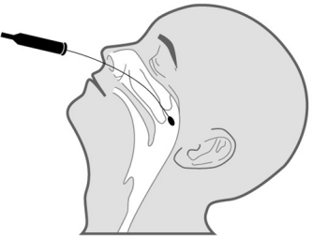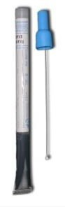  Nasopharyngeal aspirate  Provide not less than 400 microlitres in a sterile container. See the following link for further guidance: CDC video how to take a nasopharyngeal aspirate.  Combined nasal/throat swabs  Collected using a virology swab in VTM tube. | Sending a pertussis culture  A nasopharyngeal swab or pernasal swab may be taken for culture. The swab should be placed in a culture medium (ideally charcoal) and submitted to your local microbiology lab. Please clearly label as ‘for pertussis culture’.
Requesting an oral fluid kit – free service
For cases aged 2 to <17 years, notify the case to your local HPT, and they will post an oral fluid kit (OFK) directly to the case.

Note that oral fluid testing is not recommended if the case has been immunised against pertussis in the previous year as a positive result cannot be interpreted.
Sending a pertussis serology test
For cases not aged 2 to <17 years, a charged-for serology test using serum can be arranged via your local laboratory, either undertaken by them or then sent on to the Respiratory and Vaccine Preventable Bacteria Reference Unit (RVPBRU). Form R3 can be used.

Note that serology is not recommended if the case has been immunised against pertussis in the previous year as a positive result cannot be interpreted.
Managing cases
Follow UKHSA and NICE recommendations about appropriate antibiotics once PCR and culture tests have been taken. If antibiotics are indicated exclude the case from school or work until they have completed 2 days of the antibiotic course. Work with the local HPT to identify and manage vulnerable close contacts. There is no need to prescribe a second course of antibiotics even if symptoms are not resolving.

Further information is available in the Pertussis guidelines for public health management on the testing for and management of pertussis or please contact your local HPT for advice 0344 225 3861/PHE.sshpu@nhs.net

