We are now taking referrals for our next programme:
Early Years Programme
A 10-week programme for Mothers/carers who have experienced unhealthy relationships.
Separate Thera-Play sessions for their children (3-5 years) delivered by a qualified Play Therapist.
Covering:
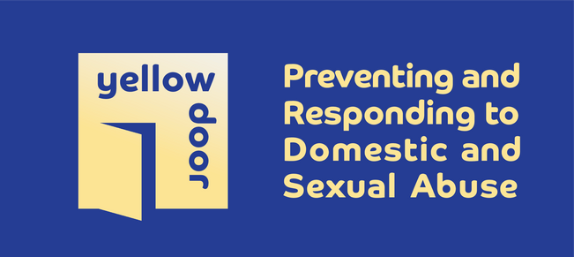
•The effects of domestic and sexual abuse on women as mothers and on children and young people
•Effective communication skills with children and young people
•Working with challenging behaviour
•Protective behaviours and strategies for keeping mothers, children and young people safe
Where: 30 Brookvale Road, SO17 1QR
Dates: 23rd April 2024 Time: 10am - 12pm
Referrals can be made via Yellow Door email info@yellowdoor.org.uk or call 02380 636312

