Southampton Primary Care Limited Acute Respiratory Infection Hub
Standard Operating Procedure
Contents
Background 2
Aims 3
Key Clinical Functions 4
How Will the ARI Hub work 5
Consultation Outcomes 6
Point of Care Testing 7
Infection Control 8
Governance 9

Background
(Taken from Combined Adult and Paediatric Acute Respiratory Infection (ARI) Hubs (previously RCAS Hubs) NHSE 18th October 2022)
NHS England and UK Health Security Agency (UKHSA) Emergency Department Syndromic Surveillance reports from 2020-2022 show that acute respiratory infections are one of the most common reasons for emergency attendance and admission. Scenarios for COVID-19, combined with those for flu, suggest that even in optimistic scenarios, high numbers of appointments and beds may be needed for respiratory patients during winter.
https://www.england.nhs.uk/wp-content/uploads/2022/10/BW2064-combined-adult-paediatric-ari-hubs-october-22.pdf
- Patients presenting with acute respiratory infection are already the most common reason for ED attendance/admission with nearly 500,000 attendances in 2020-2021 to include 209,747 lower respiratory tract infections, 139,645 COVID pneumonitis and 125,108 upper respiratory infections [1]
- SAGE and NHSE modelling indicate that up to half of NHS beds will be occupied with acute respiratory infection admissions
- With Influenza, during the 2017/18 and 2018/19 seasons there were 2 million GP consultations, 46,215 and 39,670 hospital admissions respectively. This resulted in a hospital cost of £128,153,810 and £99,565,310 across both seasons.
- The RCGP Primary Care surveillance within the Weekly national surveillance report suggests that for week 26, 2022, ARI (not including URTI) amounts to 257.3 consultations per 100,000 registered patients.
- Ambulance data from one region indicates that there are approximately 10,000 respiratory impressions per month.
- Around 40% of ED attendees with respiratory symptoms are discharged within a few hours of arrival indicating that many of these could be treated in the community [5
Providing timely face-to-face assessment in general practice to large numbers of symptomatic patients alongside non-COVID-19 clinical activity may be challenging, particularly where premises do not allow easy separation of patient groups.
Supporting optimal management of respiratory infections over coming months using dedicated hubs may support the healthcare system to provide high quality and timely care for these patients as well as supporting existing healthcare services to address the backlog of non-COVID-19 care and acute pressures.
As a result, Southampton Place in HIOW ICB has suggested standing up at-scale solutions across Southampton to see patients with Acute Respiratory Infections, including COVID, Influenza, RSV, infective exacerbation of COPD and children with viral illness. SPCL will provide 2 Hubs one in the centre of Southampton and one on the East of the City.
Aims
An Acute Respiratory Infection (ARI) hub model is a system approach that drives a collective objective to provide timely and appropriate care to the population and helps reduce pressure on other parts of the system. The hub model may be best suited to those with acute, episodic needs.
As a result, the goals are to:
- Support patients with urgent clinical needs by enhancing same day access to assessment and specialist advice as needed. This may include accessing secondary care respiratory clinics.
- Access to point of care (POC) testing or other diagnostics may be helpful if available.
- Seek to reduce ambulance callouts, A&E attendances and hospital admissions for patients who could be appropriately managed in the community.
- Reduce the burden of acute respiratory illness on primary care and provide more time for practice teams to support patients where continuity of care is most important.
- Reduce nosocomial transmission by separating the high expected flow of infectious patients through hubs rather than usual GP waiting rooms and clinics.
- Seek to provide an accessible and equitable service to support same day access (with consideration given to the location of these services). This approach would support a positive impact on the health outcomes of the Core20PLUS population for tackling health inequalities and provision of inclusive services.
- Provide an opportunity for portfolio integrated care working and training for staff at system level that may help with staff development and retention. This could include optimizing workforce opportunities such as links with new Allied Health Professional roles to support delivery.

It is recommended that where implemented, an ARI hub local evaluation should be undertaken to support development of evidence base and ensure sustainability of services.

Key Clinical Functions
The inclusion criteria should be adults and children Aged 5 years and over with acute respiratory symptoms, most likely due to infection (e.g., bacterial, or viral infections including COVID-19, RSV, influenza), who have been identified through an initial remote/triage consultation as requiring face-to-face assessment but not as requiring hospitalisation.

Consideration will need to be given to those more complex patients who may benefit from continuity of care in their general practice setting

The Acute Respiratory Hub is for those patients aged 5 or over with symptoms of an Acute Respiratory Infection following who need a face-to-face assessment following a clinical triage by their registered GP practice.

The Hub is not for all patients with likely Viral Illness. Those who only have mild symptoms should self-care at home, but it is for those who are symptomatic and who have sought medical help and triage determines the need for a face-to-face appointment

ACUTE RESPIRATORY INFECTION HUB
SOUTHAMPTON SPCL – ARI Hubs
Opening Hours: 09:30– 18:30 Monday to Friday
How will the ARI Hub work?
The ARI Hub will be staffed by a combination of GPs, PCPs and HCAs who will provide face to face assessment.
Operations support will be provided by the Operations Lead at SPCL.
All patients will have a baseline set of observations taken and consideration for Point of Care testing. This, along with a clinical assessment, will then determine whether they can safely self-manage at home, or whether they require active monitoring through the ARI@Home or SPCL Virtual Ward pathways, or whether they need admission to UHS.
Table 1 – Clinical signs & symptoms that indicate possible bacterial causes of RTI or COPD.
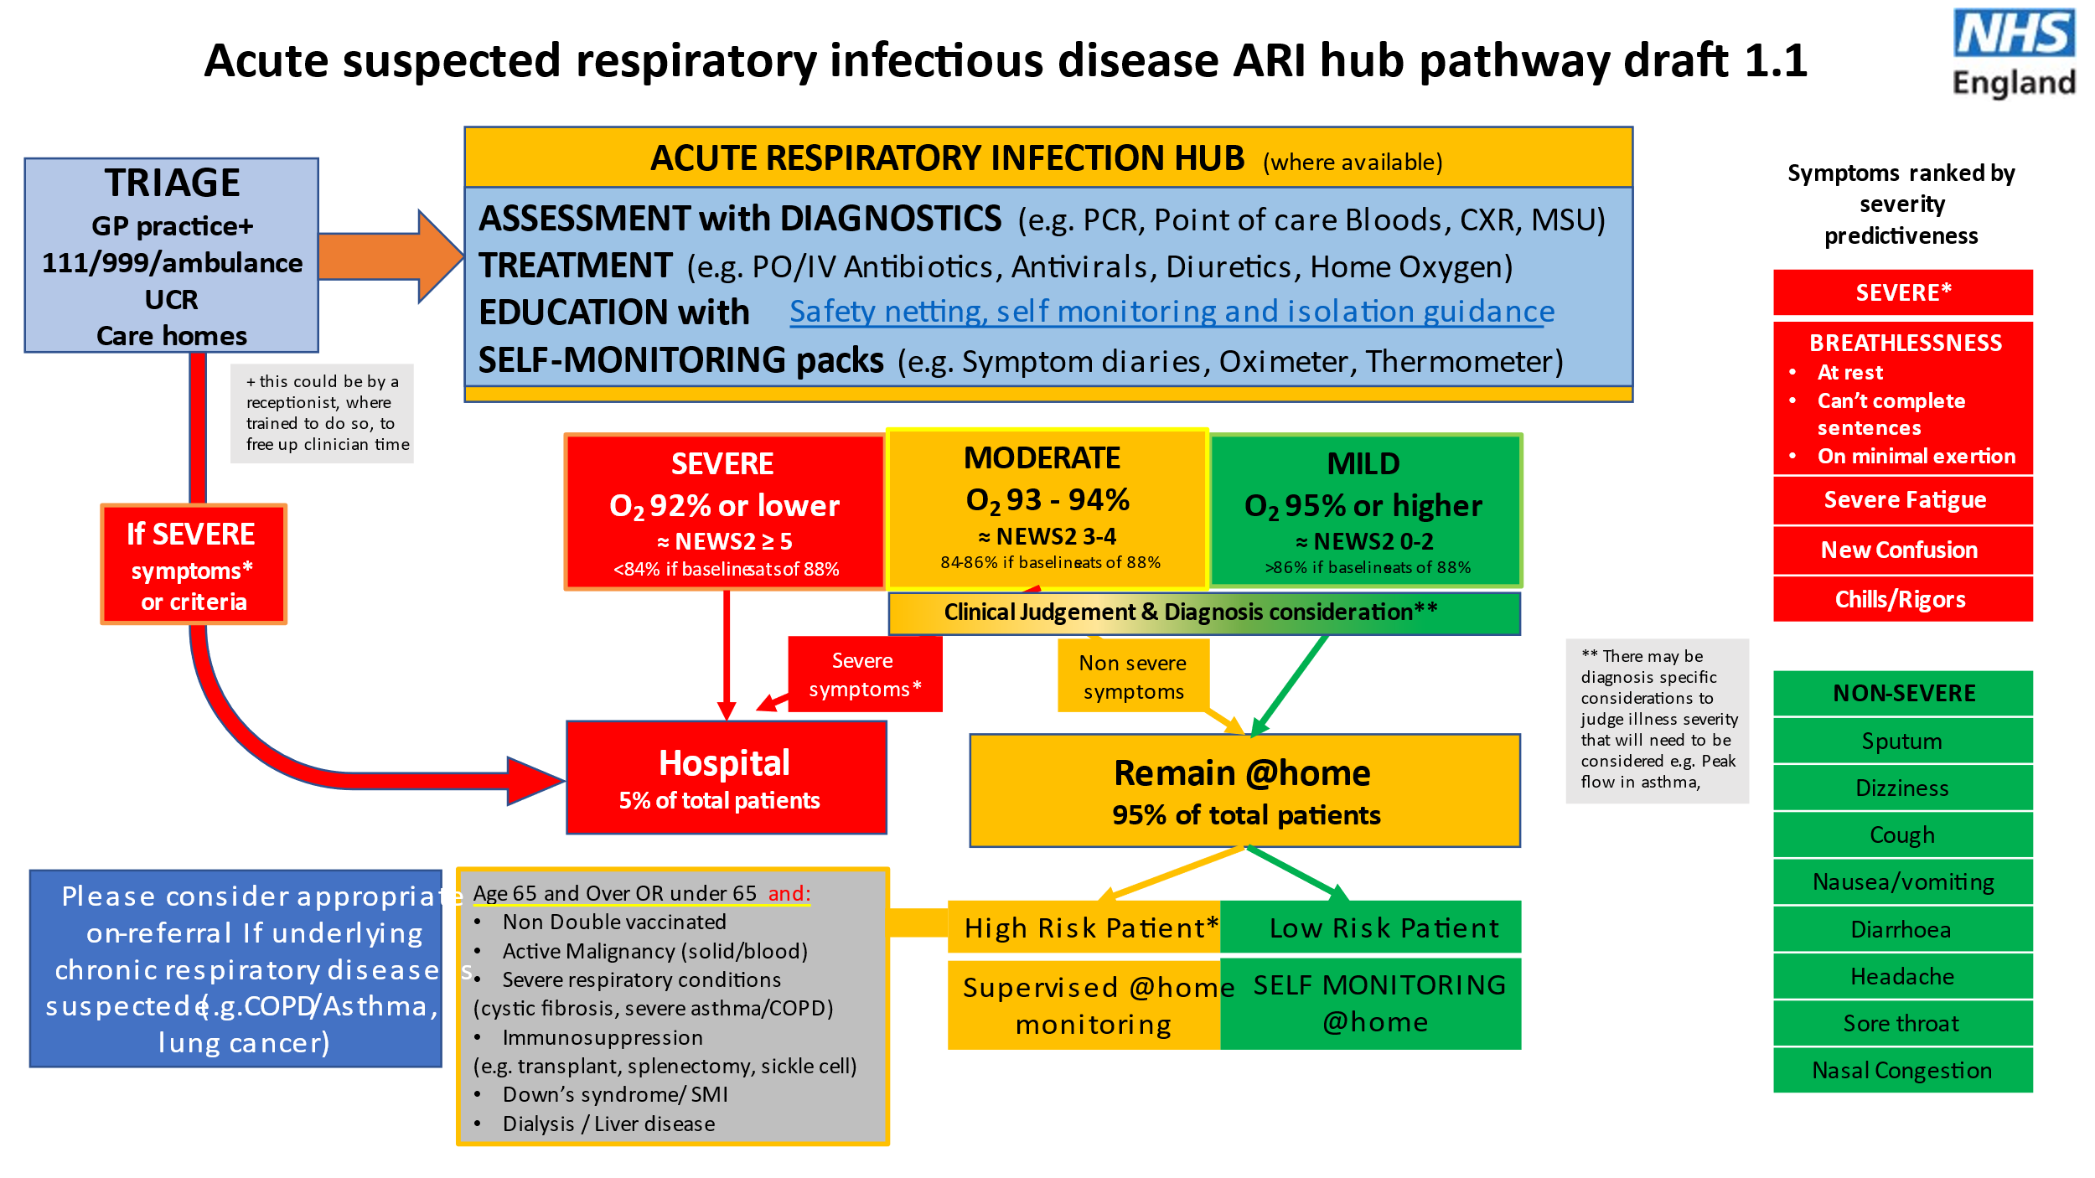
Consultation Outcomes
- RED – Discuss with ED Triage Nurse and advise that patient is critically unwell and will need review in Majors/Resus by Medical Team
- AMBER – Call (insert number) and consider further patient assessment in SDEC and/or admission to UHS. The virtual ward team can support with patients at high risk of hospital admission that require daily follow ups. Ideally patients should be able to submit their observations onto our digital platform, however we are also able to support patients through telephone calls that do not have access to digital technology. We can support patients that are in the ‘Amber’ category with Oxygen saturations between 93-94% or above or a News of 4 or below. Please also issue patient with a Pulse Oximeter.
- GREEN – HIGH RISK – Discuss with ARI@Home team via SPCL Central Hub (02380 170610) and admit to ARI@Home pathway. Issue patient with Pulse Oximeter. There will be a stock held in each Clinical Room.
- GREEN – LOW RISK – Reassure and advise patient. Discuss safety netting and signpost to online resources.

NOT SUITABLE FOR ESCALATION - Consider patients who might not be suitable for escalation to a hospital setting and please discuss early with Palliative Care team to consider JIC medication and support, especially if actively dying.

ASSESSMENT CARRIED OUT BY CLINICIAN
Senior Clinician assessment if clinically indicated
Consider POC CRP and/or Flu/COVID/RSV Swab if it will change management
RED  Send to Medics/ED  Discuss with ED Team and move into main ED | AMBER  Needs further (SDEC)  UHS investigation  Consider SPCL ARI  Virtual Ward | HIGH RISK GREEN  Needs admitting to ARI@Home service.  Discuss with ARI@Home | LOW RISK GREEN  Can be safely sent home  with advice and safety  netting. | PALLIATION  Discuss early with Palliative Care Team.  Consider JIC Meds.

This is currently NOT YET available as it is being scoped and costed
Point of Care – Flu/COVID/RSV Testing
This will be helpful particularly for patients who would be suitable for COVID Anti-Viral treatments to avoid inappropriate treatment and to reduce the rate of viral transmission. Again, this is not a test for every patient, but will be helpful and should be considered when you feel it will change the clinical management.

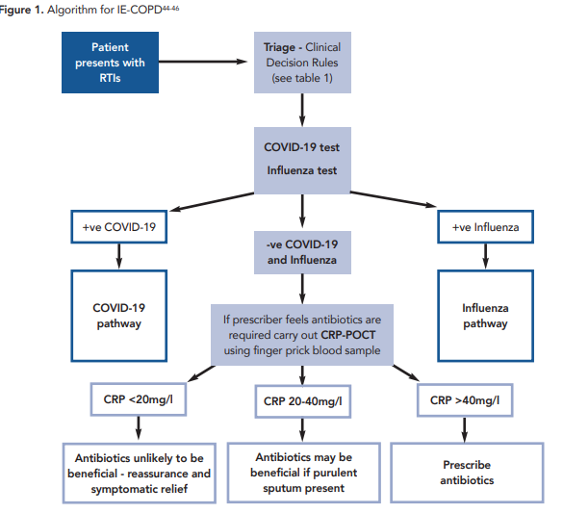

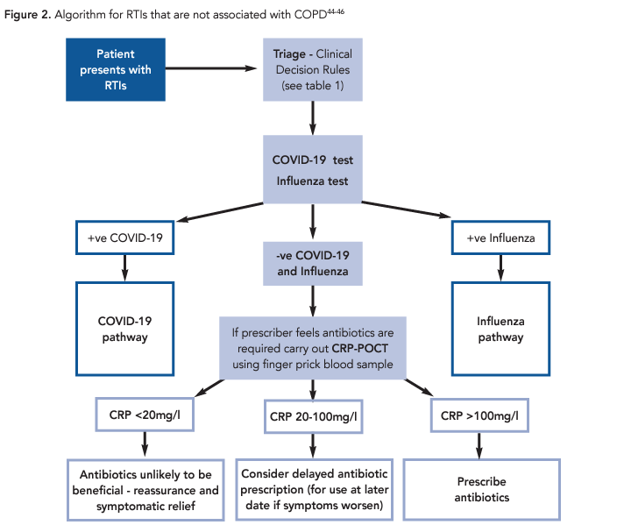

Preparing for your shift – Infection Control
SPCL is aligned to the NHS England National IPC Guidelines - NHS England » National infection prevention and control manual (NIPCM) for England which require Universal Precautions for Infection Control. We will continue to monitor and update these guidelines if they change during the winter period, and updated details will be available in the folders in the clinical rooms
All staff MUST wear scrubs (or clothes that can be washed at 60 degrees) AT ALL TIMES when working in this building. All staff must also follow PPE guidelines including the correct donning and doffing procedures (copies below and posters in all rooms). Aprons and visors will be available for those who would like to use them although they are not mandatory. FRSM type IIR masks must be worn onsite.
All staff MUST be bare below the elbows, have hair tied back (where applicable), short nails with no nail varnish and no jewelry other than one plain wedding band (although ideally none). Staff are encouraged to get changed on site at the end of their shift.
All staff working at the Acute Respiratory Infection Hub should be encouraged to be immunized against COVID19 and Flu for this season and the employer has a duty to ensure that each staff member undergoes a written COVID risk assessment to determine their personal risks and how to mitigate them.
Patients attending the hub will (in high probability) have respiratory viral disease, spread by droplet (coughing, sneezing) and contact. All areas need to be well ventilated to reduce viral load. Waiting should be kept to a minimum and social distancing of minimum 1 meter should be enforced. Patients should be provided with and requested to wear FRSM’s onsite if tolerated and age appropriate. Ideally, (where people have arrived by car) people should wait outside to be called through into the hub to prevent overcrowding (this would include when waiting for test results).
Hand hygiene should be promoted with staff and patient using alcohol hand rubs or soap and running water along with good respiratory etiquette.
Touch points (door handles, lift buttons, taps, chair arms etc.) should be cleaned at regular intervals throughout the day with terminal cleaning at the end of the day using detergent or a chlorine-based solution.
One way flow is not required.
Governance Structure
The ARI Hub is led by SPCL and falls under the SPCL Governance Structure, along with the SPCL Policies and Procedures. These are available on request.

