Paediatric Weight Management GP Information Pack
Attached below is information about who to refer to secondary or tertiary care (both can be done through the centralised weight management referral form attached). For children who do not meet criteria for secondary care input/ or who are on a waiting list we include information about how to write an obesity prescription and some further resources.
Initial assessment of children who are overweight/ obese
Background
1 in 4 children are now leaving primary school obese in England according to the latest National Childhood Measuring Programme 2021 data. This is a shocking statistic and will lead to significant comorbidity. Obesity is now the leading cause of reduction in life expectancy and we are now seeing children as young as 3 years of age with obesity related complications who require hospital care. The scale of the obesity epidemic means all healthcare professionals need to be involved in tackling the problem. Many of us find this a difficult topic to talk about but in our experience a non-judgemental open approach, often centred around the child’s growth chart measurements usually works well.
Initial assessment
The child’s height, weight and BMI need measuring and plotting on a growth chart. The free UK-WHO Growth Charts app recommended by the Royal College of Paediatric and Child Health can be very helpful in doing this.
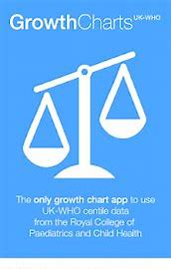
Definition of overweight and obese in children
A child is overweight if their BMI centile is between the 9^{1st} and 98th^{th} centile. A child is obese if their BMI centile is >98th centile (or the BMI standard deviation score is >2)
A simpler way of looking at this is that if a child’s weight is greater than 3 centile lines above their height they are obese.
NB: actual BMI values are not used in children as they are in adults. A child may have a BMI of 26 but still be severely obese. It is the BMI centile that is important!
Percentage excess weight
We are increasingly working out the percentage excess weight of patients as this correlates to risk of medical co-morbidities. You do this by working out the ideal weight based on their height centile and then subtract the ideal weight from the actual weight and divide the total by the ideal weight.
Our experience of looking after children who are overweight shows that once children reach 100% excess weight (ie double ideal weight) they all have at least one medically significant comorbidity.
If a child is carrying 100% or more excess weight they need urgent referral to the tertiary clinic.
Parental target height range
Most children with environmental obesity are taller than average (in the upper half of their parental target centile). A child who is particularly short or at the bottom end of the parental target centile is likely to need further assessment to rule out an endocrine cause of obesity.
Further information about calculating target parental height centiles can be found here:
http://gpnotebook.com/simplepage.cfm?ID=-133824460
Past medical history
Please include relevant details such as treatment with steroids/ asthma/ previous gallstones or pancreatitis/ conditions limiting mobility
Comorbidity screen
Please check for symptoms/ signs of
- obstructive sleep apnoea (snoring with pauses at night, morning headaches, daytime somnolence),
- type 2 diabetes (polyuria, polydipsia, acanthosis nigricans)
- hypertension (BP >90th centile for age and height)
- non-alcoholic fatty liver disease (raised ALT on bloods)
- mobility problems including Perthes (hip pain and limp)
- psychological difficulties related to weight (bullying, anxiety, low mood) if significant concerns (including worry about binge eating disorders) please also refer to CAHMS
Family history
Is there a family history of type 2 diabetes, cardiovascular disease in people under 60 or difficulties with weight management (obesity/ eating disorders?)
Social/ educational history
Please include details on family structure – is there adequate support and supervision of eating at home? Are there financial difficulties impacting food shopping? Are the family supported by social care? Is attendance at school good? Do the child or parents have learning difficulties?
Be aware that significant obesity is an indicator of neglect.
Examination findings
Check for goitre, straie, acanthosis nigricans and measure BP. Note any syndromic features.
The Paediatric Blood Pressure app (picture below) is a simple very useful tool that allows you to check blood pressure centiles for age and height. Blood pressure centile >90th requires further review by a paediatrician. Remember the correct paediatric size cuff is needed to measure blood pressure.
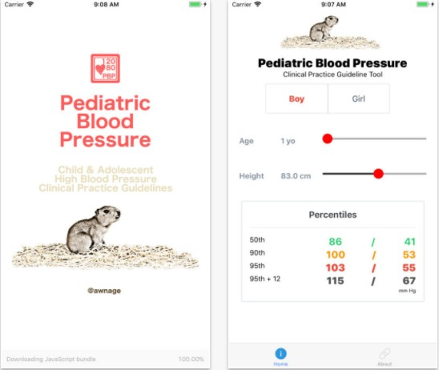
Baseline investigations
For children who have a BMI centile >98 please arrange thyroid function tests and liver function tests prior to referral. This will allow children to be triaged more appropriately. If there are symptoms of polyuria or polydipsia please check a fingerprick blood sugar immediately and discuss with the paediatric diabetes team the same day if this is >10mmol/l.
Red flags that mean you should consider referral to secondary care:
- Symptoms or signs of a comorbidity (symptoms of obstructive sleep apnoea, type 2 diabetes, abnormal liver function blood tests, hypertension, significant mental health difficulties related to obesity, mobility difficulties related to obesity)
- Iatrogenic cause of obesity such as high dose steroids or previous chemotherapy or radiotherapy treatment
- Syndromic features (including deafness, visual problems, renal problems and developmental delay)
- Concerns about an endocrine cause of obesity – abnormal thyroid function bloods, short stature (lower half of parental target centiles or below) or poor growth velocity
Primary Care weight management advice
Children who are overweight or obese should be referred to the Public Health Nurses or Health Visitors as part of the Universal Plus or ECHO programme where they will be offered 3-6 structured sessions of support and education around healthy eating and lifestyle.
For school aged children (aged 5 years and above) refer to public health nurses:
SNHS.Publichealthnursingsouthampton@nhs.net
For children aged 5 years and under contact:
SNHS.healthvisitingsouthampton@nhs.net

Information that can be provided as GP – how to write an obesity prescription
Diet:
First steps to recommend
- All drinks should be switched to water, be particularly aware to avoid high sugar content of fizzy pop, milkshakes or smoothies
- Limit snacks – if possible cut these out: they should have no more than 2 snacks of 100 calories each, ideally these should be a piece of whole fruit,
- Be aware of high sugar breakfast cereals – consider swapping to lower glycaemic index foods such as porridge made from whole oats, Weetabix, wholegrain bread toast with eggs
- Encourage home cooked meals from scratch and avoiding processed food as much as possible.
- The evening meal should consist of half the volume of the plate being salad or vegetables, one quarter being carbohydrate (rice, pasta, potatoes, bread) and one quarter being protein (chicken, fish, meat, legumes).
- Encourage families to review portion sizes as these are frequently too large. Information above age appropriate portion sizes can be found on the following websites
- 0 – 4 years http://infantandtoddlerforum.org/toddlers-to-preschool/portion-sizes-for-toddlers/toddler-portion-sizes-table
- Older children http://www.bda.uk.com/resource/food-facts-portion-sizes.html
- Please also see CHEW guides attached in appeddix
- Encourage a window of at least 12 hours overnight where no food is consumed to allow the body to burn fat.
- The appendix below outlines average recommended calorie intake for children according to sex and age. In children who are very sedentary or who are aiming to lose weight reduce the calorie target by 20%.
- The free app MyFitnessPal can be useful for families who are interested in counting calories.
Activity:
- Children of pre-school age should take part in 3 hours of active play per day. This can include running in the garden, going to the park, walking, climbing, building dens at home etc
- Children of school age should take part in 60 minutes of moderate to vigorous exercise per day. This would include brisk walking, jogging, cycling, trampolining, swimming, playing football or dancing to music. This is equivalent to 10,000 steps per day. Recommend the use of an activity tracker.
Referral to secondary or tertiary care via the centralised weight management referral template (see appendix)
The following children should be referred for hospital based care:
- BMI centile >99.6 (once they have completed the public health nurse programme)
- BMI centile >98 plus symptoms of co-morbidity (symptoms of obstructive sleep apnoea, type 2 diabetes, abnormal liver function blood tests, hypertension, significant mental health difficulties related to obesity, mobility difficulties related to obesity)
- Iatrogenic cause of obesity such as high dose steroids or previous chemotherapy or radiotherapy treatment
- Syndromic features (including deafness, visual problems, renal problems and developmental delay)
- Concerns about an endocrine cause of obesity – abnormal thyroid function bloods, short stature (lower half of parental target centiles or below) or poor growth velocity
- Children who are severely obese (BMI standard deviation score or >3 who are carrying more than 50% excess weight should be referred to the tertiary obesity service if there are concerns regarding poor engagement of family or neglect. These patients may be referred once offered the public health nurse program if this does not result in improvement of BMI or if the family refuse to engage).

Further information is available on the PIER guideline for obesity which is available on the internet. https://piernetwork.org/obesity/html.
Further training is available for health professional via the Southampton Hospital online learning system– please email uhs.weightmanagementteam@nhs.net if you would like access to this.
WHO growth charts can be found here:
- www.rcpch.ac.uk/sites/default/files/Boys_2-18_years_growth_chart.pdf
- www.rcpch.ac.uk/sites/default/files/Girls_2-18_years_growth_chart.pdf

Appendix

REFERRAL TO THE PAEDIATRIC WEIGHT MANAGEMENT SERVICE AT SOUTHAMPTON CHILDREN’S HOSPITAL
For GP, please attach a completed copy to your e-referral and use service “Paediatric Endocrinology”
For queries and all other referrers, send via uhs.weightmanagementteam@nhs.net
Referral criteria:
- BMI >98th centile (SDS >2) with symptoms of co-morbidity or
- BMI >99.6th centile (SDS >3) or
- Baby who has cross >3 centiles upwards in 6 months or whose weight is > 3 centiles above height

Patient name  DoB  NHS Number  Address | Age  Weight  Weight centile  Height  Height centile  BMI  BMI SDS  (Can use Growth charts UK-WHO App)
Relevant PMH (including behavioural difficulties, learning difficulties, complex social circumstances)

Co-morbidity screen:
Symptoms of obstructive sleep apnoea, T2DM, slipped upper femoral epiphysis or reduced mobility, gallstones, PCOS or depression? Please provide details:

Ethnicity | FHx of  Obesity:  Cardiovascular disease:  T2DM:
Weight management input so far: | Parental consent for referral:
Results of bloods tests: (need TFTs and LFTs prior to referral being accepted)

Professional referring patient:
A healthy eating pattern for a child or young person should result in*:
- 50-55% of their total energy (kilocalories) coming from carbohydrate
- Less than 35% of their total energy (kilocalories) from fat (with less than 10% of fat being saturated fat)
- 15-20% of their total energy (kilocalories) intake coming from protein
- A short guide to calories and carbohydrates in children
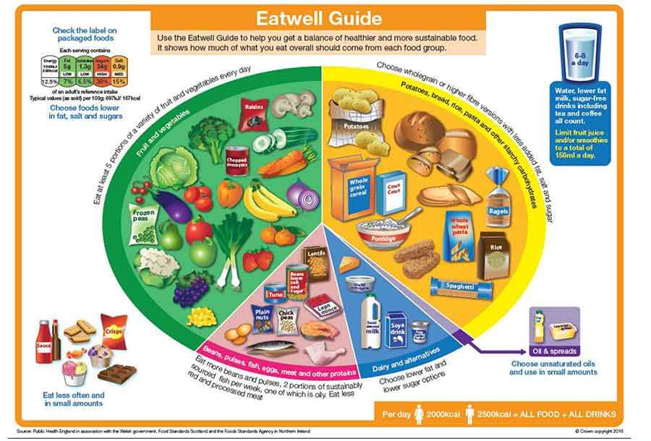
Table 1 shows the Estimated Average Requirement (EAR) for girls and boys aged 1 to 18 years (this is the total energy on average you would expect a healthy active child or adolescent to consume each day). It also shows how much carbohydrate (grams) would need to be eaten to provide the recommended 50-55% of the daily energy intake. For young people who are underweight, overweight or particularly active or inactive the recommended daily intake would be different.
Age  (years) | Boys |  | Girls
 | EAR*  (Kilocalories) | Suggested daily  Carbohydrate  Intake (grams) | EAR  Kilocalories | Suggested daily Carbohydrate  Intake (grams)
1 | 765 | 95 – 105 | 717 | 90 – 98
2 | 1004 | 125 – 138 | 932 | 116 – 128
3 | 1171 | 146 – 161 | 1076 | 134 – 148
4 | 1386 | 173 -190 | 1291 | 161 – 177
5 | 1482 | 185 – 203 | 1362 | 170 – 187
6 | 1577 | 197-217 | 1482 | 185 – 203
7 | 1649 | 206 -226 | 1530 | 191 – 210
8 | 1745 | 218 – 240 | 1625 | 203 – 223
9 | 1840 | 230 – 253 | 1721 | 215 – 237
10 | 2032 | 254 – 279 | 1936 | 242 – 266
11 | 2127 | 266 -292 | 2023 | 252 – 278
12 | 2247 | 280 – 309 | 2103 | 262 – 289
13 | 2414 | 301 – 331 | 2223 | 278 – 306
14 | 2629 | 328 – 361 | 2343 | 293 – 322
15 | 2820 | 352 – 387 | 2390 | 298 – 328
16 | 2964 | 370 – 407 | 2414 | 301 – 332
17 | 3083 | 385 – 423 | 2462 | 308 – 339
18 | 3155 | 394 - 433 | 2462 | 308 - 339

- Further resources
www.nhs.uk/better-health/lose-weight/
www.nhs.uk/healthier-families/
www.nhs.uk/live-well/eat-well/the-eatwell-guide
www.parkrun.org.uk
www.marathonkids.co.uk

