Suicide Awareness and Prevention across HIOW

Suicide is sadly increasingly common, with the impact of COVID19 on communities continuing to be felt, and it is important that those working in primary care have the knowledge and understanding to support patients who are struggling with suicidal thoughts.

We know that suicides do happen, and we want to support primary care when patients die by suicide. Our aspiration is to support all our primary care staff to feel confident in supporting and managing patients who are suicidal.

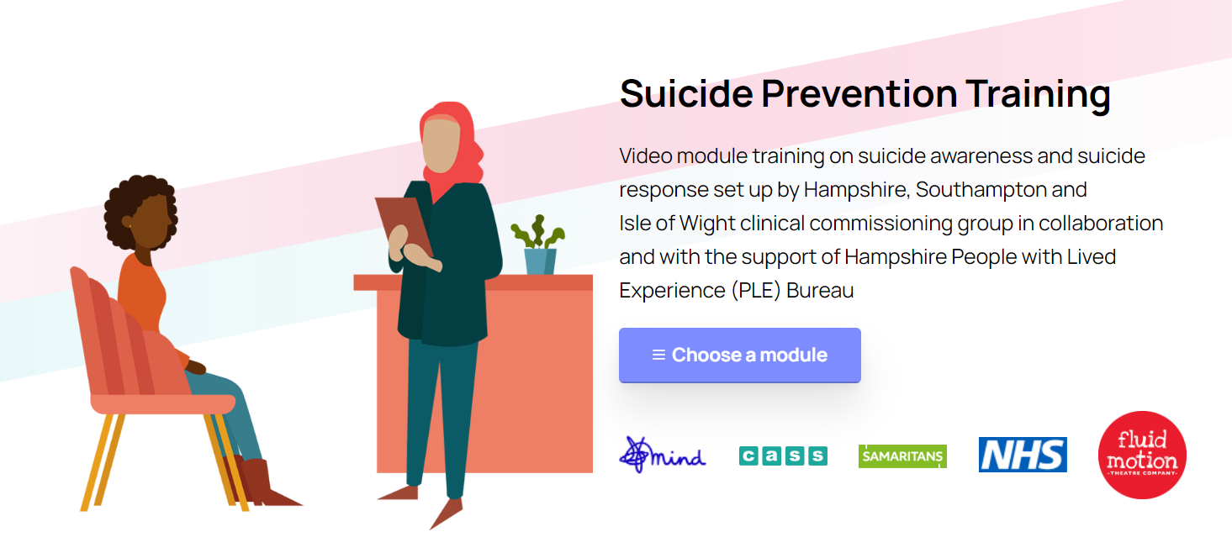

Working with patients and local charities, dedicated training is now available for all primary care staff online. This collection of videos, created by our patients and charities, offer insight and support to all those who may encounter suicidal patients wherever they work.
Suicide awareness focuses on understanding our suicidal patients so that we can best support our patients to access help.
Suicide prevention focuses on the immediate response to those patients who are suicidal, including how to respond safely and empathically. Our expert patients will explore what this means in reality and how clinical staff can support them during this difficult time.

All the training is available at https://suicideawareness.info/ (Password – Cass101), with certificates available for staff who complete the training.

Our aspiration is that all practices across Hampshire and Isle of Wight receive dedicated training in suicide awareness and prevention which we know will save lives.

Over the course of this year we will also be specifically focussing on ‘postvention’, supporting our practices when they are affected by the death of a patient by suicide. This tailored support will help practice teams safely explore these difficult events and provide ongoing support for your clinical teams.

With your help we can support our patients, help them during their time of crisis and save lives.

Dr Tim Cooper Dr Emily Walmsley
Deputy CMO for Primary Care Consultant in Public Health, Southampton

Dr Emma Seria-Walker Dr Sue Cochrane
Consultant in Public Health, Portsmouth Consultant in Public Health, Hampshire
and Isle of Wight

