Targeted Lung Health Checks in Southampton

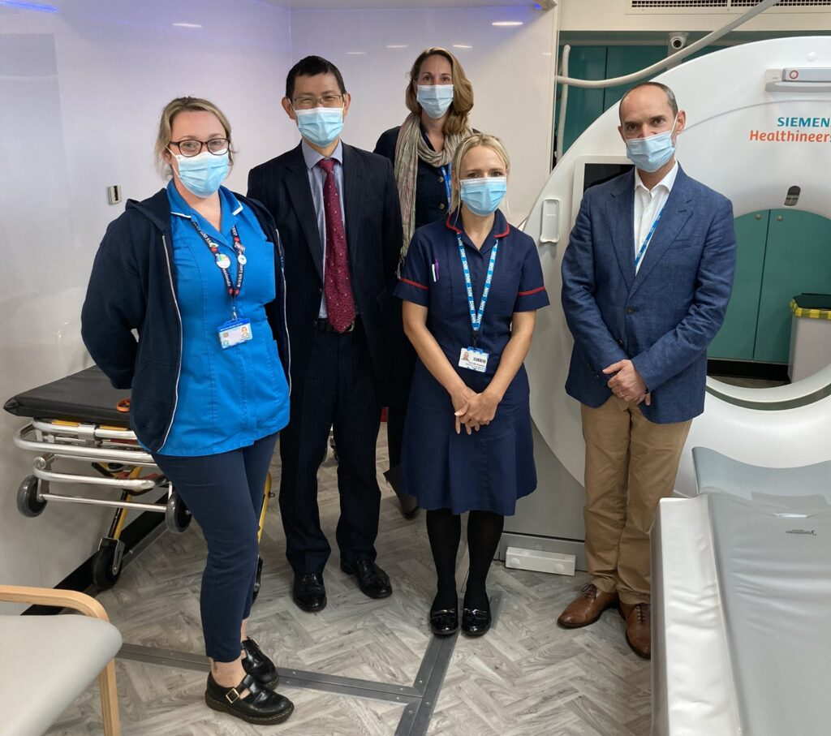

Targeted Lung Health Checks (TLHC) in Southampton went live in 2020, with the aim being to detect lung cancer at early stage as this is a key issue for the City. The program will be expanding to cover GP’s from areas around Totton and Eastleigh in 2023.

Some key facts from the programme to date:

- 22,829 patients have been invited for a lung health check
- 7,791 lung health checks have been competed
- 4,797 participants have gone on to have baseline CT scans
- 1,596 Participants have been able to have surveillance scans

To date, 132 lung cancers have identified, of these 100 have been identified at stage 1, which is a tremendous achievement for the programme. Not only have lung cancers been found at early stage, but there has been positive feedback from participants:

- 99% if participants said their experience of the service was “very good” and “good”
- 92% found the advice about quitting or reducing smoking helpful
- 61% of participants say they are likely to make a serious attempt to stop smoking after their lung health checks.

We are currently carrying out the surveillence scans for the participants, as well as having an increased number of people get in contact that either were unable to attend when first invited or have now seen about the program through media and GP information.

Participants who have not received an invitation letter through the post, but feel they are eligible for the targeted lung health check programme, are encouraged to contact the TLHC team via phone or email to discuss a self-referral to the programme.

Southampton Targeted Lung Health Check Programme contact details
Telephone: 02381 20 8883
Email: uhs.targetedlunghealthcheck@nhs.net

