Online Services – Full record access
Article metadata.
This article was updated• 29d ago29 days ago
This article has 1851 views.• 1851 Views

In line with the NHS (GMS Contracts) Regulations 2015, Part 10, Items 71ZA. & 71ZB. and the NHS Digital Accelerated Access to GP Data - Urgent Change Request, dated September 2021, EMIS are working on a series of enhancements to the EMIS Web Online Services (also known as Patient Facing Services) capabilities.

Contents
- How we will help
- Protecting patients
- Your preparation
  - Review codes
- Enhancements to EMAS Manager and Online Users
  - 9.16 release
- Next steps
  - Library resources
  - Additional enhancements
- FAQs

How we will help
We are working closely with NHS Digital to create a tool that will run for each organisation, and will provide a consistent level of access for patients when viewing their online care record from Date X (this date is to be confirmed by NHS Digital), unless the data has been hidden by the GP practice or exceptional circumstances apply. The tool will be run by EMIS, in line with NHS Digital approval, removing the need for practices to manually change the settings for each patient individually.
The tool, once run, will allow patients to see the following:
Allergies | All
Medication | All
Lab results | All coded data from date* plus free text from date*
Documents | All coded data from date* plus free text from date*
Immunisations | All coded data from date* plus free text from date*
Problems | All coded data from date* plus free text from date*
Consultations | All coded data from date* plus free text from date*
Patients will not lose any services that they already have, even if this is more than the tool grants access to and all changes will be visible in EMIS Web Audit Trails.
*You will be notified by email once we are able to confirm a date for the tool to be run for your organisation.

Protecting your patients
The tool will not make any changes for patients or online accounts that fall into the following categories:
- Those under the age of 16 on date x
- Proxy accounts
- Patients with the SNOMED CT code 1364731000000104 Enhanced review indicated before granting access to own health record (situation) added to their record
Organisations will continue to be able to hide individual items from patient view.
Back to top.

Your preparation
Prior to the Online Services tool being run at your organisation, you will need to perform the following actions:
- EMAS Manager settings will override any individual patient dates. By updating the EMAS Manager settings to the year 1900, it minimises the risk of patients being given individual dates prior to this.
Configure your EMAS Manager Online Services settings so they look like this:
Click image to enlarge.
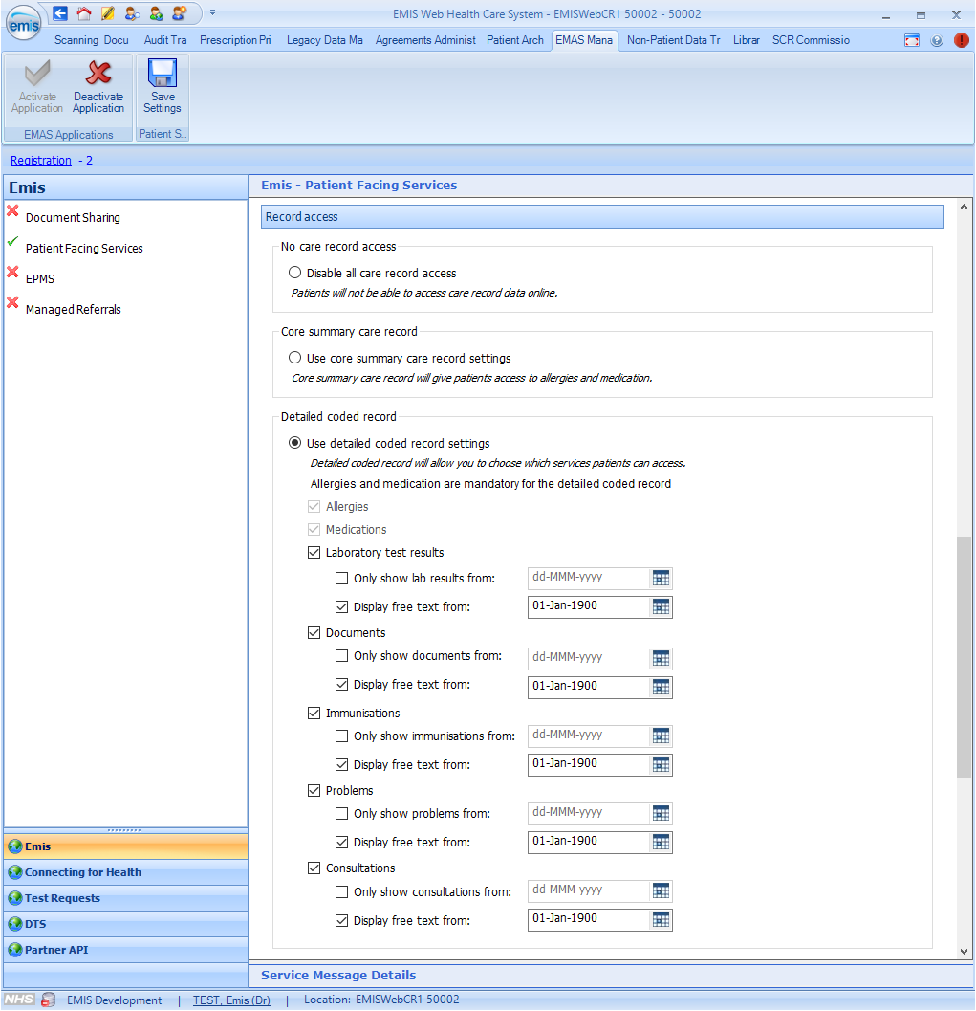
- Identify any patients that should not be given access to their online care record and add the SNOMED CT code 1364731000000104 Enhanced review indicated before granting access to own health record (situation) to their record. This will prevent them from being included when the tool is run.
This code could be added as a problem so that is is easily visible.
If you decide that, following a review, the patient should be given access to their online care record, SNOMED CT code 1364751000000106 Enhanced review not indicated before granting access to own health record (situation) should be added. The tool will then include the patient. If you complete a review after the tool has been run, you will need to configure online access manually for the patient.

Review codes
Important points to note:
- Do not batch add the 104 or 106 code to your whole patient population.
- The codes don't do anything after the script is run, only before.
- If the 104 code is added prior to the script being run, and 106 is not added, access will need to be updated manually.
If certain data is added e.g. referral letters, and they contain clinical data, this data might be 'historical' and will provide visibility to data outside of their usual setup.
Back to top.

Enhancements to EMAS Manager and Online Users
In EMIS Web v 9.15, we have made enhancements to both EMAS Manager and Online Users to support the definition of prospective / future access level. We have added the option of free text for Immunisations, along with additional date controls to make choosing a service, dates and free text more consistent.
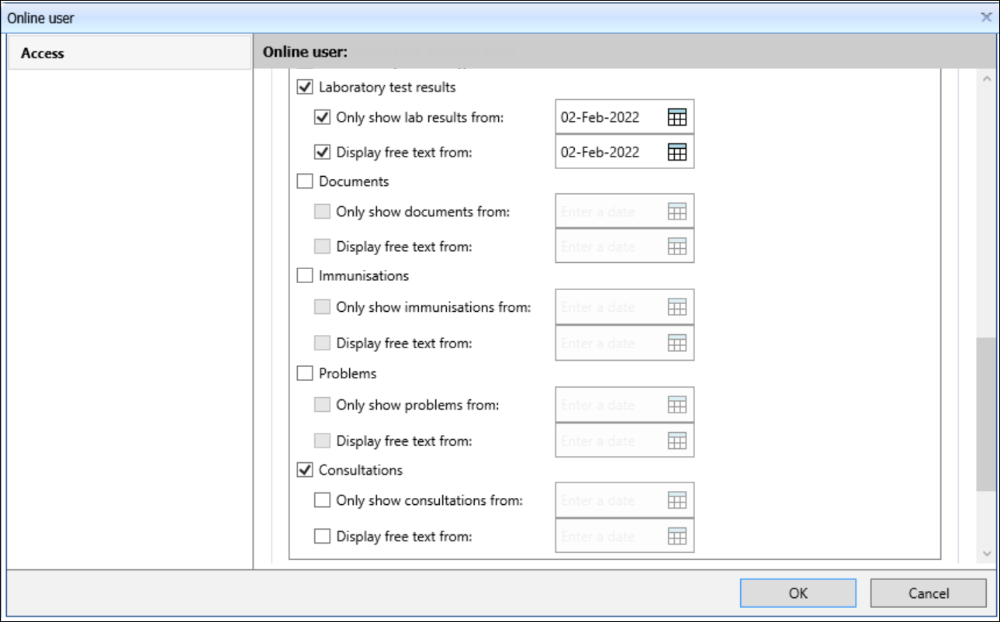
Back to top.

9.16 release
The changes below are included in the 9.16 release, but will be initially switched off. We will inform practices using service notifications when the changes are due to be activated.
Access for patients with new online accounts is as follows:
- Patients with a newly created Online Services accounts will have their access updated to future/prospective from date X, instead of core access only.
- When a patient registered at the practice after practice date X is setup for online care record access, the default setting is prospective access from the patient's registration date.
This ensures data entered by the previous practice is not visible by default until checked by the new practice (new data controller).
- Patients that turn 16 and have their Online Services account will have prospective/future access enabled from the date of their 16th birthday.
The above does not apply to proxy users, under 16 year olds and patients with the 364731000000104 code in their record (recorded last in the sequence of 1364751000000106 and 364731000000104).
Back to top.

Next steps

Library resources
New searches will be available to help your organisation manage the preparation and ongoing management of these changes.
Back to top.

Additional enhancements
We will be making enhancements to EMIS Web that will add new functions in Online Users to make is quicker to assign the correct level of care record access, without the need to select each item individually.
Back to top.

FAQs
How is 3rd party data hidden from online access?
Any data that you would not like to be visible to a patient online can be hidden using Online Visibility.

Are patients able to see documents before they have been filed?
No, all documents will remain as ‘Provisional’ until a member of staff has viewed and filed the document task. Documents will not be available to patients online until this has taken place. Documents that go through a Docman workflow to be viewed, actioned and filed will only be visible to a patient using online access once they have completed their Docman workflow. Until this point, the document will be marked as ‘Provisional’ in EMIS Web and will be hidden from patient view.

Will any data be visible to a patient without it being viewed and filed by practice staff?
There are certain types of data that will be auto-filed within EMIS Web. These include:
- COVID-19 vaccinations
- COVID-19 test results
- NHS 111 - suspected COVID-19
- Flu vaccinations
- Consultation Write Back - There is an option for the sending organisation to set the Online Visibility flag to ‘Do not display on the patient's online care record’, meaning the consultation will not be visible via Online services until the patient’s registered practice chooses to enable it.
This means that any data coming into EMIS Web through these means can be visible to the patient without being reviewed by a staff member first.

Will data filed from a partner system be visible to the patient via Online Services?
When data is viewed and filed from a partner system into EMIS Web, it will be visible to the patient unless it has been marked as ‘Do not display on the patient’s online care record’ using Online Visibility.
This only applies to data where there is no option to set the online visibility in the partner system.

Can patients see data that has been added by an administrator?
If an administrator has added data to a patients record in the form of a consultation (even using the consultation type of ‘Administration Note’), medication or a clinical code, these will be visible to the patient using online access. The following will not be visible:
- Patient Tasks
- Admin Notes
- Screen Messaging
- Internal Email
- Patient Warnings

What happens to a patient’s online access when they move from one GP practice to another?
When a patient chooses to register at a new GP practice, access to any care record data they had at their old GP practice will no longer be available to them by default. The patients online care record will only show data added from the date of practice registration.
When a patient’s record is received via GP2GP:
- The patient will not be able to see any of this data as it is dated prior to the registration date.
- It is possible for the patient to request access to this data. Each practice should have a process in place to decide on the correct outcome for this.
If the patient’s record fails to send via GP2GP:
- The patient’s new GP practice will need to wait for the paper copy, and summarise following their usual process.
- Data will need to be summarised accurately. Anything that is added with a date after the date of registration will be visible online.
This only applies to patients where there is no exception such as under 16s.
If the patient has code 1364731000000104 - Enhanced review indicated before granting access to own health record added to their record, but has not since had code 1364751000000106 Enhanced review not indicated before granting access to own health record added, they will not have access to their online care record. GP practices will need to consider how to identify these patients and whether they wish to conduct their own review with the patient.

Does each practice have to review each patient record and hide any sensitive information?
No, only data added after date X (TBC) will be visible to the patient online. A patient may request access to data prior to this date but this can be reviewed on a patient by patient basis. We recommend that a process is implemented to ensure that any data added after date X is clear, concise and patient friendly. This will prevent unnecessary calls to the GP practice from patients asking for more information or explanation.

Will documents sent to the GP system from other providers be excluded or does the practice have to flag them as not for online if sensitive?
The documents will need to hidden from online access manually if there is a reason that the patient should not see the document, for example 3rd party data.
EMIS recommends that each organisation reviews any 3rd party applications to ensure they know which ones are auto filing data. It may be necessary to put a process in place to ensure items are reviewed to ensure online visibility is set appropriately.

Will GP practices have functionality to audit Patient Access? If so, how in depth? Will there be an option to see if any part of the record has been printed for example?
Yes, EMIS Web already has functionality that allows a user to view certain information. Users will be able to see what information a patient has viewed. In the Audit Trail module, the user will display as Patient Services – Patient Access.

Will the Care Record contain an alert to show if a patient has accessed their online record?

Will it be possible to hide specific parts of a consultation, e.g. where a GP is recording their query of a possible serious diagnosis but do not want to share this information as their initial query until results return or a future consultation?
Unfortunately this is not possible. You can only display or hide a whole consultation. If there is any information you need to hide, it would need to be added as a separate consultation.

Will patients who have online access to their records be able to amend or edit their patient data?
No, they will only have the option to view their data.

