Flu Issue 2
South East Region
Updates for week ending 9 September 2022
Supporting uptake of flu vaccination for people with a learning disability
In line with the aim to reduce premature mortality amongst people with a learning disability, the same innovative approaches used during COVID-19 vaccination roll out should be considered for the flu programme. This includes drawing on the many vaccinators with the knowledge and skills about people with a learning disability and their need for reasonable adjustments.
Easy read flu resources are available here Flu vaccination: easy-read flu vaccination resources - GOV.UK (www.gov.uk)
Vaccine ordering via ImmForm for children
Anticipated ordering opening dates and arrangements are set out below.
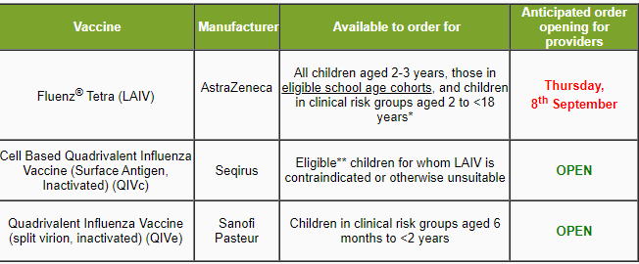
** Children in clinical risk groups aged 2 to <18 years, healthy children aged 2-3 years, and those in eligible school age cohorts.
There are ordering controls in place to balance incoming supply with demand:
- Each GP practice has been given an initial allocation of LAIV sufficient to vaccinate up to 45% of their eligible patients (all 2 and 3 year olds, plus children in clinical risk groups from age 4 to <18 years).
- Amendments to these allocations will be made in response to vaccine availability and demand. The most up to date information on LAIV allocations will be available on ImmForm at all times, so please check regularly for updates.
- Requests for extra vaccine will be considered on a case-by-case basis throughout the ordering period. Requests should be sent to the helpdesk (helpdesk@immform.org.uk) and in good time before your order cut-off.
Managing LAIV and QIVc allocations within Multi-Branch Practices
GP practices or groups that operate over multiple sites but are part of the same organisation will have a single allocation for LAIV and QIVc, even where each site has a unique ImmForm account. This means that it is possible for one site to order all of the vaccine available for the group. It is recommended that you agree within the practice/group how vaccine allocations are to be shared and ordered before ordering starts. The allocation information above should help you estimate the amount of LAIV available to the group, and how to split it equitably. Please remember that LAIV allocations are per season, and not per week.
For QIVc, the total amount available per week, will be 8 doses per site, multiplied by the number of sites in the organisation.
To keep up to date and for more information regarding vaccine ordering please ensure you regularly visit ImmForm: Intranet Portal - Home (phe.gov.uk)
ImmForm GP Flu Collection Schedules
The flu vaccine uptake surveys collect cumulative data on influenza vaccinations in the GP registered population in England between 1st September 2022 and 28th February 2023 in the following groups:
- Patients aged 65 years and older.
- Those aged six months to under 65 years in clinical risk groups as defined by the Green Book.
- Pregnant women.
- Children aged 2 to under 18 years (Flu Childhood collection only).
There are two surveys:
- weekly automated collections from a large sentinel group of GP practices. This allows ‘real time’ monitoring of the programme from week 36 (w.e. 11th September 2022) to week 4 (w.e. 29th January 2023).
- 5 monthly surveys of all practices (includes both automated and manual returns) in October, November, December, January and February. These will provide a more complete data set. For the first 4 surveys, there are some mandatory data items. The final survey will be more comprehensive and will entail those submitting data manually to complete some optional data fields.
The collection schedules are overleaf.

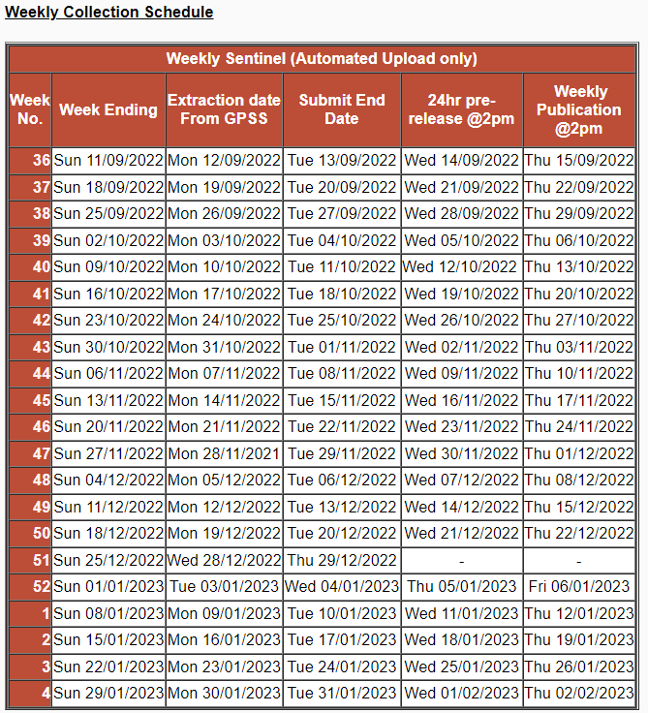
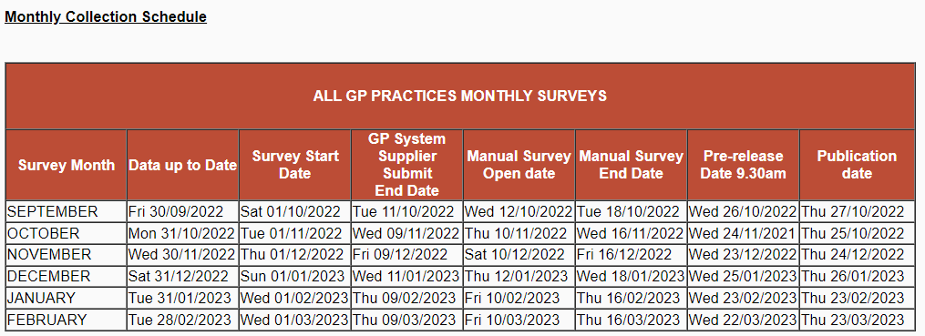
If you have any feedback or queries relating to this communication, please contact:
england.htvphcontracting@nhs.net - Hampshire and the Isle of Wight, Berkshire, Oxfordshire and Buckinghamshire, Frimley
phst@nhs.net - Kent and Medway,
PHE.Screening-ImmsSSAT@nhs.net - Surrey and Sussex

