EMIS Collaborative Working & Enhanced Access Support Guide

Document Date: 27/06/2022
Document Version: V0.1

Version Control

Version | Date | Author | Comments
0.1 | 27/06/2022 | Charlie Gale, Senior Project Manager | First Draft

Contents
Version Control 1
EMIS Solutions 4
Option One - EMIS PCN Hub/Clinical Services 5
EMIS PCN Hub Introduction Package 5
EMIS PCN HUB Process 6
EMIS PCN Pricing Model 7
Enterprise Sharing Agreements 7
Activate an enterprise appointments agreement 8
Data Sharing Manager 10
Enable Document Sharing 11
How to use Consultation Write Back (CWB) 12
Organisations with un-activated agreements 13
Audit 13
Cross Organisational Appointments 14
Target Organisation 14
Booking Organisation 14
Considerations 14
Configuring Cross Organisation Appointments 15
GP Connect Appointment Configuration – for 111 and/or PCN appointment sharing 15
Enable GP Connect Service 15
Add an Organisation Group 16
Creating Appointment Sessions and/or Slots 17
Creating a session and applying a filter 17
Editing Filters 19
Mark Individual Appointment Slots as GP Connect 111 Bookable 20
Prescribing 22
Pathology 22
Request a MESH Mailbox 22
Request EDI Code from NHS Digital 22
Enable Pathology Links in EMIS 22
Role Based Access (RBAC) 23
Third Party Providers 23
Resources 24

EMIS Solutions
Options for delivery within an EMIS only estate.

Requirements | EMIS Web GP | EMIS PCN Hub (Clinical Services)
Single Sign-On | X
Cross Org Appt Booking (shared appt book)
Video Appointments | Via video consultations third party provider
Appointment Reminders (text messaging) | Via SMS third party provider
Patient can cancel appointments | Via SMS third party provider
Patient can book appointments online |  | X
Access to un-registered patients
Shared Patient Record Access
Consultation Write Back (direct to record)
Consultation Summary (PDF) | N/A | N/A
Make e-RS referrals |  | X
Order and view tests
Prescribing (EPS)
NHS 111 directly bookable appointments

- Cross organisation booking can be achieved in both EMIS Web GP and PCN Hub via either EMIS cross organisational booking functionality or GP Connect functionality
- If using EMIS Web GP a lead Practice is required to house shared appointment books and PCN staff
- Access to un-registered patients in GP EMIS Web - patients are temporarily registered with the lead practice when using an EMIS GP Web model
- NHS 111 booking are achieved via GP connect functionality
- Additional charges for third party providers connecting to EMIS PCN Hub - TBC

Option One - EMIS PCN Hub/Clinical Services

PCN Hub enables clinicians in any service to access patient records they need to deliver accurate and personalised care – whether the patient is registered to that specific Practice or not.
PCN Hub is based on sharing agreements and provide the following key functionality:

- Record Sharing – view the GP record and shared information from any organisation within a PCN, including from the Hub

- Consultation Write Back - allows organisations that are connected to use their enterprise agreements to receive a copy of any consultation notes added to a patient’s record, including all coded and QOF data

- Direct Prescribing – via EPS to the nominated pharmacy, all medications recorded at the Hub are copied back to the registered Practice

- Clinically Intelligent Decision Support – enables prescribing alerts at the point of care in a hub or custom alerts relevant to PCNs

- Cross Organisation Appointments – book from any other organisation into another organisation (including non-EMIS via GP Connect) without the need for multiple log-ins

EMIS PCN Hub Introduction Package

EMIS offer a full support and implementation package designed to support PCNs by providing consultancy, engagement, training and system build. Costs are incurred for sessions – see table in Pricing Model section.
The package can include the following:
Session | Purpose | Optional
Engagement Visit | EMIS representative will work with PCN representative to gather information on internal process and review set up of how the PCN will work. Will consider any reporting/KPI requirements, along with any required templates and documentation | Combined with System Build day
System Build Visit | EMIS representative will advise on configuring the system around areas of Org configurations, clinical and documentation templates and the appointment book | No
Training Visits | EMIS Representative will deliver the bespoke training plan designed during the engagement visit. This is dependent on the PCN and the services they provide | Yes – training can be provided by AGEM at no cost to PCNs
Go-Live Floorwalking Visit | EMIS representative will be available to provide floor-walking support to all users. Where possible and time permitting, they will aim to provide refresher training as and when users are available | Yes – AGEM can provide telephone/Teams floorwalking support post go-live at no cost to PCNs

EMIS PCN HUB Process

EMIS PCN Pricing Model

Products | Single PCN Order (recommended 10 Licences) | 10 PCN Order (100 Licences)
EMIS Web Clinical Service | 10 x £690 = £6900 | 100 x £375 = £37500
Clinical Service Training Day | 1 x £650 | 10 x £650 = £6500
PDS and EPS | 1 x £792 | 10 x £792 = £7920
EPS Training & Project Management | 1 x £650 | 10 x £650 = £6500
Pathology Links | 1 x £750 | 10 x £750 = £7500
Engagement Day | 1 x £995 | 10 x £995 = £9950
TOTAL | £10,737 | £75,870

- Discounts are available and specific to the licence element; for example, 10 licences for a single PCN, the cost would be £690 licence, if procured in a larger amount such as 100 licences across 10 PCNs, the cost would be £375 licence.
- Licences are purchased on a per user basis
- Pathology links may not be required – dependant on how the PCN wishes to operate

Enterprise Sharing Agreements

EMIS PCN require Practices within a PCN to activate Enterprise Sharing Agreements, which may well have been completed to support cross-organisation booking already. By activating an enterprise appointments agreement the organisation consents to all other organisations within the enterprise appointments agreement having the ability to book and cancel appointments for all patients registered with all organisations in the agreement.
Through an enterprise appointments agreement organisations also consent to share:
- All future appointment slots marked as externally bookable
- Basic patient demographic information (name, address, gender, date of birth, NHS number and status) that allows you to trace and correctly identify the patient when you book an appointment
- A patient's past, future and cancelled appointments
- Your organisation's locations, services, slot types and session categories
- All care record data for an externally booked patient, from the point of making the booking to the point of consultation taking place, plus an additional legitimate relationship duration that is configured within the agreement itself. This data will be shared with the appointment session holder(s) only

Complete the data sharing agreements within the table below. Once completed email to DeliveryOperations@emishealth.com

Data Sharing Agreement Description | EMIS Description (Hub) | EMIS Description (Practice) | DSA Purpose | DSA Form
QF1091 Many to One EMIS Web Care Record Sharing | Viewing other organisations care record | Sharing my care record | Hub can view patients practice care record.
QF1091 One to Many EMIS Web Care Record Sharing | Sharing my care record | Viewing other organisation’s care record | Practice can view patient hub care record.
QF1093 One to Many EMIS Web Cross Org Tasks Agreement | Organisations allowing me to create tasks | Organisations creating tasks to me | Hub sends tasks back to patients practice
QF1093 Many to One EMIS Web Cross Org Tasks Agreement | Organisations creating tasks to me | Organisations allowing me to create tasks | Practice send Task back to Hub
QF1092 One to Many EMIS Web cross org appointments agreement | Sharing my appointments | Viewing other organisations appointments | Hub sharing appointment books with Practice
W18001 Consultation Write Back request form |  |  | Required for Consultation write back functionality

Organisations using an enterprise appointments agreement needs to activate the agreement in Data Sharing Manager, in order to book appointments for remote consultations and view/add data during a remote consultation.

Activate an enterprise appointments agreement
- Access Data Sharing Manager.
Click , point to Configuration, and then select Data Sharing Manager.
The Data Sharing Manager screen is displayed.
- On the ribbon, click My Agreements.
- In the navigation pane, click the Appointments tab
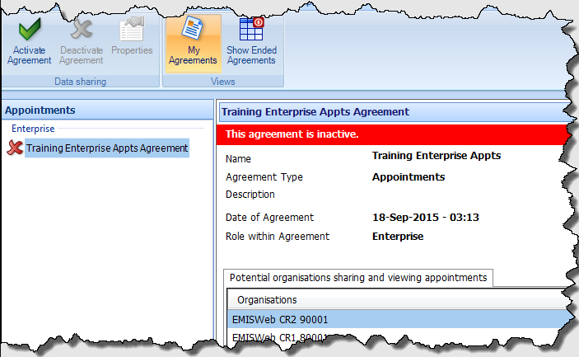
- Any active agreements are displayed with a green tick , and any agreements that have been created, but not yet activated, are displayed with a red cross .
- In the navigation pane, in the Enterprise section of Appointments, select the required agreement.
- On the ribbon, click Activate Agreement.
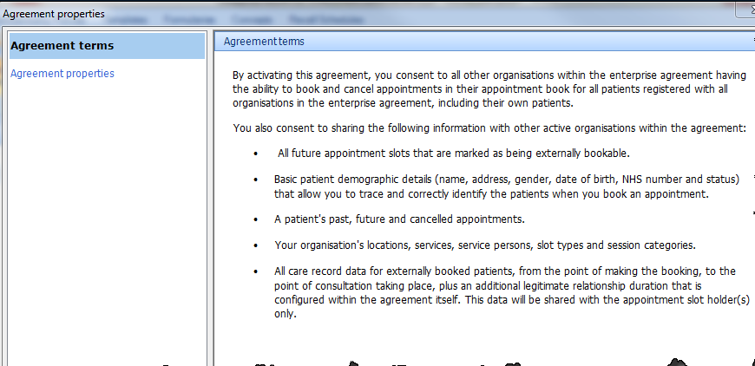
- On the Agreement Properties screen, read the agreement terms before proceeding to the next step
- Click Next
The fields on the Agreement Properties screen are mandatory.
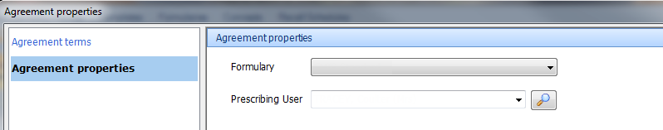

- In the Agreement Properties pane, complete the following mandatory fields:
  - In the Formulary field, click and select the required formulary.
This is the formulary that an organisation will use when prescribing to your patients using remote consultations. All organisations will need to add the same stamp doctor if they want all prescriptions for the service to have same stamp.
  - In the Prescribing User field, click and select the required prescribing user (the Stamp User Choice). These details are displayed on the patient's script.
Scripts must be printed out at the time of the remote consultation. If a script is stored, it is stored in the patient's registered organisation and can then only be printed from there.
- Click OK.
The enterprise agreement is activated for your organisation.

Data Sharing Manager

Once the enterprise agreements between two organisations have been activated, Copy Consultations can also be activated, ensuring that the consultation details are automatically added to the patient’s care record if they attend an appointment at either organisation.

- Access Data Sharing Manager
Click EMIS Ball, point to Configuration, and then select Data Sharing Manager.
- On the ribbon, click My Agreements and ensure any Copy consultation agreements show as active with a green tick .

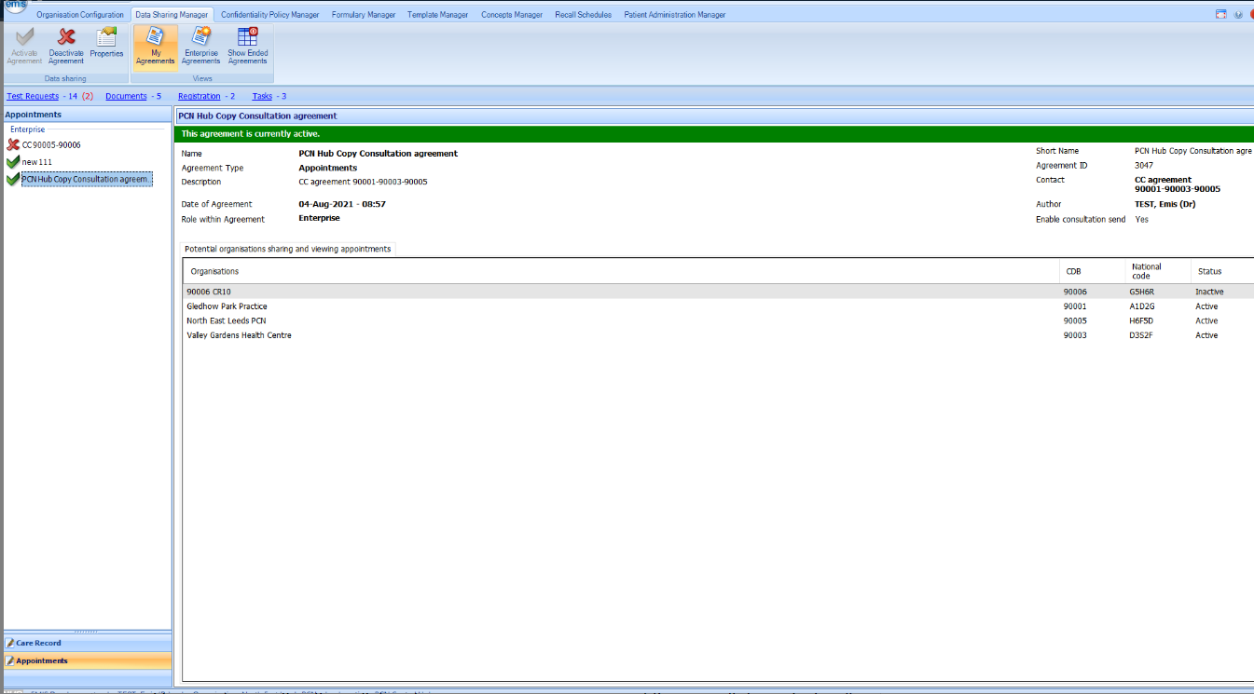

- Organisations within the collaboration can now receive a copy of the consultation which will be recorded on the patient record in their organisation's EMIS Web.
If an organisation you wish to share consultation information with does not appear, please contact EMIS Customer Fulfilment to have them added to your agreements.

Enable Document Sharing

You can send documents (i.e. Discharge Summary) stored within a patient’s care record via Direct Message. Before you can send a document via direct messaging you must activate Document Sharing using EMAS Manager.
The hub must also be set up as a target referral organisation:
- In the 'Organisation Details' section you need to set the option 'Allow referrals?' to 'Yes'
- In 'Service Details', go to 'Referral Source', set the drop down box to 'Both Internal and External'

How to use Consultation Write Back (CWB)

For Consultation Write Back to function correctly, the patient must be registered in at least one organisation within the agreement.

- Medications issued within the consultation will also be copied across
- Test requests are not subjected to delays as they take place immediately
- Referrals can also be made without the patient needing to go back to their registered clinician/GP
- Any documents attached to the care record will also be copied
Confidentiality flags are applied to the data copied across to show they can only be accessed by organisations/users within the agreement.

Consultation Write Back will function whether the appointment was booked as a cross-organisational appointment or directly with the location where the appointment will take place.
- The consultation is added as normal to the patient's care record.
- Upon save the status shown to the right of the pane will display whether it has been sent to the organisations within the copy agreement.
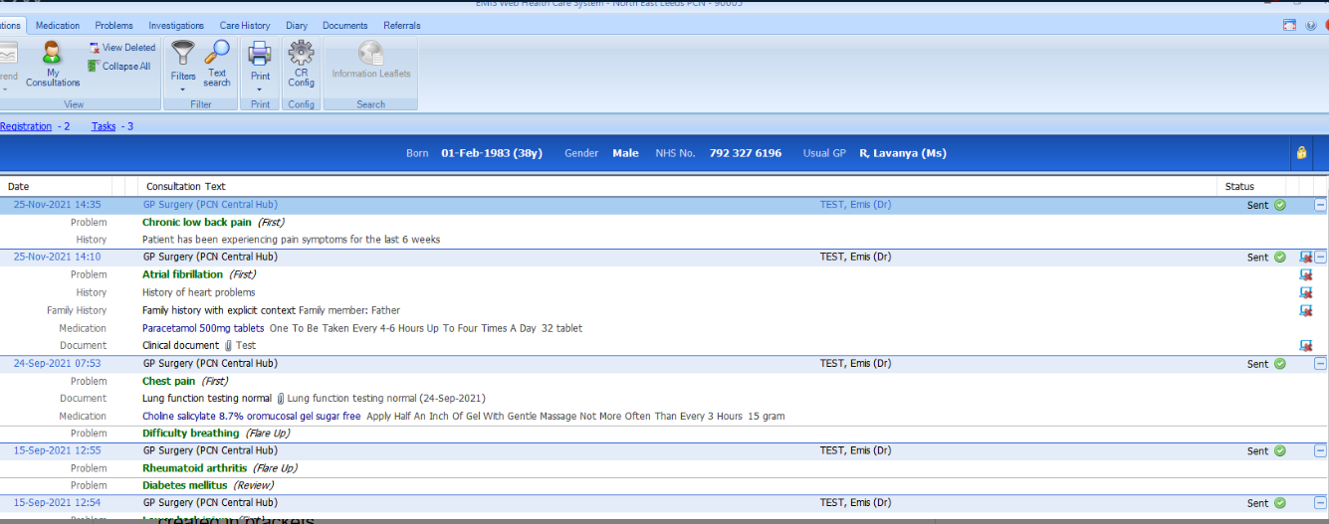

The consultation will appear in the patient's registered practice (the receiving practice) as an Enterprise Consultation, followed by the location of where the consultation was created in brackets.
- The confidentiality of the new consultation can be amended as well as the online visibility. These will be displayed to the right of the pane when the consultation is viewed in either organisation
- Any Problems, Medications, Documents, etc. that are added within the consultation will be copied into the applicable modules of the receiving organisation's care record for that patient
- Shared patients' consultations can be copied to the care record of any organisation they appear in.
Consultation Write Back.mp4 | EMIS Health (vids.io) - CWB demo video

Organisations with un-activated agreements

If no agreement is in place, the consultation will be saved locally and the following error will appear.

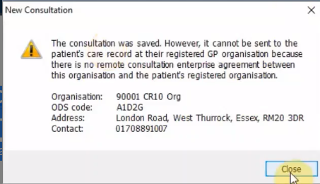

Amendments to existing consultations will not be transferred between organisations, only newly created consultations.
Adding status indicators to show if copy has been successful (also where it is sent to/from for audit trail).

Audit
If you right click on a consultation that has been copied across organisations and select Audit Trail, details of where the consultation was created, and where it was copied to are shown, along with details of the user who added it to the care record.
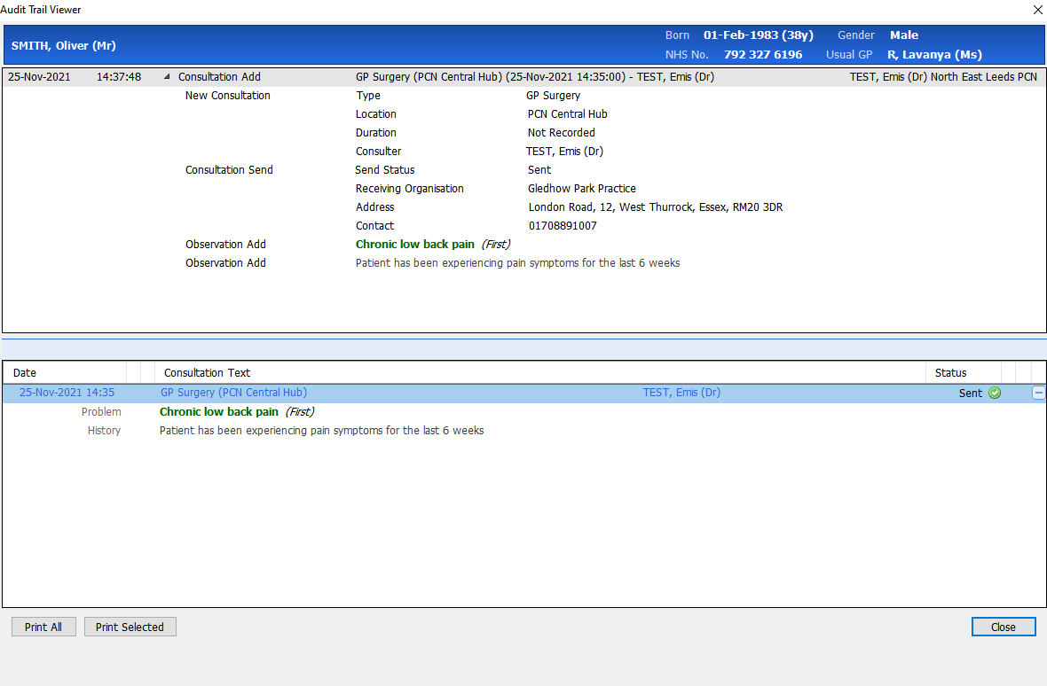

This audit trail will be visible in both the sending and receiving organisations.

Cross Organisational Appointments

This function allows a booking organisation to use cross organisational appointments to book an appointment with another organisation (target organisation) providing each organisation has an active appointment sharing agreement. Complete the QF1092 request form in the table above to request set up.

Target Organisation

The target organisation, i.e. you have an active sharing agreement to make your appointment slots available to other organisations, you can:

- Allow unregistered patients to be booked into your cross organisation appointment slots
- Create and maintain cross organisation appointment sessions and slots
- View the details of which organisation booked your cross organisation appointments
- Cancel cross organisation appointments (for registered patients only) and print standard cancellation letters
- View the audit trail of externally booked appointment slots, as well as those booked by your own organisation

Booking Organisation

The booking organisation, i.e. you have an active sharing agreement to view and book appointments with another organisation, you can:
Find and book cross organisation appointments for registered patients and print standard appointment letters.
- Find and book appointments for unregistered patients (if configured)
- Search for cross organisation appointments
- Cancel cross organisation appointments (for registered patients only) and print standard cancellation letters
- View an audit trail of the cross organisation appointment slots booked and cancelled by their organisation, provided they have an active reporting sharing agreement with the target organisation

Considerations

When using cross-organisation appointments, the following should be considered:

- Patient data visibility: the booking organisation can only see patient data that the target organisation holds if the following conditions are met:

  - The patient is actively registered at the target organisation, i.e. not deceased or left
  - The patient has not opted out of sharing their data
  - The patient has not opted out of detailed Spine sharing

- RBAC activity of the staff will need to be managed at the organisation that use cross organisation appointments. RBAC activity B0560 Perform Patient Administration must be added role profiles

- Protocol triggers are not triggered when booking a cross organisation appointment

Configuring Cross Organisation Appointments

Target organisations using cross-organisation appointments can:

- Configure cross organisation appointment settings - to allow unregistered patients to be booked into your cross organisation appointment slots
- Plan the Appointment Book
- Create and maintain cross organisation appointment slots - mark appointment slots as externally bookable
- Edit appointment slots from the Appointment Book
- Edit session templates

GP Connect Appointment Configuration – for 111 and/or PCN appointment sharing
GP Connect functionality and configuration available within GP Connect PCN and Enhanced Access Support Guide.
Enable 11 direct bookings into EMIS PCN Hub. Pre-requisites must be completed:

- Data sharing agreements
- Enable GP Connect for Appointments
- Set up new Organisation Group between PCN Hub and 111 Provider
- Configure appointment slots for 111 direct booking
- Understand mechanism for receiving 111 case notes into Practice

Enable GP Connect Service

- Click EMIS Bubble, select Configuration, click Organisation Configuration and the select Organisation from the left navigation pane
- Click Edit on the ribbon and the select GP Connect Configuration
- Select the box beside GP Connect
- Select the Foundation box and then Appointment box to enable Appointment booking
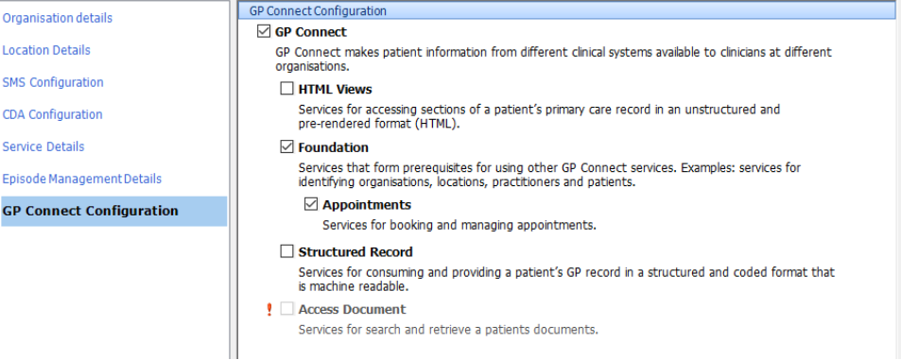

Add an Organisation Group
An organisation group is a group that can share appointment slots – for 111 or PCN/EAS.

- Click EMIS Bubble, select Configuration, click Organisation Configuration
- Select Organisation Group from the left navigation pane
- On the ribbon, click Add
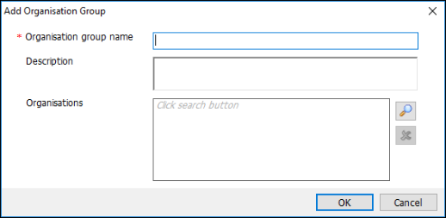

- On the Add Organisation Group window, type the Organisation group name and Description in the appropriate fields
- Click on the search glass next to the Organisations field to search for an Organisation
- On the Find Organisations screen, type the practice ODS code, and then click on the search glass. Double click to add to the group
- Click on the search glass again in the Find Organisations screen, type the ODS Code 111 Provider Service, and then click on the search glass. Double click to add to the group

Creating Appointment Sessions and/or Slots
There are two approaches a PCN Hub may wish to take when creating appointment slots for 111 Direct Booking. Creating a session with filters that reserve or limit which slots can be booked by 111 or just share individual slots within existing appointment book.

Creating a session and applying a filter
Session filters allow you to restrict your GP Connect 111 appointments to ensure they are only offered to the organisation you want – i.e. just the 111 Provider. This allows you to filter out slots by either reserving or limiting an organisation group, organisation type or organisation in specific appointment sessions. So for example a practice may have a session with slots opened up to both 111 Direct Booking and Enhanced Access booking. The practice can then use this to fulfil requests and reserve some GP Connect slots for 111 or limit the number of slots an Enhanced Access service can book in an appointment session.

- To create a session and apply filters click on the EMIS Bubble and select Appointments then Appointment Book
- On the ribbon click Create Session
- By default, the ‘All slots GP Connect Bookable’ option are greyed out and are only applicable when the session name, type, category and date are completed

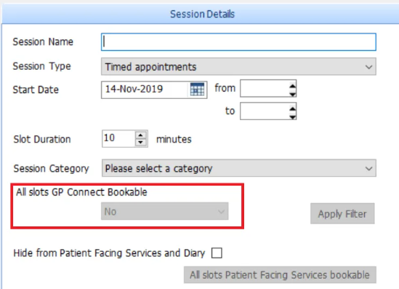

- Add a Session Name, Session Type, Session Category and complete the dates and times. The All slots GP Connect Bookable option is now available and a drop down box appears
- Click on the drop down box under All slots GP Connect Bookable and select Yes. The Apply Filter option is now also available. In the Session Preview pane, the appointment slots are displayed
- Click on Apply Filter

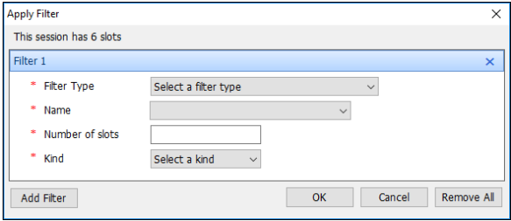

- Complete the Apply Filter screen:
  - Filter Type: Organisational Group
  - Name: Select the Organisation Group created above (111 Direct Booking – <Practice Name> (<Practice ODS Code>)
  - Number of slots: how many slots do you wish to either limit or reserve for 111 Direct Booking?
  - Kind: – Reserve or Limit – Do you wish to reserve a number of slots for 111 or limit the number of slots for 111?
- Click on OK. Upon completion your filter will look something similar to this:
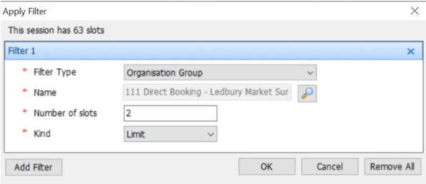

- Select all the created slots on the right, right click and select Slot Properties. Add a Slot Note if you wish but make sure only the GP Connect Bookable option is checked. You may wish to create a Slot Type for 111 and select this instead of Default. Do not select an Embargo or select Patient Facing Services Bookable or Urgent:

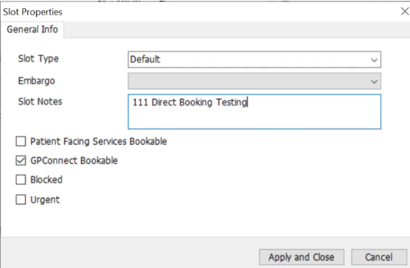

- Click on Apply and Close
- In the Create Session window click on Create

Editing Filters
If you wish to edit the filters after you have created a session.

- Click on the EMIS Bubble and select Appointments then Appointment Book. The Appointment Book is displayed.
- Use the calendar to select the required date. Find the session whose filter(s) you wish to edit
- Right-click the session and then on the ribbon click Session Properties. The Session Properties screen is displayed.
- Click Edit Filter:
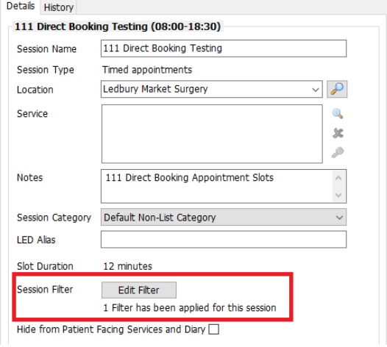

NOTE: you cannot edit filters once the Appointment Session has been used.

Mark Individual Appointment Slots as GP Connect 111 Bookable

- In the Session Preview pane, select the required appointment slot or slots to be GP Connect bookable, right-click and then select Slot Properties:

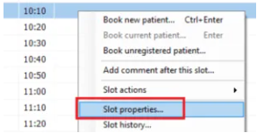

- On the Slot Properties screen, if required, click and select a slot type 111 Bookable. Do not add an Embargo or check the Urgent box
- If required, in the Slot Notes field, type any additional slot notes
- Tick the GP Connect Bookable Box

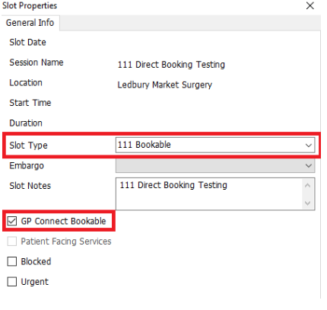
If there are other data sharing agreements activated in EMIS you will see the externally bookable field, click the drop down and select No:
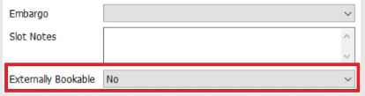
- Click on OK

Prescribing
Organisations must have a Prescribing Cost Centre Code. These usually start with the letter Y and are followed by 5 digits. A Spurious code for Prescribing GPs will also be required.

- New Cost Centre proforma to be completed to inform NHSBSA that a new service has been set up

- Complete and send the spurious code request form (omitting the cost centre code field only. When filling in the form, please select ‘Generic spurious code for a new/existing cost centre/practice
- Send completed forms to nhsbsa.prescriptioninformation@nhs.net
Contact Registration Authority at support@healthcarecomputing.co.uk to update smartcards with new Y code.

Pathology

Request a MESH Mailbox
Complete the request for a new MESH mailbox here

Mailbox Type: MESH Client
Workflow ID: Pathology PATH_HL7 Pathology Result from Trust Lab to GP Practice

Request EDI Code from NHS Digital
Complete the form and email to dnsteam@nhs.net

Enable Pathology Links in EMIS
Complete the form with all the relevant details in the Organisation Details section and then complete the details in the Pathology Links Information section and send back to EMIS. Cost of Pathology connect is approx. £450 - TBC

Role Based Access (RBAC)
Work with Registration Authority to ensure Smartcard roles for new organisation code/Hub – support provided from Healthcare Computing support@healthcarecomputing.co.uk

A number of new RBAC positions have been created to support ARRAS staff – further information can be found here

Third Party Providers
EMIS PCN Hub/Clinical Services allow connections with a number of third party providers for the provision of SMS, online and video consultations etc…. Depending on the supplier there may be a cost associated with connecting products to EMIS PCN Hub. Federations and Alliances delivering on behalf of PCNs will need to have contracts in place with chosen third party providers.
iPlato – Video Consultations – ICB level contract for all practices. Practices should have the iPlato software currently installed. If installation is required, please contact Healthcare Computing for support Support@healthcarecomputing.co.uk Confirmation of any costs associated with connecting to EMIS PCN Hub to be confirmed.
Federations/Alliances can contact iPlato directly for pricing and implementation information:

Corinne Pegrum
Partner Manager – NHS South
corinne.pegrum@iplato.com
Office: +44 20 3743-0060
Mobile: +44 7940 448493

AccuRx - text messaging, appointment reminders and cancellations, batch messaging – ICB level contract for all practices - excluding North and Portsmouth. Confirmation of any costs associated with connecting to EMIS PCN Hub to be confirmed.
Federations/Alliances can contact AccuRx directly for pricing and implementation information:

Support email address: support@accurx.com
Live chat function here: https://www.accurx.com/contact-us
Account/Customer Success Manager: Helena Brown helena.brown@accurx.com

MJog – text messaging, appointment reminders and cancellations, batch messaging – ICB level contract for North (excluding Mid) and Portsmouth Practices. Confirmation of any costs associated with connecting to EMIS PCN Hub to be confirmed.

Resources
Digital Primary Care Team hiowicb-hsi.dpc@nhs.net
EMIS Account Director – john.boland@emishealth.com

EMIS Now - https://www.emisnow.com/

Healthcare Computing - support@healthcarecomputing.co.uk
Tel: 0845 0346344

AGEM Clinical Systems Training Team agcus.gpsystemstraining@nhs.net

