|  |  |
| --- | --- |
| **OptimiseRx** | July 2022  Issue 05 |
| Hampshire and Isle of Wight ICS  Southampton Area |  |

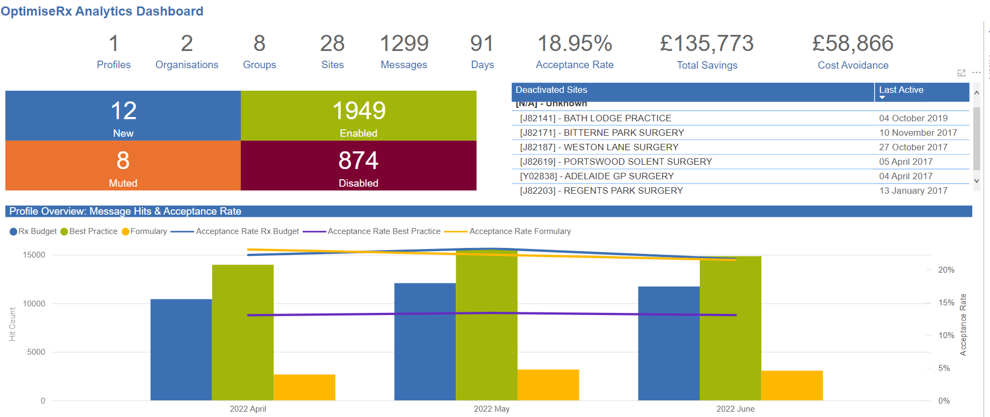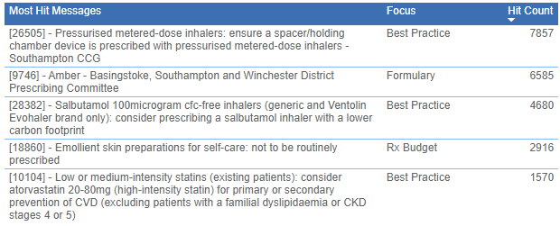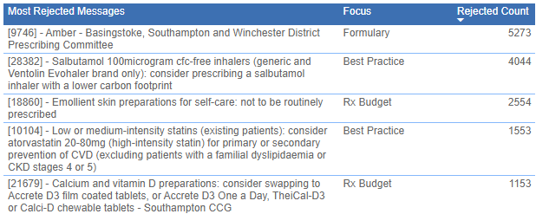

**CONTENTS**

__

HIGHLIGHTS FROM THIS QUARTER

Any good news about performance over the last quarter

__

MESSAGE IN FOCUS

Message(s) that need some education around or update on progress on them e.g., ACB or PINCER set

__

OptimiseRx TOP TIP

Info that may improve use of ORx for example rejection reasons being optional

**There has been an excellent acceptance rate of cost and formulary messages and a good acceptance rate for best practice messages.**

**Message In Focus**

**COPD Management and Prescribing Guidelines for Hampshire and Isle of Wight:**

Messages are currently being reviewed to reflect local COPD Guidance

see link: [COPD-Management-and-Prescribing-Guidelines-2022.pdf](https://gp-portal.westhampshireccg.nhs.uk/wp-content/uploads/2022/04/COPD-Management-and-Prescribing-Guidelines-2022.pdf)

**Phenobarbital 15mg/5ml sugar-free elixir (licensed):**

Consider prescribing phenobarbital 50mg/5ml oral liquids (unlicensed) in children (CAUTION: change in strength)**.** Phenobarbital 50mg/5ml oral liquids (unlicensed) are recommended for children instead of Phenobarbital 15mg/5ml sugar-free elixir (licensed) (CAUTION: change in strength).

The RCPCH and NPPG (Neonatal & Paediatric Pharmacists Group) Position Statement 2020-01 V6 (Nov 2020) states phenobarbital elixir (15mg/5mL) contains 38% v/v ethanol, and this is over the 75mg/mg/dose threshold, as a result recommends using an ethanol-free unlicensed 50mg in 5mL liquid for the oral administration of phenobarbital to children. The RCPCH and NPPG Position Statement 18-01 V6 (July 2020) also recommends prescribing standard concentrations of unlicensed liquid medicines to reduce the risk of errors being made in the doses given to children and prevent hospitalisation from accidental under and overdoses.

**OptimiseRx – Hampshire & IOW ICS**

**RESOURCES**

__

**Hampshire, Southampton & Isle of Wight CCG – NEW WEBSITE**

The new website is now live, following the merger, on the 1 April, of Southampton, Fareham and Gosport, North Hampshire, West Hampshire and South East Hampshire CCGs.

Click [**HERE**](https://gp-portal.westhampshireccg.nhs.uk/) to see the CCG’s Medicines Optimisation landing page and links to SCGs and other guidance

Click [**HERE**](https://interactive.fdbhealth.com/optimiserx_lunchtimelearnings_ondemand) for **Lunchtime Learnings on-demand** webinars to learn more about how OptimiseRx can support your job role

**NEW COST MESSAGES**

Oycodone/naloxone MR brands or generics Myloxifin® brand

Fostair®100/6  Luforbec® brand for new or appropriate patients

Melatonin IR or solutions Adaflex® tablets 1mg, 2mg, 3mg, 4mg and 5mg, which can be crushed for appropriate patients

Consider alternative contraceptive device from NuvaRing®SyreniRing® device

Consider cost effective brands of colecalciferol generic and brands Strivit®, Fultium®, Invita®, Terexol® and Desunin® brands in appropriate strengths

**OptimiseRx Top Tip**

Department of Health and Social Care (DHSC) has issued a medicine supply notification for Colestipol (Colestid®) orange and plain 5g granules sachets.

• Colestipol (Colestid®) Orange sachets have been discontinued with remaining supplies expected to be exhausted by late July 2022.

• Colestipol (Colestid®) Plain sachets have also been discontinued following a long period of out of stock.

• Other bile-acid sequestrants remain available and can support the uplift in demand.

[Clinical management of the bile acid sequestrant shortages](https://www.sps.nhs.uk/articles/clinical-management-of-the-bile-acid-sequestrant-shortages/)

**BEST PRACTICE MESSAGES**

Greener prescribing inhaler messages have been updated to trigger on all brands and generics of the respective cfc-free inhalers and exclude patients with brittle asthma.

Following a recent review and customer feedback, a decision has been made to remove the age-related adrenaline messages from the core national profile (14373, 14374, 14375). This change will take place week commencing 18 July 2022.

**MONITORING AND RECORDING MESSAGES FOR BEST PRACTICE**

Following a recent MHRA drug safety update, messages 5283, 24473 and 24593 have been updated to remind prescribers that **a patient alert card is available to all patients receiving amiodarone.**

5283—Amiodarone: monitor and record liver function tests at least every 9 months

24473—Amiodarone: monitor and record liver function tests at least every 6 months

24593—Amiodarone: monitor and record thyroid function tests at least every 6 months

**National antipsychotic messages for patients with GAD (5629) and learning disabilities (13388) have now been updated, so that they exclude patients with valid alternative indications for antipsychotics** (i.e. schizophrenia and other psychotic conditions, bipolar disorder or mania/hypomania).

To avoid over-supressing, message 5629 will still trigger for patients with explicitly dementia-related

psychotic conditions (such as senile psychosis), as these do overlap with the main target of the message

(prescribing antipsychotics for behavioural symptoms of dementia)

5178—Antipsychotics: not recommended for generalised anxiety disorder

5629—Antipsychotics: not recommended for non-cognitive symptoms of dementia

13388—Antipsychotics: not routinely recommended for challenging behaviour in learning disability