develop your skills & knowledge in having healthy conversations about alcohol  Our three-hour online training is designed to encourage and support the philosophy behind Making Every Contact Count (MECC) to deliver Identification & Brief Advice (IBA) or Very Brief Advice (VBA) on alcohol.  The course is currently subsidised by Public Health so is available at no cost to you.  Who should attend?  Primary care staff, volunteers & social prescribers from Southampton, Isle of Wight, Portsmouth or Hampshire.  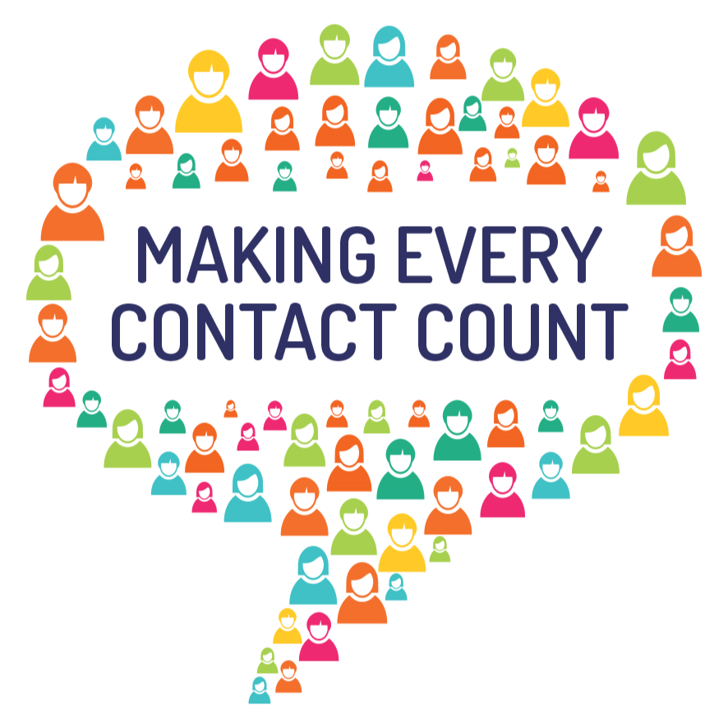  Book your place now by visiting our Eventbrite page | Develop skills and knowledge around alcohol and use of an evidenced based intervention  ____  Understand how to make SMARTER goals around alcohol use & reduction  ____  Become part of a larger network of people who want to help  ____  Free tools & resources provided  fOR FURTHER INFOrMATION CONTACT  Rob Anderson Weaver  Email: robert.anderson-weaver@portsmouthcc.gov.uk

