Contact us
Phone: 0300 123 6609
Email: snhs.childrenshospitalathome@nhs.net
2nd Floor, Adelaide Health Centre, William MacLeod Way, Southampton, Hampshire SO16 4XE

Opening hours:
7 days a week 10am - 6pm Referrals accepted until 5.30pm

If you need to contact us we have a secure answerphone which is checked regularly throughout the service opening hours.

Tell us how you feel
Please tell us how you feel about the services we provide.

If you have a compliment, concern or complaint please contact the Patient Advice and Liaison (PALS) and Complaints Services on: 0800 013 2319
or snhs.solentfeedback@nhs.net Alternatively, visit: www.solent.nhs.uk/contact-us

When leaving a message please give
your name, child’s name, telephone number along with your message.
Further information about this service:

Friends & Family Test Under 11
NHS
Healthier Together website:

Friends & Family Test Over 11

Children’s

Hospital @ Home
Service (CH@H)

www.solent.nhs.uk
Out of hours
Please speak to a member of our team if you’re unsure of who to contact outside of our working hours.

NHS 111 is available outside of our working hours and can help with urgent medical needs.

For any life-threatening or emergency need, please dial 999 for the emergency services.
Service provided by
Solent NHS Trust
University Hospital Southampton

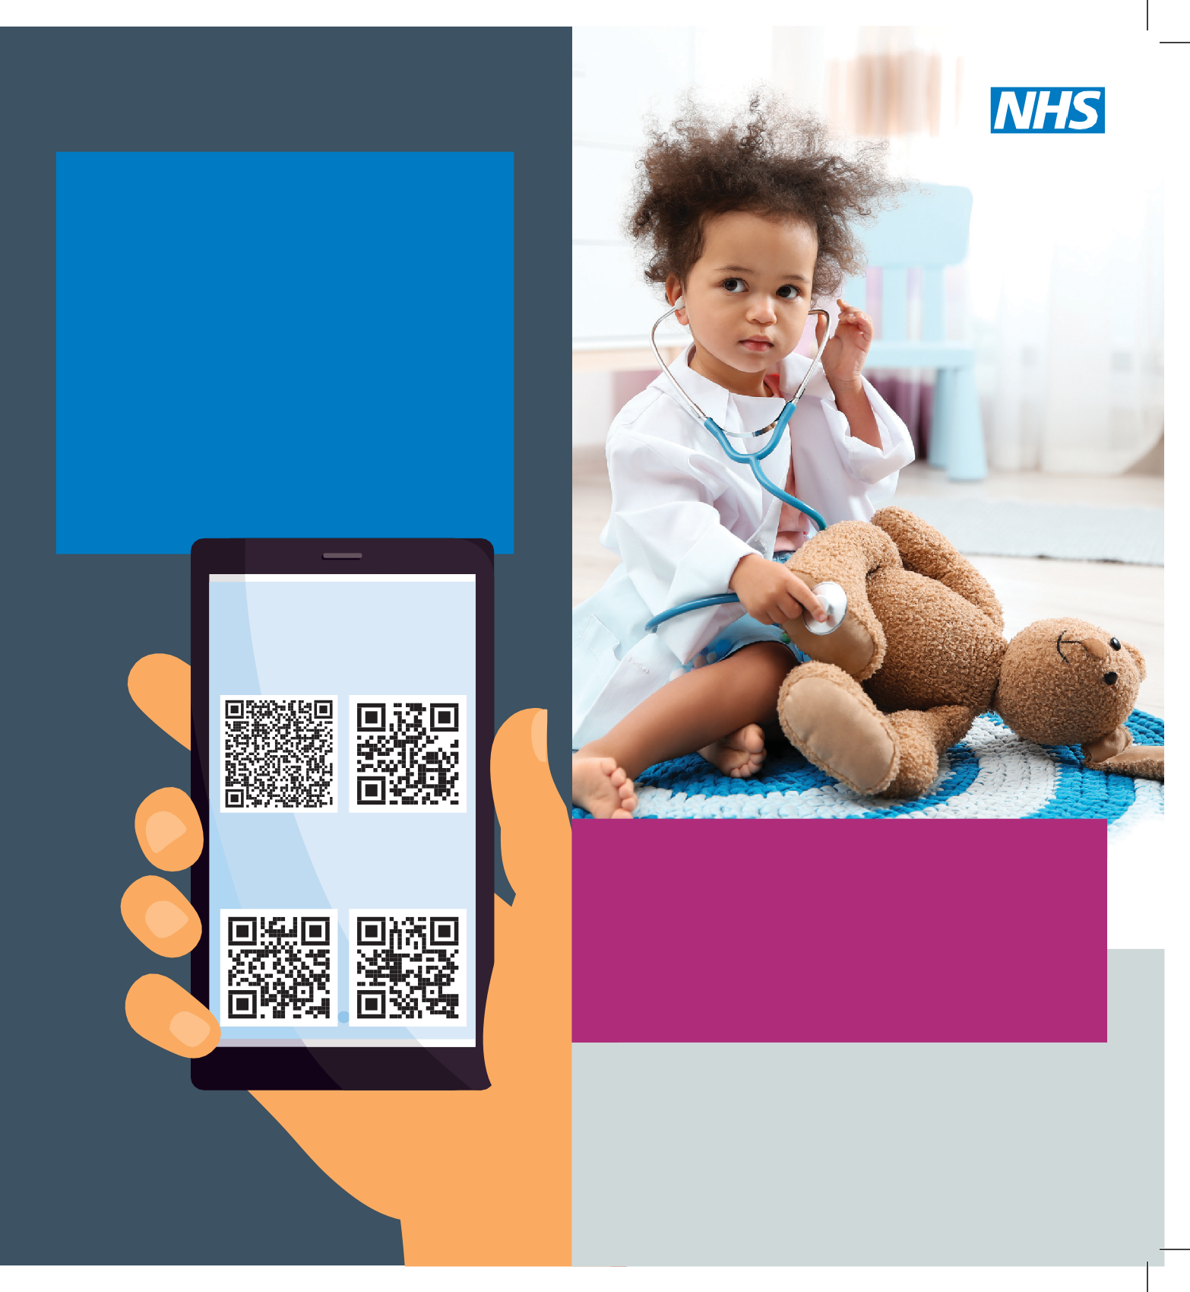

Geographical area
We cover the area below and will visit children who are registered at a Southampton or West Hampshire
Romsey

GP within this area.
Totton Lyndhurst
Southampton

Hythe

Bursledon

New Milton
Lymington

We are a team of paediatric nurses and doctors with specialist skills and experience in caring for children and young people.
Our nursing team are dedicated to providing care for children and young people with acute and short term health needs at home, and in other community settings. They work closely with the medical team at the hospital and GPs.

Our aims are to:

- Prevent and minimise admissions to hospital

- Facilitate early discharge from hospital wherever possible

- Provide advice and practical support for children and their families in the self-management of acute and short-term health conditions

- Promote the physical, psychological and emotional wellbeing of children and young people in their
own environment

Contact with us
Our initial contact with you to assess your child will be by telephone. Following on from this, we may need to visit your home to assess your child face-to-face. We will agree and arrange any follow up contacts with you depending on your child’s needs.

Our team will work together with other health professionals to ensure we can provide you and your child the best care of acute and short term health conditions in the most appropriate place.

