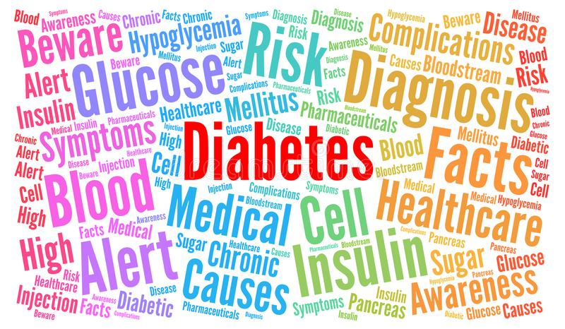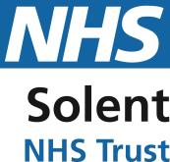

This will count as 6 hours of CPD credits, and a certificate will be issued. This session will be

**THURSDAY 9TH DECEMBER 2021.**

**FROM 9:30 TO 4.30 AT THE ROYAL SOUTH HANTS – EDUCATION SUITE**

**DUE TO SOCIAL DISTANCING MEASURES WE CAN ONLY BOOK A MAXIMUM OF 12 ATTENDEES.**

**YOU MUST BOOK A SPACE- PLEASE DO NOT TURN UP WITHOUT CONFIRMATION**

**This would suit all members of staff including HCA’s, Practice Nurses, Community and District Nurses and Allied Healthcare Professionals.**

**FREE DIABETES EDUCATION PROGRAMME OF LEARNING**

The module one learning outcomes include:

* Define Diabetes and be aware of different types.
* Understand the risk factors for developing diabetes.
* Recognise signs and symptoms of diabetes.
* Understand how a diagnosis is made.
* Have a basic understanding of the treatment and management of the condition.
* Understand the risks of unmanaged diabetes and be able to recognise and appropriately manage hypoglycaemia and hyperglycaemia.
* Have knowledge of the basic recommended dietary and lifestyle guidelines.
* Develop carbohydrate awareness.
* Test blood glucose levels accurately and appropriately.
* Support regular patient reviews.
* Undertake foot checks.
* Enable partnership working with patients to achieve lifestyle change.
* Have knowledge of local services.