How to create a referral to Wessex Rapid Diagnostic Service from EMIS

From the patient’s consultations page:

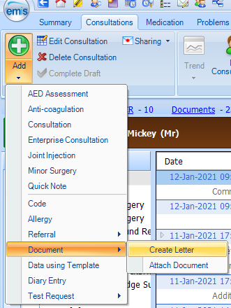

Then ‘New Patient Letter’ dialog appears

If you have Arden’s look for ‘WCA – Referral to Rapid Investigation Service (RIS) & Guidance’ (if not you will need to import the form manually so you can select it at this stage)

Next 3 dialogs – Please select the items to include in this letter

Next stage is filling in the form

Then File -> Save and Close

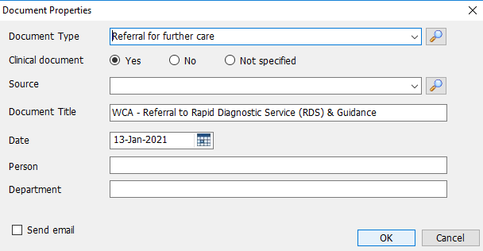

Next stage is to create the referral (you need to be logged into EMIS with your smartcard for this):

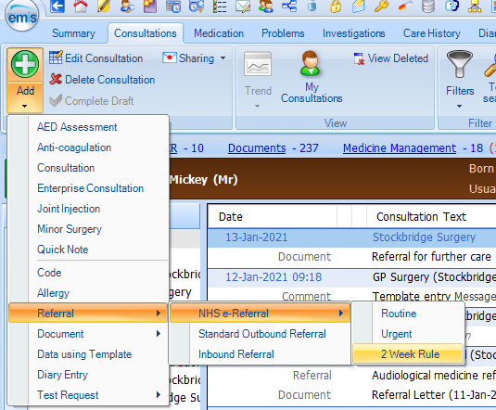

Then it’s onto the eRS screenshot you sent me

