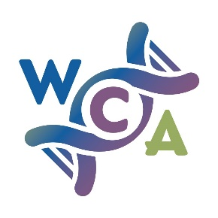

Practice Nurse Advisor Wanted

Wessex Cancer Alliance is responsible for overseeing the delivery of cancer care across Wessex, by supporting the two Integrated Care Systems (ICS). One ICS covers the whole of Hampshire and the Isle of Wight (HIOW ICS) and the second ICS is in Dorset.
Wessex Cancer Alliance brings together health, social care and other organisations to transform the diagnosis, treatment and care for cancer patients in Hampshire, the Isle of Wight and Dorset. It is a collaboration of NHS organisations responsible for commissioning and providing services; local councils who commission and provide public health services; charities, community and voluntary organisations; patient representatives and groups and academic organisations.
We work closely with primary, secondary and community care providers and commissioners and also charities and other third sector organisations to achieve the aims of the Long Term Plan for cancer. We have a Primary Care Strategy that you can find here
To implement this we have an extensive primary care team and we are looking to expand that team to include greater representation from the wider primary care community. We need a Practice Nurse Advisor for the following:
Covering prevention and early diagnosis of Cancer and other parts of the pathway to help provide the support patients need such as Cancer Care Reviews.
- To represent the views of Practice Nurses in terms of the WCA work programme
- Provide practical support in key projects e.g. increasing screening rates
- Work with primary colleagues to understand, share and promote best practice.
- Advise the WCA on practice systems and needs.
- Trialling ideas in your practice.
- Identifying the need for and advising/leading on training for non-clinical practice and PCN staff.
- Leading projects to increase the number of people diagnosed in stages 1 & 2 rather than later or by emergency presentation.
1 day per week (0.2 wte), £40 per hour.
The expectation is that the Advisor will represent the views of Practice Nurses as well as working closely with them on implementing Wessex Cancer Alliance initiatives. It is expected the Advisor will be input into Wessex Cancer Alliance Primary Care meetings and where relevant, the Early Detection Board.
The Advisor will be working closely with an established team of primary care professional - GP, CRUK facilitators and Macmillan representatives as well as Wessex Cancer Alliance team members to deliver on the actions contained with our Primary Care Strategy.

If you would like to discuss this opportunity further please contact Rob Chambers Robert.chambers1@nhs.net

To apply please complete the expression of interest form below and email to england.wessexcanceralliance@nhs.net by 2nd July 2021.

Expression of interest for the WCA Practice Nurse Advisor

Name
Practice name and J Code
Email address
Telephone
Practice Nurse experience
Reason for applying
What can you bring to this role?
Any opportunities that you would like to implement to increase the early detection of cancer?

