 |  | OptimiseRx | July 2021  Issue 02
Hampshire and Isle of Wight ICS
Southampton Area Hampshire, Southampton and Isle of Wight CCG
Contents  __  Highlights from this quarter  Any good news about performance over the last quarter  __  Message in Focus  Message(s) that need some education around or update on progress on them e.g. ACB or PINCER set  __  OptimiseRx Top Tip  Info that may improve use of ORx for example rejection reasons being optional |  | 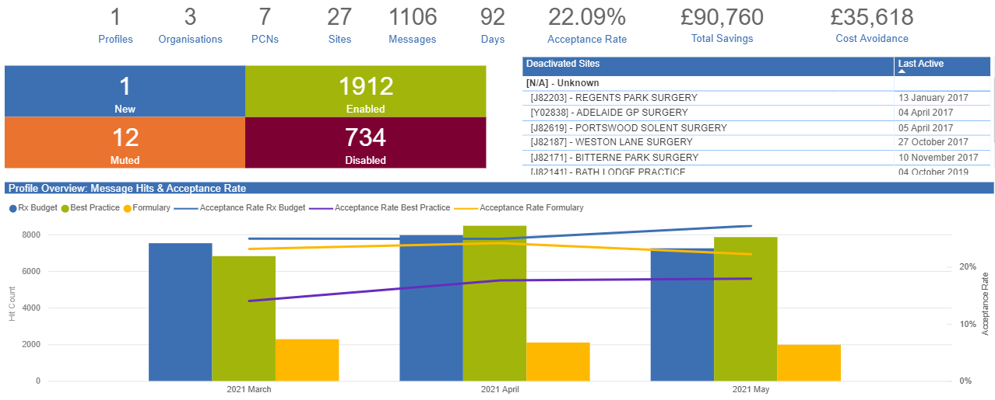  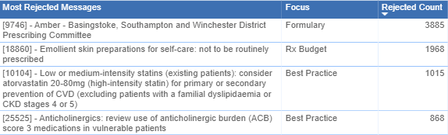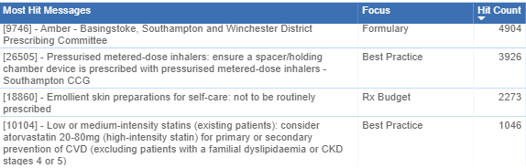  There has been an excellent acceptance rate of cost and formulary messages and a good acceptance rate for best practice messages  Message in Focus  - Review and adjust quantities of GLP-1 inhibitors being prescribed to ensure that more than  intended quantities are not mistakenly prescribed, dispensed and charged for.  - Review prescribing of GLP-1 mimetics to ensure they are being prescribed in line with  NICE guidance. Discontinue treatment if NICE criteria have not been met.  The GLP-1 mimetics are exenatide (Byetta®, Bydureon®), liraglutide (Victoza®), dulaglutide  (Trulicity®), lixisenatide (Lyxumia®), and semaglutide (Ozempic®).  GLP-1 mimetic products are available as either prefilled syringes or a powder and solvent to be  made up. They are either given as a once or twice daily or weekly dose depending on the product.  Some products need to be titrated before the maximum dose is reached.
All products come in a pack size which is sufficient for a one month supply and care needs to be
taken that larger quantities are not prescribed mistakenly.
Monthly prescription quantities are generally encouraged to avoid waste and for safety
reasons.

OptimiseRx – Hampshire & IoW ICS
OptimiseRx Top Tip  Display of Cost Savings in EMIS Web  Previously, when an OptimiseRx cost saving message was presented to prescribers in EMIS Web, the saving was presented as the average cost saving per dose unit. There is a change to show savings per pack, prescribers are now able to see a more representative saving when accepting an alternative on a complex cost message and therefore this is expected to improve message acceptance rates.  .  Best practice messages:  The OptimiseRx Content team have recently reviewed the Specialist Pharmacy Service (SPS) ‘Suggestions for Drug Monitoring in Adults in Primary care’ document for monitoring messages that may be useful in OptimiseRx.  Each medication was assessed for its suitability, considering things such as is there a timeframe given for monitoring, does the guidance advocate a local monitoring policy should be followed instead and can we code for the monitoring required.  Many of the medications included in this document are also already covered by existing OptimiseRx messages that support prescribing indicators such as RCGP (for example, lithium, ACE inhibitors and warfarin monitoring.  New cost messages:  Efient® 5mg or 10mg tablets Prasugrel 5mg or 10mg  Vagifem® vaginal tablets Vagirux® vaginal tablets  Alimemazine 7.5mg/5ml Oral Solution Alfresed® 7.5mg/5ml Oral Solution  Alimemazine 30mg/5ml Oral Solution Alfresed® 30mg/5ml Oral Solution  *Please note alimemazine preparations are non –formulary in Soutampton area locality. The switch only applies to patients who are unable to have these preparations de-prescribed. |  |  | Upcoming events  FDB OptimiseRx 2021Webinar : Backstage with our OptimiseRx Clinical Content Team  Learn about the in-house OptimiseRx clinical content team  Discover how our FDB clinical content experts build local and national content for OptimiseRx  Understand the depth behind the logic of OptimiseRx messages and how our clinical content team endeavour to make them concise and specific to each clinical scenario  Thurs 8th July 2021 12:30-13:15  Tues 13^{h} July 2021 12:45-13:30  Thurs 21st July 2021 13:00- 13:45  Click here to Register!  Hampshire, Southampton & Isle of Wight CCG – New Website  The new website is now live, following the merger, on the 1 April, of Southampton, Fareham and Gosport, North Hampshire, West Hampshire and South East Hampshire CCGs.  Click HERE to see the CCG’s Medicines Optimisation landing page and links to SCGs and other guidance
DOAC messages:
A set of messages has been authored for each monitoring requirement for standard DOAC monitoring but also
for high risk patients who require more frequent monitoring:
26669-Direct-Acting Oral Anticoagulants (DOAC): monitor and record creatinine clearance (CrCl) annually in
patients aged under 75 years without frailty
26671-Direct-Acting oral anticoagulants (DOAC): monitor and record liver function tests (LFTs) annually in
patients aged under 75 years without frailty

26672— Direct-Acting oral anticoagulants (DOAC): monitor and record a full blood count (FBC) annually in
patients aged under 75 years without frailty

26674—Direct-Acting oral anticoagulants (DOAC): monitor and record creatinine clearance (CrCl) at least every
6 months in patients with frailty or aged 75 years and over

26675—Direct-Acting oral anticoagulants (DOAC): monitor and record a full blood count (FBC) at least every 6
months in patients with frailty or aged 75 years and over

26676—Direct-Acting oral anticoagulants (DOAC): monitor and record liver function tests (LFTs) at least every 6
months in patients with frailty or aged 75 years and over

