Press Release
Southampton Dementia Festival 2021 Goes Ahead

A small group of intrepid volunteers have pushed ahead with plans for a low-key festival in July 2021 despite the restrictions placed on get-togethers.
Southampton Dementia festival will mix up online Zoom sessions and bookable in-person events held over two days on 13th and 14th July 2021. Zoom sessions will be running from 10 am to 12noon on the mornings of the 13th and 14th July. On both afternoons, Mayfield Nurseries in Weston Lane Southampton are hosting pre-booked activities.
We have taken our inspiration from nature for the 2021 festival. Sessions will help to connect us with our natural world.
Morning Zoom sessions will feature an eclectic mix of talks, exercise, singing and reminiscence. Learn more about the advances in Alzheimer's Disease Research on Tuesday morning with Dr Clive Holmes. Dr Holmes, from Southampton University, said: 'I am thrilled to be taking part in the dementia festival. After years of little advance in new treatments for Alzheimer's Disease, hope is on the horizon.
Why not limber up and participate in the Saints Foundation online exercise class? Or get your dancing shoes on for a fun-filled session by Folk Active? Take a trip down memory lane with Memory Box who are hosting reminiscence activities.
On both afternoons, Mayfield Nurseries are hosting craft activities, live music and refreshments. Do make an afternoon of the occasion and bring a picnic if you wish. Jonathan Klein will be keeping us entertained, singing and playing the guitar. The events will follow the Covid guidelines currently in force, but it will be wonderful to celebrate together in person.
A Festival Brochure will be available in early July, listing the statutory services and many of the voluntary and private services in the city that offer support to people living with dementia and their carers. If you offer services to people living with dementia and their carers and would like to feature in this brochure please contact Katherine Barbour, portswooddag@gmail.com 07763 863360. Entries need to be submitted by 11th June 2021
If you wish to book a place for you and your family member/friend at Mayfield Nurseries on the afternoons of 13th or 14th July or want further information regarding this year's festival, please contact Katherine on the contact details above.

Katherine Barbour
Chair, Southampton Dementia Festival 2021
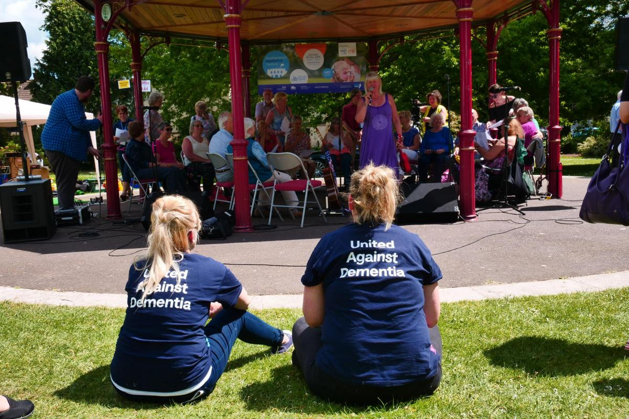
Image from the Festival held in Palmerston Park in 2019

