COVID-19 vaccination status
Website suggested text
The practice is not able to provide you with a letter that shows your COVID-19 vaccination status.
From 17 May 2021, people in England who have been fully vaccinated against COVID-19 can demonstrate their vaccination status for international travel. A full course is currently two doses of any approved vaccine. Vaccine status will be available from:
- the NHS App which you can download from app stores
- the NHS website (from 17 May 2021) – {please delete the date when using from Monday}
It may take more than a week for your identity to be checked and verified so you can use these services.
If you cannot access these online services, and you have had 2 vaccines, you can request a paper letter from the NHS by calling 119.
Only call 119 if you had your second dose more than 5 working days ago. It may take 7 working days for the letter to arrive.
When you're planning your travel, check the latest information on demonstrating your COVID-19 status when travelling abroad on the gov.uk website. Make sure there is time to get proof of your vaccination status before you leave.
Telephone voicemail suggested wording
GP practices cannot provide you with a COVID-19 vaccination status letter. You can get your status via the NHS App. Or you can call 119 and get your status five working days after you’ve had your second dose.
Facebook and Twitter posts
Social media image | Suggested wording
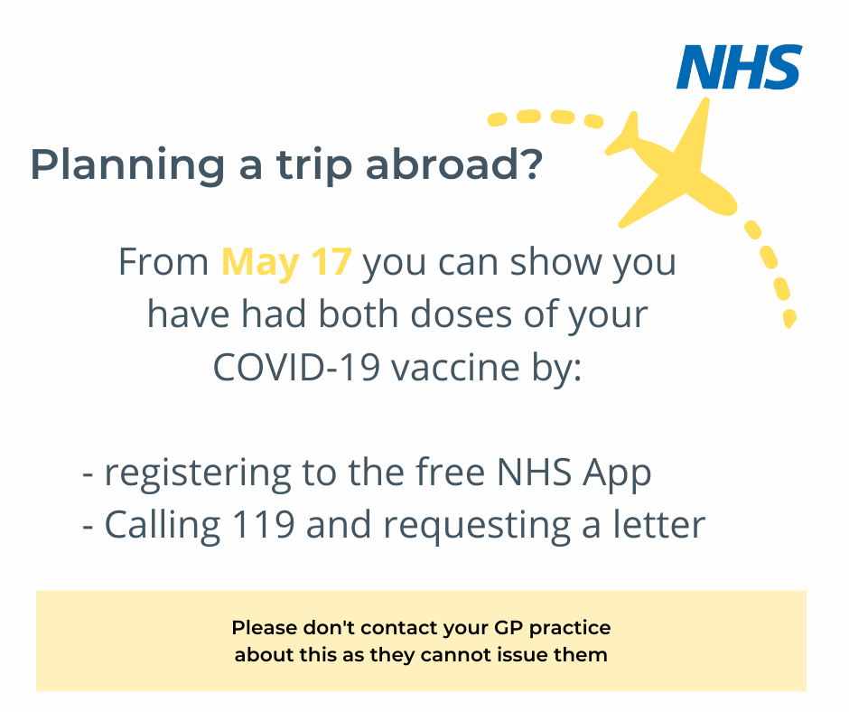 | Please do not contact us for a vaccination status letter – we cannot issue them.  If you need to prove your COVID-19 vaccination status please download the #NHSApp. More info at nhs.uk/nhsapp and www.gov.uk/guidance/demonstrating-your-covid-19-vaccination-status-when-travelling-abroad  Only call 119 if you had your second dose more than 5 working days ago. It may take 7 working days for the letter to arrive.
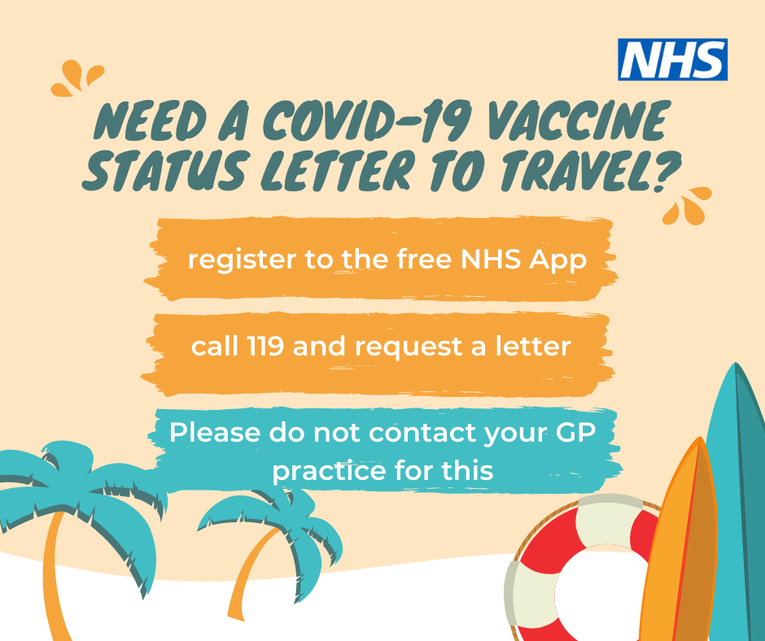 | Please do not contact us for a vaccination status letter – we cannot issue them.  If you need to prove your COVID-19 vaccination status please download the #NHSApp. More info at nhs.uk/nhsapp and www.gov.uk/guidance/demonstrating-your-covid-19-vaccination-status-when-travelling-abroad  Only call 119 if you had your second dose more than 5 working days ago. It may take 7 working days for the letter to arrive.

