 |  | OptimiseRx | March 2021  Issue 01
Hampshire and Isle of Wight ICS
Southampton Area Hampshire, Southampton and Isle of Wight CCG
Contents  __  Highlights from this quarter  Any good news about performance over the last quarter  __  Message in Focus  Message(s) that need some education around or update on progress on them e.g. ACB or PINCER set  __  OptimiseRx Top Tip  Info that may improve use of ORx for example rejection reasons being optional |  | 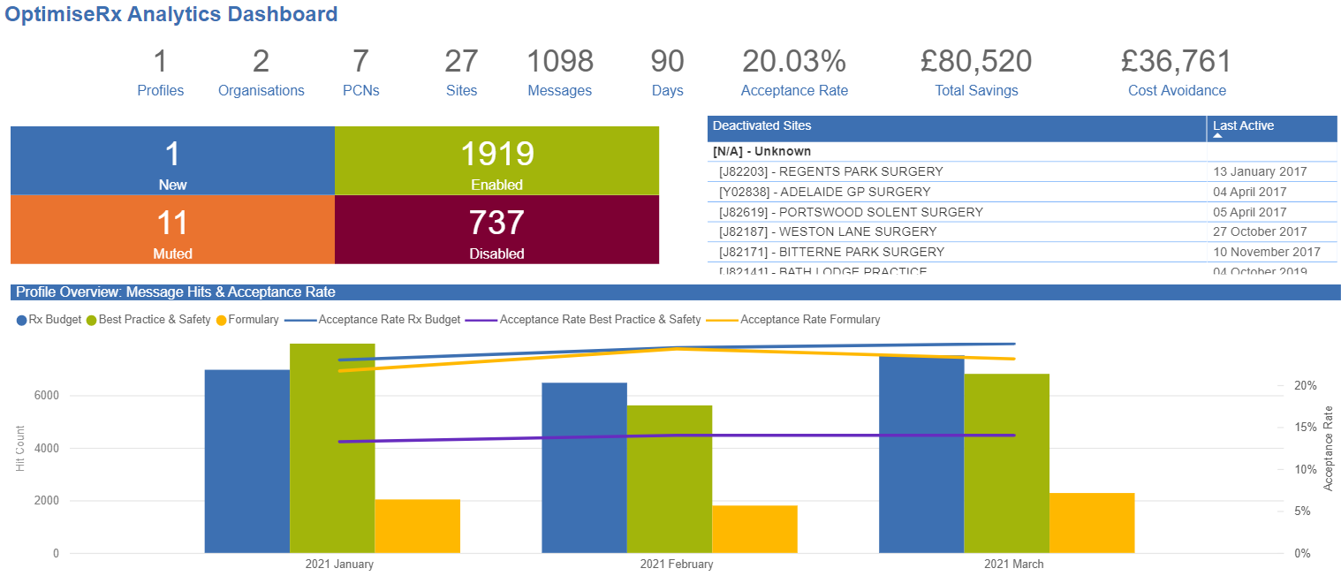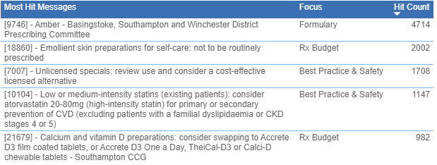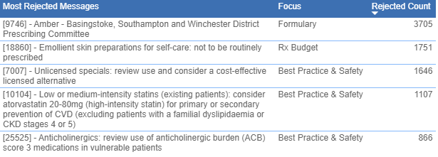  There has been an excellent acceptance rate of cost and formulary messages and a good acceptance rate for best practice messages  Message in Focus  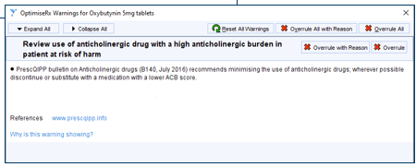
 |  | An increasing number of systematic reviews and meta-analyses report that drugs with anticholinergic effects are associated with an increased risk of cognitive impairment and all cause mortality in older people.

OptimiseRx – Hampshire & IoW ICS
OptimiseRx Top Tip  When rejecting a message, although it is not mandatory to leave a rejection reason, we encourage you to use it as an opportunity to feedback. The more informative the rejection reason, the more insight it gives both the CCG and FDB to be able to improve our message sets  Best practice messages:  Lithium carbonate 250mg tablets (generic):  The UKMi Q&A (Nov 2017) advocates brand prescribing of lithium preparations; due to differences in bioavailability they are not interchangeable. If any doubt exists, clarification should be sought to identify which brand they currently use in order to maintain current treatment; lack of clarity can lead to sub therapeutic or toxic dosing.  Aerochamber Plus Flow-Vu are preferred spacer range in Southampton  All guidelines advice that all MDI patients should use a spacer which (in the case of the Aerochamber Plus Range) should be replaced every 12 months in order to remain at optimal performance.  Using Antistatic Aerochamber Plus Flow Vu has been shown to reduce visits to A&E and Hospital Admissions when compared to other spacer devices due to increased emitted mass of medication to the lungs  New cost messages:  Mycophenolate mofetil 250mg Mycophenolate 250mg capsules/ tablets  capsules/ 500mg tablets (brands) (generic) *for non-transplantation indications  MIMPARA® 30mg /60mg film coated tablets Cinacalcet 30mg /60mg tablets  Atropine sulfate 1% Atropine sulfate 1% 0.5ml unit dose  eye drops (brands/ generic) preservative-free |  |  | Upcoming events  FDB OptimiseRx 2021Webinar 1: How OptimiseRx can support your job role within PCNs and Practices  From the perspective of your job role, in this webinar we aim to showcase how OptimiseRx can benefit and help PCNs and practices deliver value to healthcare priorities.  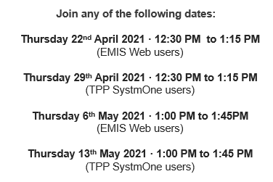  Click here to Register!  Hampshire, Southampton & Isle of Wight CCG – New Website  The new website is now live, following the merger, on the 1 April, of Southampton, Fareham and Gosport, North Hampshire, West Hampshire and South East Hampshire CCGs.  Click here to see the CCG’s Medicines Optimisation landing page and links to SCGs and other guidance

Message 7301: Apixaban is recommended is patients with non-valvular atrial fibrillation with risk factors and a confirmed eGFR of 30–50ml/min/1.73m2

The logic of this message has been amended trigger only for patients newly prescribed warfarin. Previously it triggered for all warfarin prescriptions.

Supported by NICE (CG182, Jan 2015) which recommends prescribing apixaban in preference to warfarin in patients with a confirmed eGFR of 30–50ml/min/1.73m2 and non-valvular atrial fibrillation who have one or more risk factors for stroke (prior stroke or transient ischaemic attack, age 75 years or older, hypertension, diabetes mellitus or symptomatic heart failure). Warfarin should only be changed to apixaban once the INR is less than 2.
The MHRA Drug Safety Update (Oct 2019) advocate creatinine clearance (CrCl) should be calculated (using the Cockcroft-Gault formula) to determine dosage adjustments for DOACs in patients with renal impairment

