Request for Advice and Guidance for Covid-19 vaccination

There are very few individuals who cannot receive the Pfizer BioNTech, Moderna or AstraZeneca COVID-19 vaccines. Where there is doubt, rather than withholding vaccination, appropriate advice should be sought. Please refer to the Green Book for detailed advice https://assets.publishing.service.gov.uk/government/uploads/system/uploads/attachment_data/file/955548/Greenbook_chapter_14a_v6.pdf

The tables below summarise the clinical actions required for the Management of patients with a history of allergies and for those patients who have a Possible allergic reaction to 1st dose of COVID-19 vaccine.

Figure 1 Management of patients with a history of allergy Figure 2 managing patients who have allergic reactions to the first dose of COVID-19 vaccine

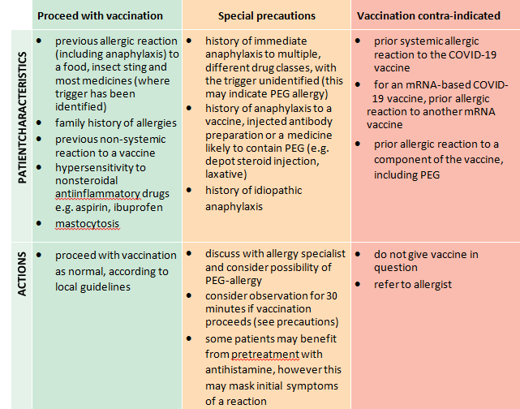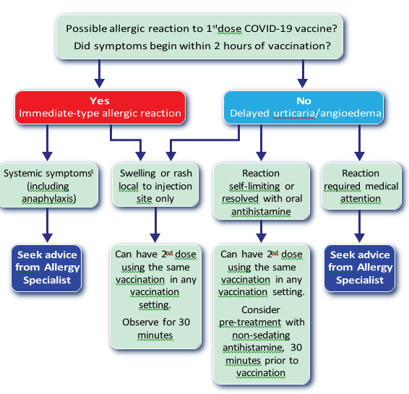

This form is to be used to support an Advice and Guidance request re Covid-19 vaccination for a patient who is deemed to be high clinical concern due to either a history of allergy/anaphylaxis or a possible allergic reaction to 1st dose of COVID-19 vaccine. It is intended to ensure a prompt response and clear guidance around the following key questions:-

- Which Vaccine can I give?
- Where should the vaccine be administered community/hospital?
- Should the patient be advised to take an antihistamine pre vaccination?

All requests need to be made via A&G to the dedicated Allergy Service at UHS, using the New Service details:- COVID Vaccine Concern- (Advice & Guidance)- Southampton-UHSFT-RHM

Patient Name: |  | Contact Number: |  | NHS Number:
Date of Birth: |  | Email Address: |  | GP:
Address: |  |  |  | GP Address:

Name and Role of Requester
Date of Request:
Date and details of Dose 1 vaccination given
Adverse event details- please include full details
Date dose 2 needed (12-week schedule)
Dose 1 query

Questions
1.Has this patient seen any Allergist in UHS within past 5 years |  | Unsure | No | Yes who/when
2.Has the patient been an inpatient (not just A&E) at UHS/UBH/PHU within past 5 years and are they under any current specialist OPD team eg Respiratory (if so what team(s) |  | Unsure | No | Yes
3.Has the patient got a clear history of anaphylaxis (resus council definition) or Severe allergy (immediate onset, multisystemic reaction) to any of the following:-  - Drugs/vaccines  - cancer drug/monoclonal or vaccine  - depo steroid (eg Joint injection) or depo hormone treatment  - Any labelled ADR to drugs not covered by above of episode |  | Unsure | No | Yes Please give the following information if applicable  - Drug Name (manufacture dose/route)  - Symptoms, documented use of adrenaline, location of reaction/management (own home/GP/A&E/inpatient – which hospital)
4. What are co-morbidities which make vaccination priority?
What are the current major health concerns (asthma, CVD, immunodeficiency – any/all the CEV indications)

5. Advise us of the following:-

- Hx of Significant anxiety/mental health diagnoses and particularly of any history of “mast cell activation syndrome”/EhlerDanlos/Chronic fatigue/Fibromyalgia

- List of current medication (include if patient has even been prescribed an Epipen?

Any communication concerns (eg need for translator) /learning difficulties/dementia (anything which might affect ability to consent patient properly by phone)

