Anticipatory Medications Template V1.3

Deployed to all GP Practices in 5 Hampshire CCGs March 2020 as part of the Palliative Care response to COVID19

The following pages illustrate the Anticipatory Medications Dose Calculation Worksheets developed over much of 2019 to sit alongside the Future Planning Template and SHFT/Solent Community Syringe Driver and PRN Administration Order sheets. In response to COVID19 this work was completed over 2 weeks in March and all of the resources mentioned were distributed to all EMIS practices by ArdensQ and all SystmONE practices via Southampton and Portsmouth CCG IT departments. This work was completed by the release of clinical Palliative Medicine Consultant time by SHFT, Solent NHS Trust and Rowans Hospice, without any additional funding.
Introductory page from the EMIS template is shown in figure 1. Generally SystmONE Template views are used to illustrate contents. Both S1 and EMIS templates link to the same flowcharts held in the FuturePlanning.org.uk webpages.

Figure 1.0 - Introductory Page
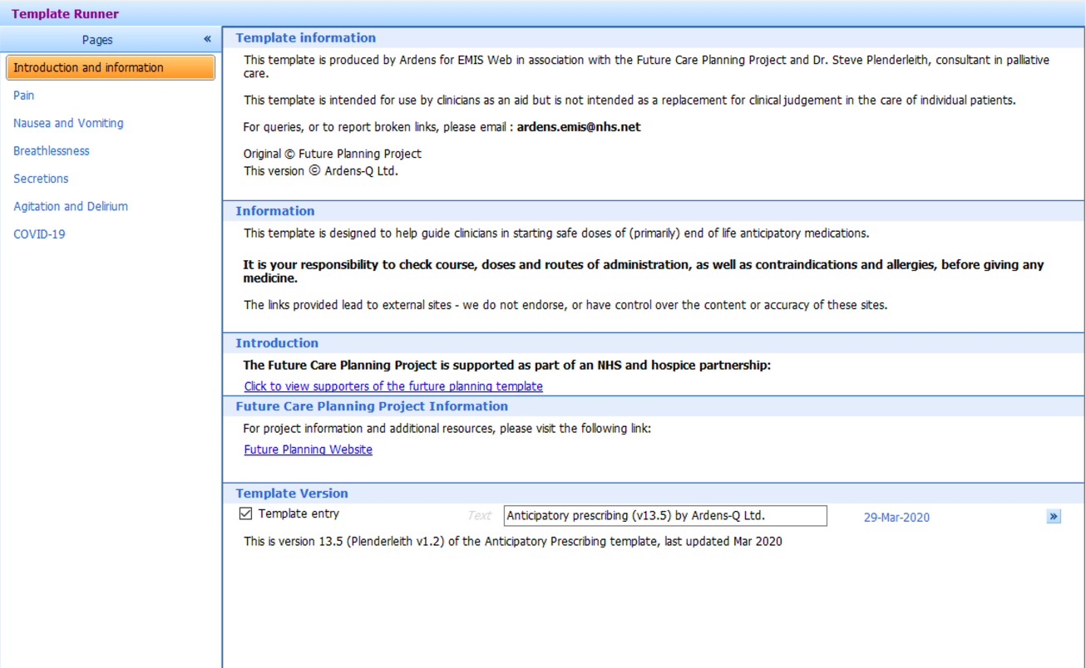

Figure 2.0 - Pain Control
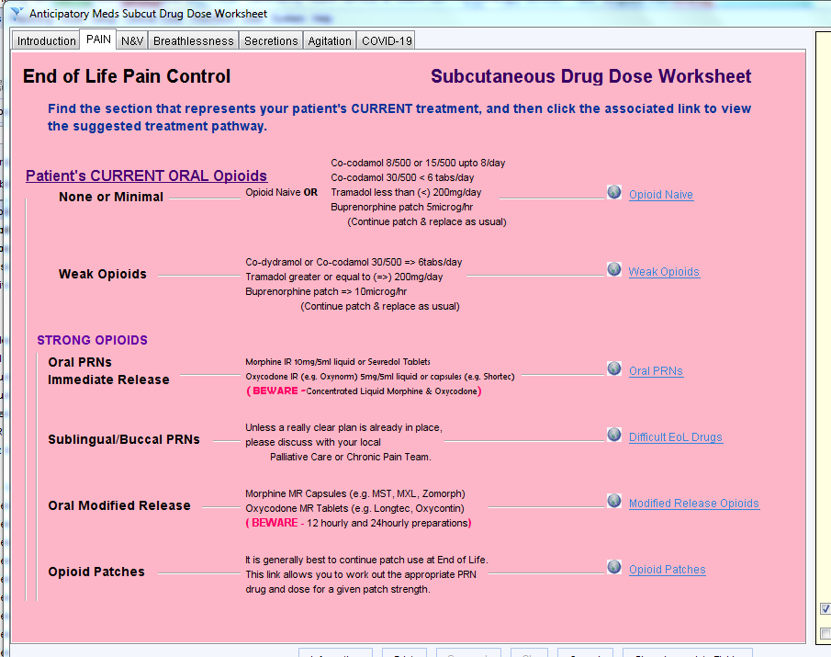
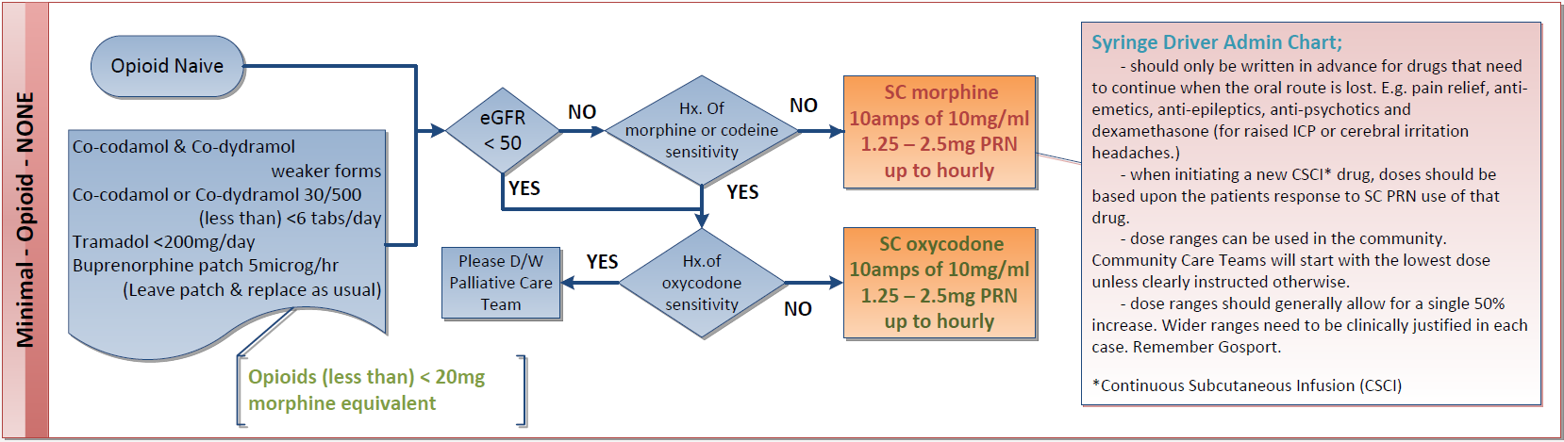
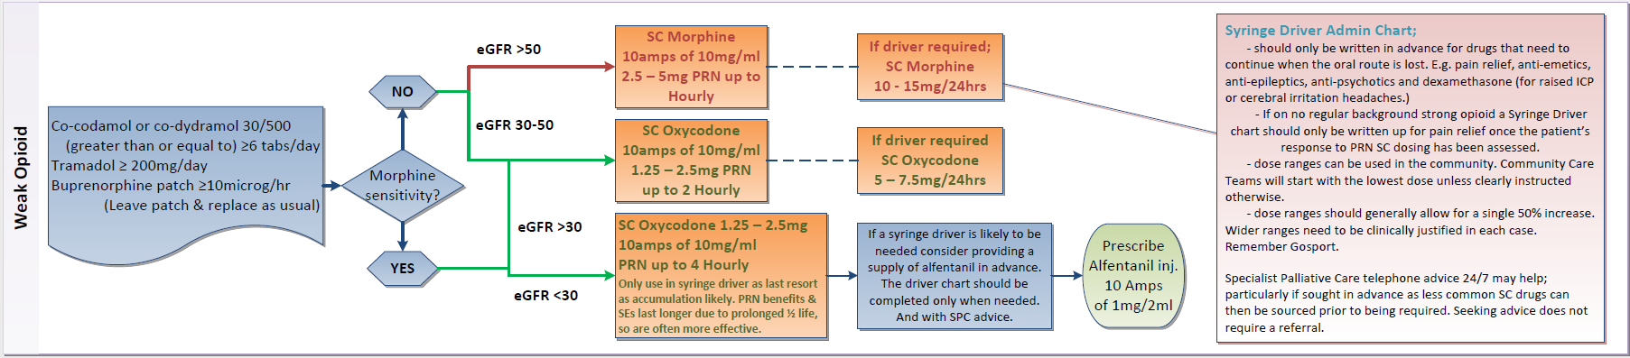
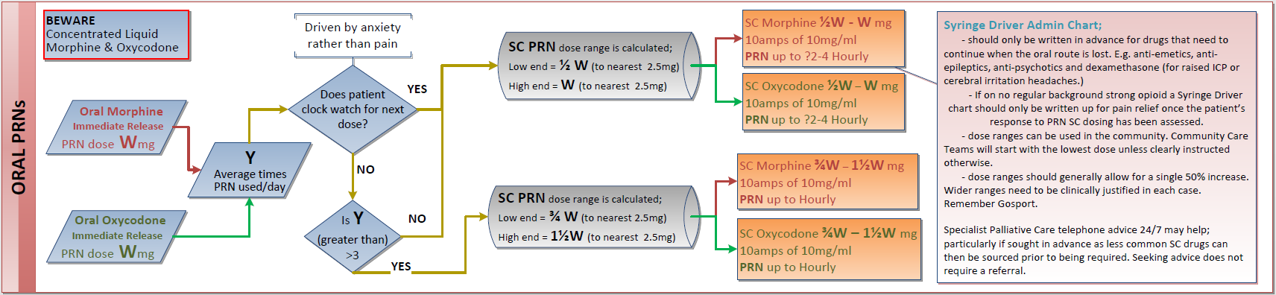
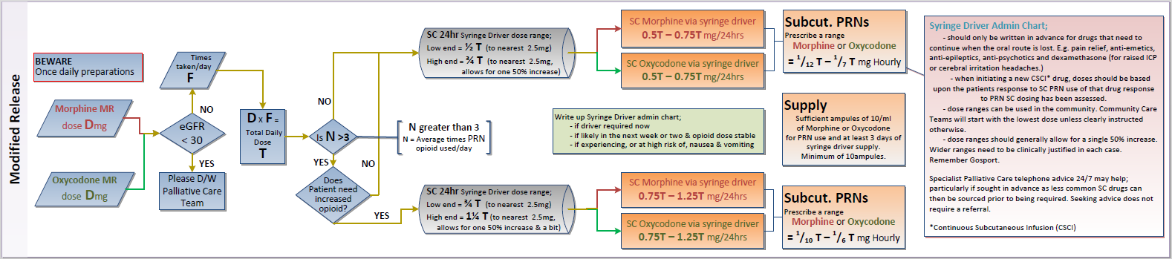
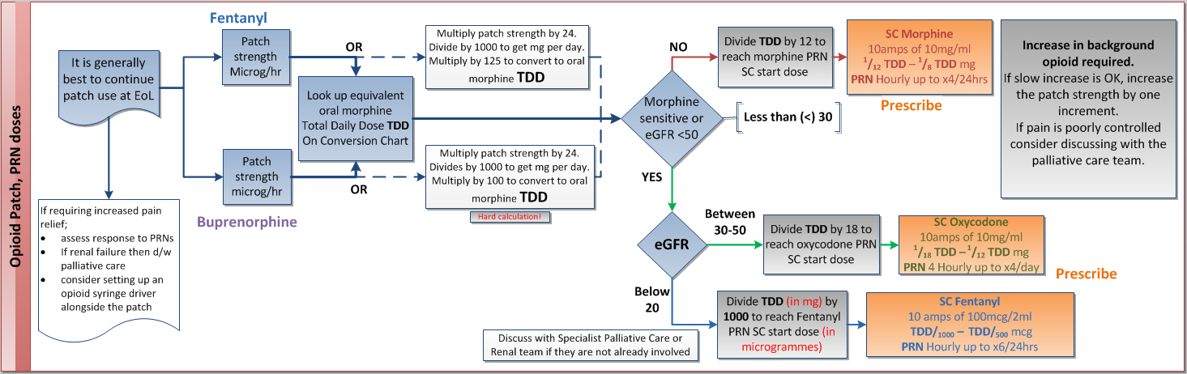

Figure 3.0 - Anti-emetics
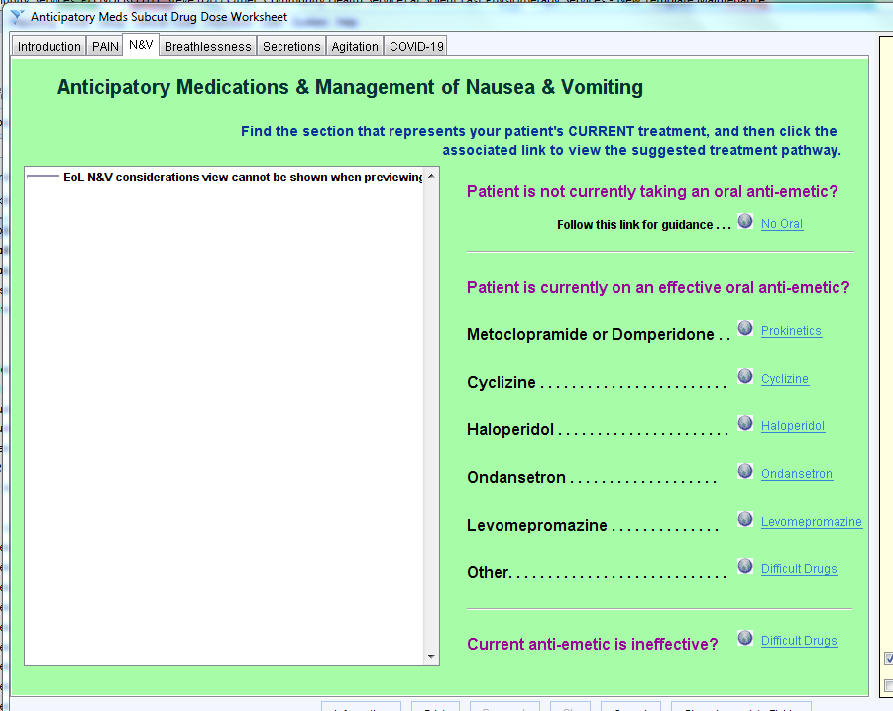
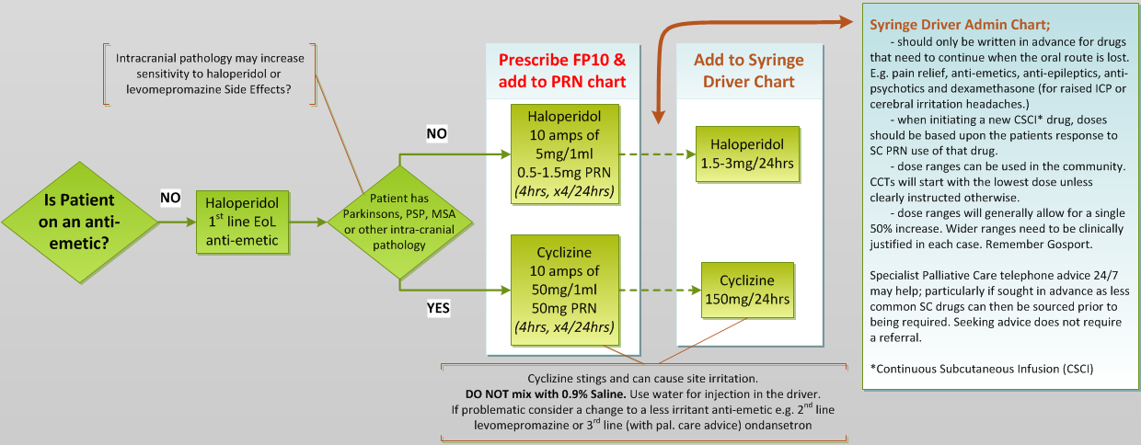

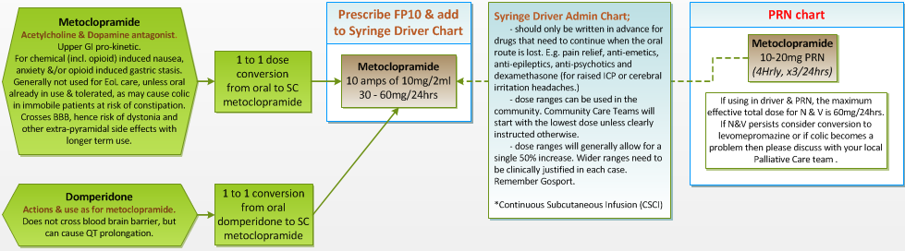
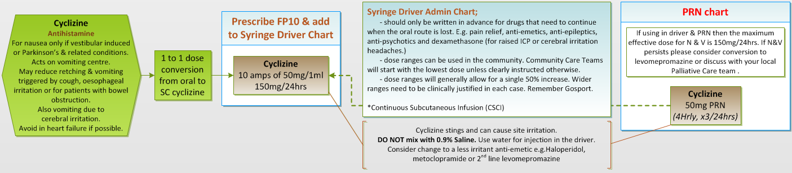
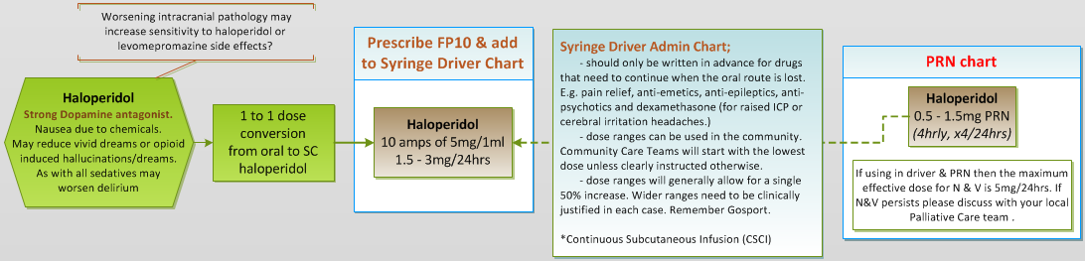
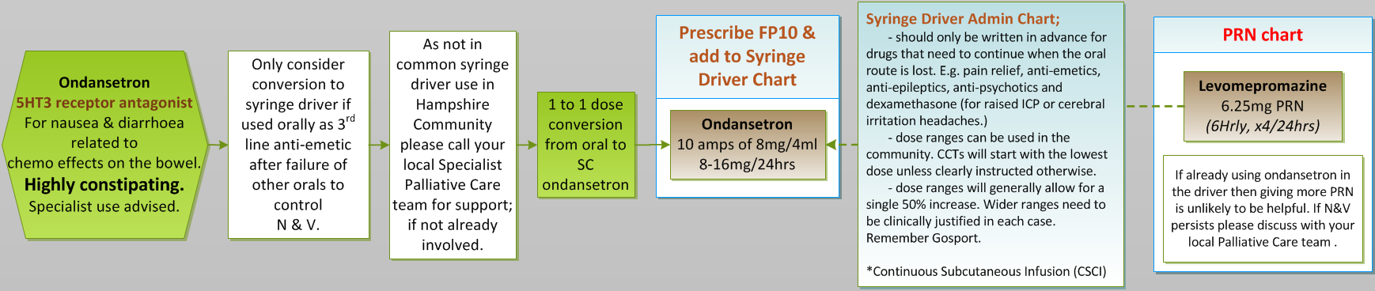
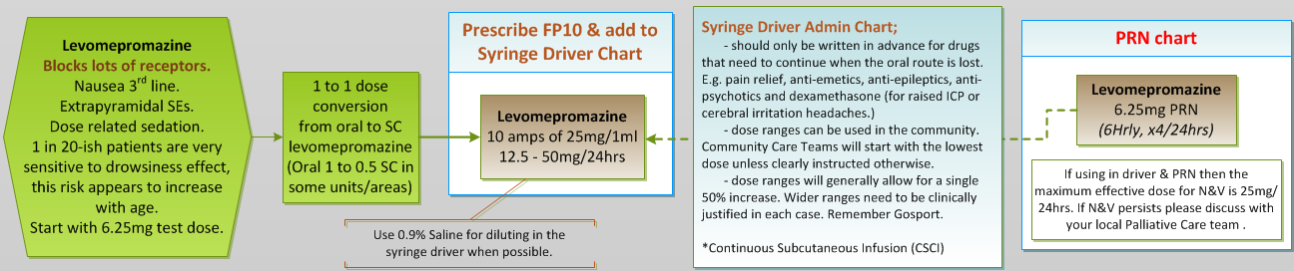

Figure 4.0 - Breathlessness
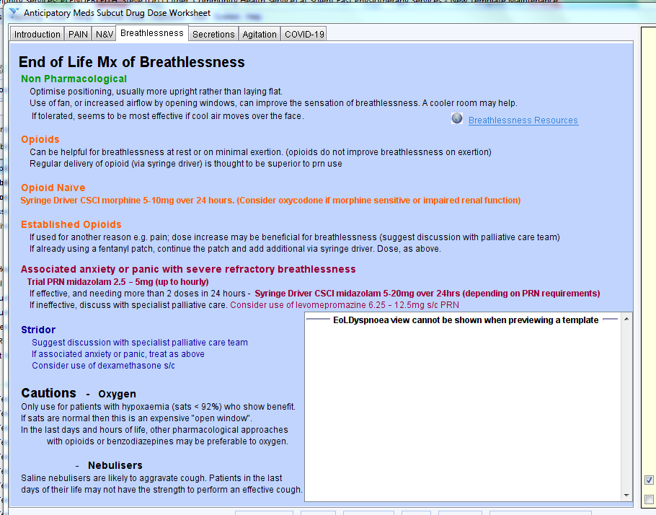

Figure 5.0 - Respiratory Secretions
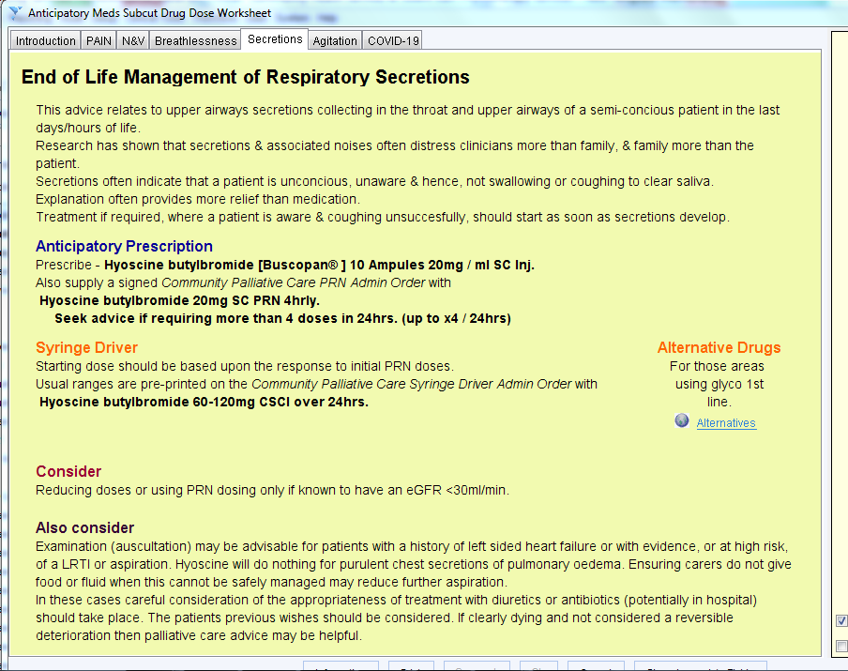
www.futureplanning.org.uk/EoLSecretions

Figure 6.0 - Agitation
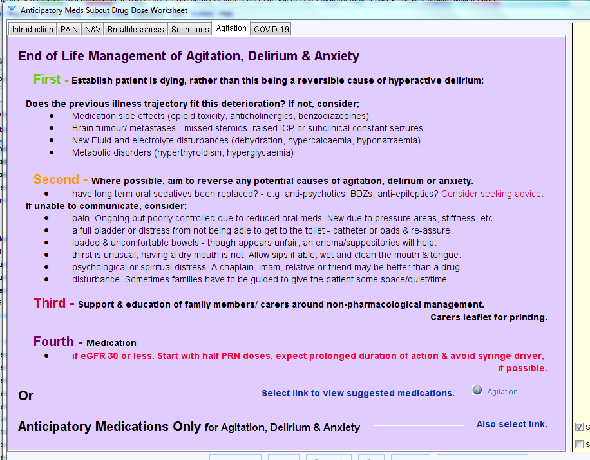
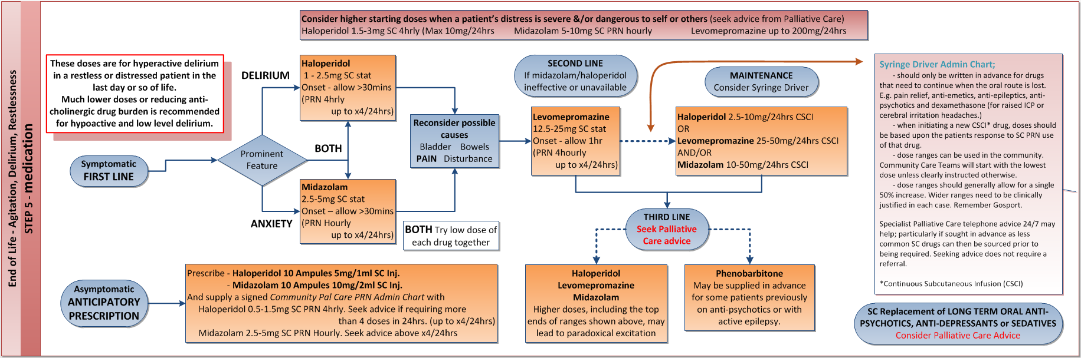

Figure 7.0 - COVID19
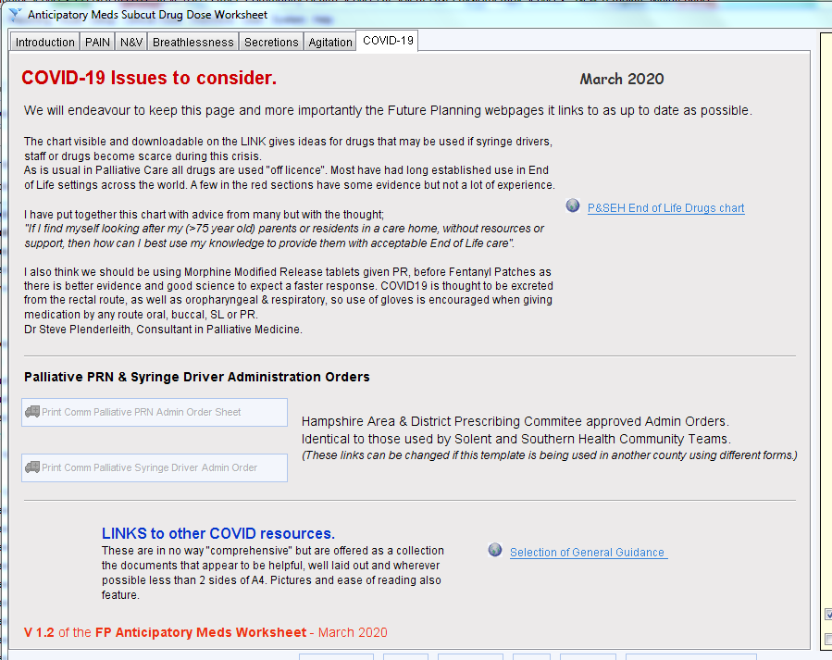
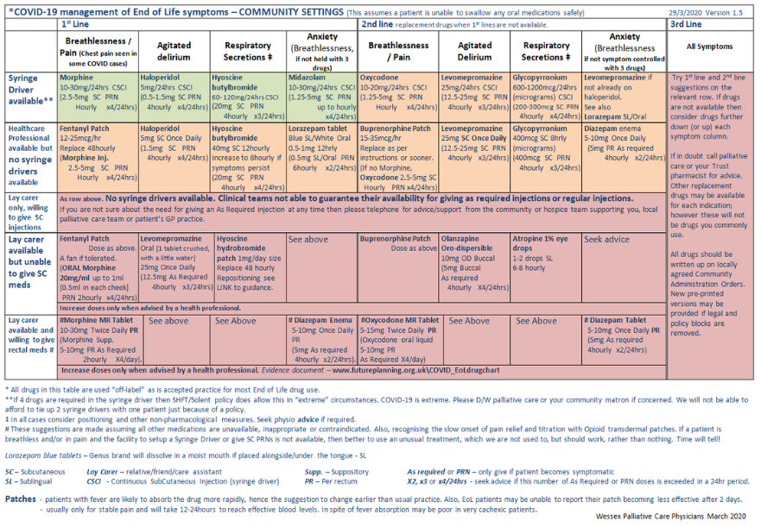
www.futureplanning.org.uk/covid19_generalguidance.html

