Guide to prescribing Oral Nutritional Supplements (ONS)
Calculate and document MUST score. MUST Calculator Then take appropriate action(s)
ACBS criteria: Short bowel syndrome, intractable malabsorption, Pre-operative preparation of patients who are malnourished, Proven Inflammatory Bowel Disease, following a gastrectomy, dysphagia, Disease related malnutrition, Continuous ambulatory peritoneal dialysis (CAPD) or Haemodialysis
Food first approach tried for at least 1 month OR if food first approach not feasible
ACBS criteria met
E.g. Evidence of malnutrition/ malnutrition risk Up-to-date MUST score
Patient identified/ ONS request form received
ONS for any Health Professional to prescribe/request
- Advise patient on high energy/ protein diet
- Provide with written information (see food first patient leaflets) from:
NHCCG website or WHCCG GP Portal
- Ensure follow up appointment booked

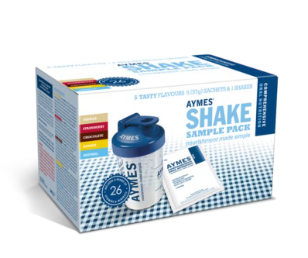
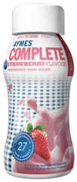
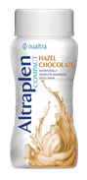
1st Line:
Powder to be made up with whole milk (Recommended dose BD)
STANDARD milkshake style supplement (recommended dose BD)
Readymade Drink ONS
*Neutral flavour as alternative for non- sweet use to be added to food.
AYMES Complete (300kcals, 12g protein) Banana, Chocolate, Strawberry, Vanilla
£1.12/200ml bottle
*GF
Direct-to-patient free samples form here
AYMES Shake
(made up: 388kcals, 15.6g protein) Banana, Chocolate, Strawberry, Vanilla, *Neutral
61p/57g sachets
*GF
Direct-to-patient free samples form
here
Key:
GF- Gluten Free LF- Lactose Free
The ONS list is correct at the time of printing. Price as per MIMS January 2017. New products and flavours may become available between updates
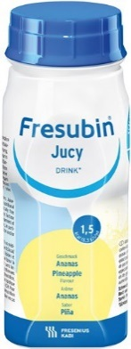
Produced by Hampshire Hospitals NHS Foundation Trust prescribing support dietitians in collaboration with North Hampshire and West Hampshire CCGs
COMPACT 125ml milkshake style supplement (recommended dose BD)
JUICE style supplement if milk based alternative not tolerated (recommended dose BD)
Altraplen Compact (300kcals, 12g protein) Banana,
Harvest Chocolate, Strawberry, Vanilla
£1.45/125ml bottle
*LF & GF
Direct-to-patient free samples form here
Fresubin Jucy
(300kcals, 8g protein, fat-free) Apple, Blackcurrant
Cherry, Orange, Pineapple
£1.99/200ml bottle
*LF & GF - No Fat
Direct-to-patient free samples form here

Oral Nutritional Supplements (ONS or Sip feeds)
ONS Request Form – to be completed for any prescription request
All shaded fields must be filled in. If information not available, explain why (e.g. unable to weigh)

Patient’s GP: | Phone: | Fax:

From: | (Nursing Home/  Community Nurse) |  | Phone No.
For: | Patient’s name NHS number |  | Patient DOB | / /
Ordered by: (Please print) |  |  | Date of Order | / /

ASSESSMENT
Resident need to meet the following 3 criteria before they can be prescribed ONS
(unless discussion between carer and GP have agreed otherwise)
1 | Resident meets ACBS criteria:  - Short bowel syndrome  - Intractable malabsorption  - Pre-operative preparation of patients who are malnourished  - Proven inflammatory Bowel Disease  - Following a gastrectomy  - Dysphagia  - Disease related malnutrition  - Cont. ambul. peritoneal dialysis (CAPD) or Haemodialysis | Please specify ACBS criteria below  e.g. Malnutrition as defined by MUST
2 | Malnutrition Universal Screening Tool (MUST) score calculated  Malnutrition defined as one of the following: | Please specify MUST score
 |  | Height
 | - BMI < 18.5kg/m²  - > 10% Unintentional weight loss (last 3-6months)  - BMI < 20 AND > 5% unintentional weight loss (last 3-6 months) | Most recent weight / Date
 |  | Most recent BMI
 |  | Highest weight 3-6 months
3 | What actions have been taken:   Food fortification / toppers   Extra nourishing snacks   Extra nourishing drinks   Food First not appropriate | Details:

/ /

PRESCRIPTION REQUEST


ONS REQUESTED  (tick required product): | Aymes Shake (1st line)  - Standard (+ 200mls of whole milk)  or  - Compact (+ 100mls of whole milk)  Fresubin Jucy  (if milky drink not tolerated) | NEW? | Yes - No  If Yes, has free samples been tried  Yes - No
GOALS:
(E.g. weight maintenance /
gain, wound healing etc.)
Continue food first plan, offer ONS between meals, review ONS efficacy monthly
The ONS list is correct at the time of printing. Price as per MIMS January 2017. New products and flavours may become available between updates Produced by Hampshire Hospitals NHS Foundation Trust prescribing support dietitians in collaboration with North Hampshire and West Hampshire CCGs

