Remote NHS Teams Implementation Pack
Project name: | NHS Teams Implementation Support
Date: | 14th April 2020
Author: | Nadia Kuftinoff, Programme Coordinator – Innovation Adoption
Programme: | Digital First Primary Care SW SE (COVID-19 Response)
NHS Teams Orientation
Resources/Human Resources
Because the implementation is remote, you will need:
- Computer/laptop
- Internet access
- A phone
The human resource is as follows:
Local Administrator
A Local Administrator (LA) may be the Practice IT Manager or an IT Coordinator for several sites – or whoever has “Local Administrator Rights”. It could potentially be the CSU if the practice doesn’t have anyone with local administrator rights on site. They are responsible for ensuring Teams is installed on staff computers/laptops/phones.
Practice Teams Champion(s)
This could be anyone, clinical or non-clinical. If possible, they should be involved or able to be involved in Partner Meetings to communicate the adoption of Teams. They are responsible for support the LA to communicate the adoption to their team and supplying you with contact details for external site implementation support (e.g. care homes). They will need to have a certain amount of digital professionalism – e.g. understand why Teams is the best option vs. Zoom
External Site Teams Champion(s)
Like their Practice counterparts, they will be responsible for adopting Teams on their site (e.g care homes). They should have access to a personal NHSmail account (not a generic one for their site). If they don’t have one, the Practice LA can set up a guest account for them (LAs can learn how to do this if they don’t already know here).
1) Implementation in a GP Practice – Step by Step: Pre-Implementation
There are several steps required to ensure Teams can be adopted at a GP practice, which in turn can facilitate virtual collaborations with their colleagues in their wider network.
- The Local Administrator for the site needs to ensure everyone has Teams app installed on their computers/laptops
The instructions for doing so if they haven’t already, as well as technical requirements, are here.
- The Practice Teams Champion(s) must communicate internally the site will be using Teams
The Practice need to understand that Teams is now available free of charge during the crisis to enable them to hold virtual meetings with each other and colleagues in their network with an NHSmail account. The Practice may use WhatsApp to send rapid communications with each other vs. email. In this instance, the below images can be saved to an email and sent to the Practice Champion, who can send them in their WhatsApp group:
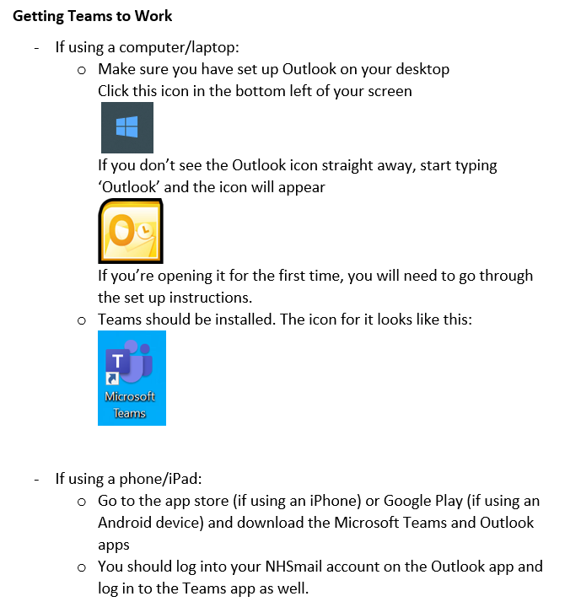

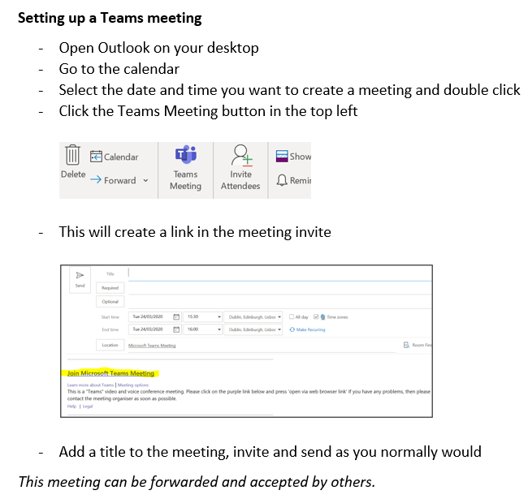

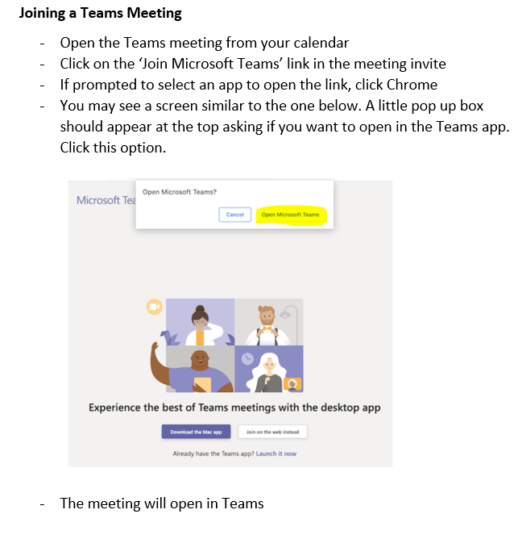
- Practices should be asked if they can facilitate Teams roll-out to external sites who have NHSmail accounts, e.g. care homes
In this instance, the LA will need to add their NHSmail accounts to the Practice Team. The LA or Practice Teams Champion(s) needs to communicate with the external site you will be calling to help talk them through the process AND email introduce you/supply you with their name and contact details (phone number preferably).
- If someone wants Teams on their phone, they need to have both the Outlook app on their phone AND the Teams app
It is important to note that Practices may not provide work phones for staff. The practice will have to consider a “bring your own device” policy and how to manage work/personal life – some Practice staff uninstall the apps when they go on annual leave, for example.
People may need help to download apps. Direct them to the App Store (iPhones) or Google Play (Androids). This is what the App Store and Google Play icons look like:
These are what the Outlook and Teams apps look like:
Be aware – the App Store/Google Play may not work due to overwhelming demand when someone tries to download these apps. They will have to try again later.
Please note: If someone wishes to view documents on their phones, they may need to install Office apps e.g. Word, Powerpoint – viewing documents will open in the phone’s native document viewer but to edit anything will require the Office apps.
It is best practice to get as many people onboarded at once as possible – it will be a few hours of frenzy but is much more effective than speaking to people over time. Then everyone is ready at once!

2) Once Teams is Installed
This section of guidance is for any staff who want to be able to set up Teams meetings in advance, e.g. daily huddles, weekly updates.
It is important to note the way in which Teams works for NHSmail users. NHS Teams does NOT sync with their NHSmail calendar. If you are a familiar with Teams, it means that this button:
Will NOT be in the NHS version of Teams. Don’t worry – this is expected. Here’s how to set up Teams meetings.
- You must use the desktop version of Outlook to set up Teams meeting
NHSmail is usually accessed through a web browser and looks a little different than the desktop version of Outlook:
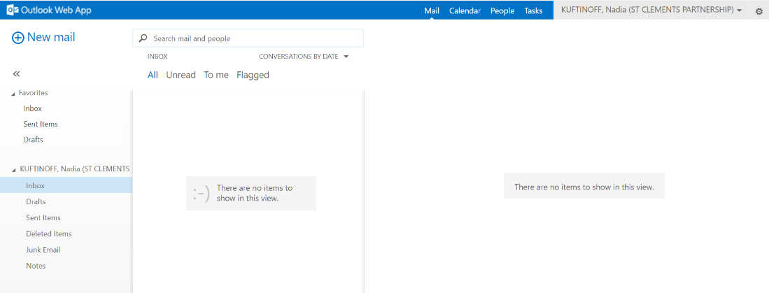
Practice staff may not be familiar with using the desktop version of Outlook. They may need to set it up if it’s the first time they’re opening it.
The desktop version of Outlook will either be pinned to their taskbar at the bottom of their screen like this:
Or they will need to press the Windows key:
Then start typing the word Outlook or scroll through to find it:
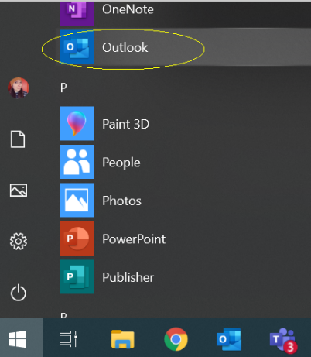
What’s important to note here is that what you see in these screenshots may differ to what the user sees, depending on their version of Windows. The process is the same, but the Outlook icon may look like this:
This is useful to know when troubleshooting over the phone – saying “press the blue Outlook button” may create confusion!
If it’s someone’s first time opening Outlook on their desktop, they may have to configure it. This means upon opening; a pop-up window will prompt them to configure Outlook – they just need to keep clicking through and enter their username/password.
- Now they can set up a Teams meeting in their calendar
Note: if it’s their first time using the desktop version of Outlook, they may need a moment to find the calendar button. In NHSmail online it’s in the top bar on the right. In desktop Outlook, it’s in the bottom bar on the left:
A Teams meeting can either be set up in the calendar straight away by clicking the Teams Meeting Button:
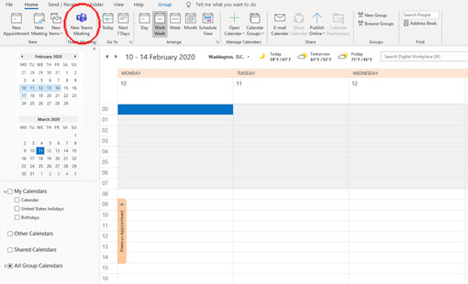

OR by double clicking in the calendar slot they’d like to set the meeting for and converting the invite to a Teams meeting:

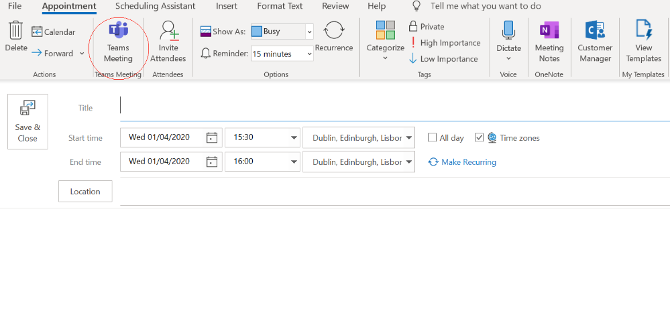
Make sure they click Invite Attendees, just next to the Teams Meeting button:
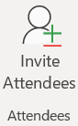
The meeting will now be ready to send to people with an NHSmail account:
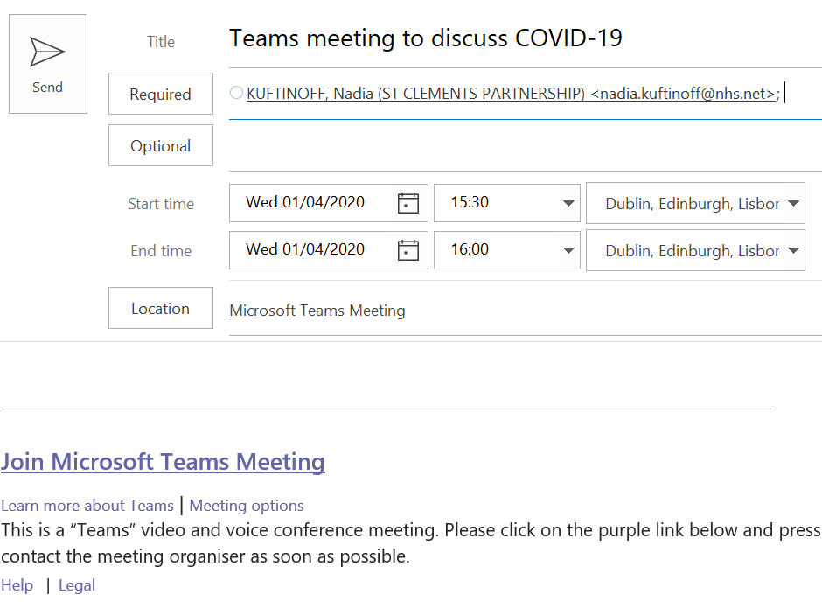
- It should be communicated to the people the invite is being sent to that they need to click the link in the email to join the meeting
They’ll get the hang of this after a few meetings!

Online instructions can be found here.

3) FAQs
Can colleagues not using NHSmail accounts be invited to Teams? E.g. @nhs.uk
Yes, but first they need the Local Administrator to Whitelist them, as per this guidance from support.nhs.net:

To support inviting external colleagues from organisations that do not use NHSmail to collaborate in Teams, the external organisation first needs to be authorised to do so (known as whitelisting). We have bulk whitelisted all the NHS organisations that use their own Office 365 service. If you work with any other organisation that uses their own instance of Office 365 that you wish to have enabled such as Local Authorities please contact feedback@nhs.net

Can I invite guests, non-NHS colleagues, to a Teams meeting?
Not yet, but soon!

Can Teams be used for patient consultations?
This feature is expected to launch in June.

4) Queries, questions, comments, revisions
Please contact:

Nadia Kuftinoff
Nadia.kuftinoff@wessexahsn.net
07784 236645

Document Control

This document must be approved by the following people:
Name | Signature | Title | Date | Version
Nadia Kuftinoff | NK | Programme Coordinator – Innovation Adoption | 30.03.20 | 0.1
Dr Matthew Hammerton | MH | Clinical Lead | 31.03.20 | 0.2
Rachel Dominey |  | Associate Director – Primary Care |  | 0.2

https://comms-mat.s3-eu-west-1.amazonaws.com/Comms-Archive/Local+Administrator+Update+Microsoft+Teams.pdf

