West Hampshire Referral Support Service

Standard Operational Guidance for GP Practices

Background

The West Hampshire Referral Service has been developed by West Hampshire CCG, for and on behalf of, GP Practices in West Hampshire. It has been developed as a result of the findings of national evidence about the effectiveness of referral services.

The service’s main purpose is to support primary care, GPs in particular, and patients. The service outcomes include:

- Improved likelihood of patients receiving the right care, by the right person at the right time and in the right place with minimum delays in their care

- Better information on referrals from a larger number of practices which will inform commissioning decisions and education for clinicians

- GPs have easier access to up to date information on caring for their patients. This includes clinical information and also choice support options. Information on referral advice and guidance and pathways can be found on DXS

- Patients having a better experience of being supported with making a choice about their provider, receiving the right help to navigate the system

- Better use of the existing resources that have been allocated to planned care

- Commissioners able to respond to requests from providers for some help in a more timely way. Commissioners will also be able to ensure that efforts are focussed on priority areas.

What is an RSS

The Referral Support Service (RSS) aims to support general practice when a decision to refer a patient is being considered, this is to help ensure patients are seen at the right place, at the right time and referrers have peer support when a decision is made.

Referral support will be a fundamental part of the outpatient pathway, with the overall aim to support and advise practices in accessing the optimum pathway for patients when making a referral through the e-Referral system. The RSS will help to ensure local services such as community tier two services and acute providers have clear pathways, criteria and sufficient availability for patients being referred. The RSS will manage the booking process through e-RS and support patients with any issues arising from the process.

The RSS will aim to provide practices with peer review feedback and educational support, highlighting areas for reflection and internal review, along with activity data for benchmarking. This will help to improve referral quality, consistency and for use as evidence of continuing professional development.

About the RSS

The RSS will consist of local GP Clinical Reviewers (GPCR) and a small team of Non Clinical Triage (NCTs) who will be available 5 days a week for advice and support to the practice when a decision to refer is being considered.

Referral advice on services and pathways can be obtained over the phone or through dedicated secure e-mail; however the onward referral route incorporating peer review will be via e-Referrals as detailed within this document. The outcome of the clinical review will be shared with the practice and any onward referral through e-Referrals will be completed by the RSS.

The RSS team will be available to support clinical and non-clinical staff within the practice offering advice on pathways, criteria and referrals across the multiple commissioned services within West Hampshire.

Clinical feedback and educational learning materials will be shared with the practice regularly; the insights gained by the GPCRs will help shape future services and educational events and help support The practice with further internal reflection, learning and development.

The Purpose

The purpose of the RSS is to:

- Support General Practice in dealing with increased workload and administration associated with referrals, due to an increasingly complex range of pathways and referral options.
- Support primary care with accurate information and decision support material at point of care.
- Help referrers navigate the system, to get patients to the right place at the right time.
- Support the development of pathways and increase the use of specialist ‘advice and guidance’.
- Better understand clinical variation and support peer review of referrals, improving quality and creating a supportive environment for education and feedback to primary care.
- Coordinate information; inform commissioning decisions on service development and to improve responsiveness, access and communication between the different organisations

Overall key benefits of using the Referral Support Service
  - Increase support to General Practice for service / pathway enquiries when a decision to refer is being considered.
  - Bring together local system information and expertise to support your referral decisions
  - Local, centralised and coordinated e-RS booking process for your patients, empowered by CCG knowledge of contracts and commissioned pathways
  - Provide supportive peer review through trusted local clinicians and with quarterly summated feedback.

Key benefits to the practice when opting to use the Referral Support Service
- Streamlined efficient referral processes, freeing–up administrative resource
- Support and advice for clinicians and admin staff at the point of referral
- Peer review and support from local GPs
- Information / advice available regarding complex management and referral pathways
- Local referral pathway information available via web link +/- DXS
- Shadowing opportunities (particularly helpful for training new staff / consistency)

The Key benefits to patients are:
- They are assessed, investigated and treated by the right person, at the right place and at the right time
- Use of increasing number of local community services, providing investigation and care closer to home for more patients
- Choice supported; based on appropriate provider options, locations, access and waiting times
- Reduced number of outpatient appointments due to prior work-up along agreed pathways
- Supportive point of contact for referral and booking queries
The Key benefits to the CCG are:
- Supporting General Practice at scale with a centralised e-RS booking system
- Development of efficient pathways and referral optimisation
- Supporting ‘every contact counts’ with preventative guidance for patients being referred (stop smoking, weight loss, pre-operative etc...)
- Provision of a platform for capturing educational and service development needs based on activity data and case review.
- Having access to real time activity data facilitating improved capacity management.
- Quality improvement and reduction in sub-optimal secondary care referrals

West Hampshire Referral Support Service – Tel: 02380 627428

The West Hampshire Referral Support Service is based on the first floor in the NHS West Hampshire Offices at Omega House, Eastleigh. It is open 5 days a week, Mon – Fri, 9:00am to 4:00pm.

The team includes:

Name | Job title | E-mail | Tel
Generic account – monitored throughout the working day |  | WHCCG.referralsupport@nhs.net | 02380 627428
David Hill | Referral Service Manager | David.Hill30@nhs.net
Emma Barnard | Service Transformation Manager | ebarnard@nhs.net
Dr Carrie-Anne Ling | Clinical Reviewer | carrie-anne.ling@nhs.net
Dr Ed Porter | Clinical Reviewer | Ed.Porter@nhs.net
Dr Tracey Ryan | Clinical Reviewer | Traceyryan@nhs.net
Dr Derrin Wilkins | Clinical  Reviewer | derrinwilkins@nhs.net
Sally Ayres | Service Administrator | Sallyayres@nhs.net
Tracey McCreery | Service Administrator | tracey.mccreery@nhs.net
Jen Wells | Service Administrator | jennifer.wells7@nhs.net

Referral Criteria
Inclusions
All routine and urgent referrals (excluding 2WWs) currently submitted via NHS e-Referral System for all age groups to secondary care from West Hampshire GP Practices.

Exclusions
Service Name | Through RSS | Available through e-RS
Surgery Breast | Excluded | Yes - not via RSS send direct
All other 2WW | Excluded | Yes - not via RSS send direct
Complementary Medicine | Excluded | Not via e-RS - not via RSS send direct
Dentistry and Orthodontics | Excluded | Not via e-RS - not via RSS send direct
Diagnostic Endoscopy | Excluded | Yes - Southampton Treatment Centre - not via RSS send direct
Diagnostic Imaging | Excluded | Some scans available through e-Rs (Ultrasound, MRI,DXA) – Not via RSS send Direct
Diagnostic Pathology | Excluded | Not via e-RS - not via RSS send direct
GUM | Excluded | Not via e-RS- not via RSS send direct
Health Promotion | Excluded | Not via e-RS- not via RSS send direct
Infectious diseases | Excluded | Not via e-RS- not via RSS send direct
Interventional radiology | Excluded | Not via e-RS- not via RSS send direct
Learning disabilities | Excluded | Not via e-RS- not via RSS send direct
Mental Health | Excluded | Not via e-RS- not via RSS send direct
Obstetrics | Excluded | Not via e-RS- not via RSS send direct
Occupational therapy | Excluded | Not via e-RS- not via RSS send direct
Orthotics and Prosthetics | Excluded | Not via e-RS- not via RSS send direct
Palliative Medicine | Excluded | Not via e-RS- not via RSS send direct
Pain Management | Excluded | For Southern Health please send direct as not one e-RS
Physio | Excluded | Some service available on e-RS – not via RSS send direct
Rehabilitation | Excluded | Some service available on e-RS – not via RSS send direct
Sports and Exercise medicine | Excluded | Not via e-RS - not via RSS send direct
Cardiology - Rapid Access Chest Pain | Excluded | Some service available – not via RSS send direct
Genetitics | Excluded | Via e-RS not Via RSS not via RSS send direct

Patient pathway

In the Consultation
Before referral onto secondary care the practice is expected to ensure local guidance has been considered within each speciality, such as utilising DXS, RSS webpage, together with other available educational information.

The RSS will offer a supportive peer review when a decision to refer a patient on e-RS for further management is being considered. The GP Clinical Reviewers recognise and respect that each referrer has their own individual referral thresholds, developed through their training, experience and attitude to risk.

The practice will:
- Continue to have a duty of care to offer patient choice when considering consultant led care as part of the national requirement within the NHS Constitution.
- Ensure the patient is aware of the local pathway and involvement of the RSS
- Ensure the patient has given consent to share personal information with the RSS team to support the care pathway and onward referral process.

Referral and E-Referrals
The practice will continue with the e-Referrals process attaching the referral letter as they currently do. The RSS service will be listed under the ‘Search Primary Care Menu’ within e-Referrals

This will then bring up the RSS service within the selected speciality. Select ‘Triage Request’ and submit the UBRN (This paperwork DOES NOT need to be sent to the patient).

Current e-RS guidance highlights booking the outpatient appointment for the patient, this process would be completed by the RSS team and not the practice.

The practice must ensure the first stages of the e-RS process are complete this includes:
- Create the UBRN on e-RS
- Select the WHCCG Referral Support Service under the Primary Care menu available under each speciality on e-RS
- Attach the referral letter within 3 working days – In line with national guidance

The review process will then take place electronically by the RSS team within e-Referrals. This will be carried out by a local GP Clinical Reviewer (GPCR) supported by an administrative non-clinical triage team (NCTs).

Below is a diagram of the process: Green = General Practice Blue = RSS

  - Responsibility for patient within pathway

The reviewing GP will always inform the referring GP of any proposed change to the pathway or treatment. The referring GP retains the right to overturn the recommendation of RSS for an alternative pathway or treatment model. The referring clinician retains overall clinical responsibility for the patient.

The triaging GP will be jointly responsible for any decision that deviates from the original pathway proposed by the referring GP. The medical defence organisations have confirmed that the triaging GP will have medical indemnity for this type of decision.

A triaging GP will only return a referral to the referring GP to request further tests if it is felt the results are significant to determining the appropriate pathway for the patient. If a patient is sent for further investigations and tests instead of immediate referral to secondary care, the practice will be responsible for checking the result of the test and the referring GP will determine the next steps for the patient. A new referral will need to be submitted to West Hampshire Referral Support Service upon receipt of the results.

The GP reviewing team will also indicate when further tests may improve the patient experience and reduce the number of follow-up attendances required in Outpatients. In these instances the referral will proceed as planned and an email of suggested tests will be forwarded to the referring GP.

Once a referral has been sent to the West Hampshire Referral Support Service it is the responsibility of the service to:

- Review the referral and take action within 48 hours.
- Advise the patient of the outcome of any onward referral to secondary care or community based services
- Liaise with the referring GP if there is a query with the referral or if an alternative pathway is recommended

It is the responsibility of the practice to:

- Regularly review the nhs.net account that they have provided to the RSS
- Liaise with the patient if the referring GP is agreeable to the advice provided by RSS

The West Hampshire Referral Support Service is not responsible for following up patients who do not book appointments.

Outcome of GP Review
The possible outcomes upon receipt of referral may be:

- GP Clinical Reviewer (GPCR) will agree and forward the referral to appropriate service (The admin team will then process the referral and send the patient an appointment request letter)
- GP Clinical Reviewer will make contact with referring GP to:
      - Discuss the referral or seek further information
      - Propose further investigations
      - Propose alternative pathway (for example 2WW) or management within primary / community care

- The RSS will action the referral according to the outcome of the discussion between referring and reviewing GP and will write to the patient to advise them of the next steps unless agreed otherwise with the practice.
- Under guidance, the Non Clinical Triage (NCT) team will deem the referral of high quality and stream the patient straight through, booking the patient into an outpatient appointment.

A pathway document outlining the patient pathway and information flows is provided in Appendix A

The referring GP retains the rights and responsibility for the agreed outcome

- Referral Support and Guidance for Referring GPs

This is currently in development. It is recommended that DXS and NICE guidance is used to support referrals.

Communication with patients

  - In the consultation
When making a referral a brief explanation of the West Hampshire Referral Support Service to the patient would be advisable. However, we have devised a patient leaflet outlining details of the service which covers data confidentiality. Please note, the practice must ensure patients are aware that their data is being supplied to the West Hampshire Referral Support Service.

It is worth stressing to the patient that if they have not heard anything within two weeks they should contact the West Hampshire Referral Support Service rather than the practice to find out further information.

6.2 Vulnerable patients
If you are referring a vulnerable patient who will require help with booking their appointment please make this explicit in the referral letter.

6.3 Contacting the patient with outcome of referral
The RSS will write to every patient receiving an onwards referral through the service to advise what they need to do next.

It is the responsibility of the practice to liaise with patients if it is agreed to continue with further management in Primary Care or if the referral is being re-directed to the 2WW service.

6.4 Patient data confidentiality
Staff at RSS will work in line with all information governance and data confidentiality legislation and will attend training in this area specifically tailored to the service. The electronic files related to the service will be stored in a restricted access area on the server and will only be available to those members of staff who require access.

Dealing with patient queries

Patients are directed on the patient leaflet to contact RSS if they have not heard about their referral within two weeks.

We recognise that often a patient will contact the practice in the first instance. By using the worklists and the View History function practice staff should be able to determine whereabouts in the system a patient is and respond to their queries without having to refer them to RSS. Medical Secretaries at the practice are able to locate passwords, rejections and patient information in an easy way on their end.

Complaints and feedback

We aim to provide a high quality and efficient service, and are keen to receive feedback from practices and patients to make improvements. If you, or a patient, have a problem that requires immediate resolution please contact the RSS in the first instance 02380 627892.

Additionally patients can contact PALS with any concerns:

Patient Experience and Complaints Team
West Hampshire CCG
Omega House
112 Southampton Road
Eastleigh
Hampshire
SO50 5PB

Email: whccg.yourfeedback@nhs.net

Tel: 0800 456 1633

General feedback from practices on the service can be made directly to the Referral Service Manager, David Hill on 02380 627892 or David.Hill30@nhs.net.

Communication with practices

Each practice has provided the West Hampshire Referral Support Service with an nhs.net address to use for communicating with the referring GP or medical secretaries in case of queries. Please ask your practice manager for email contact details related to your practice.

Where a GP reviewer wishes to discuss or query a referral he/she will contact the referring GP by nhs.net email.

Practices are asked to regularly check the nhs.net e-mail address provided for queries from the West Hampshire Referral Support Service.

9.1 Returned referrals

There are several reasons why a referral may be returned to a practice:

- Technical - there is insufficient information provided on the referral or the referral is for a procedure that is not normally funded by the CCG. In this instance the triaging GP will email the practice with explicit instructions on what further information is required or what action the practice needs to take.

- Clinical – after correspondence between the referring and triaging GP another approach to management of the patient has been agreed. This will be outlined within the email sent back to the practice and RSS will make clear what action is required by the practice.

Referrals – templates/minimum data requirements

This is currently non-mandatory and practices may continue to produce referral letters, but all the data requested within the referral template should be outlined within the letter. For specialties that have produced their own templates, these should continue to be used without the need for the RSS template to be completed.

We would request that all practices include BMI and BP for all patients being referred. This could significantly reduce patient waiting times and increase patient choice. We would also suggest that practices do not specify particular hospital, unless there is a specific clinical reason, or it is the patient’s specific request.

In order for the RSS to function effectively it is important that each practice includes on referral letters the intended destination of the referral. Please include– SPECIALTY and CLINIC TYPE on all referrals.

Sending referrals

The process for sending referrals to West Hampshire Referral Support Service is outlined below. This may differ slightly if e-Referral System is integrated into your clinical system.

- Select patient using NHS number

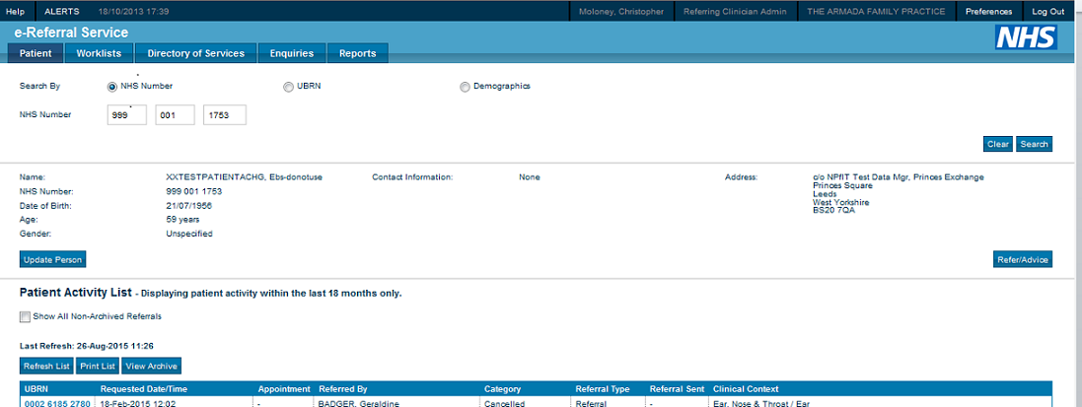

- Select refer/advice

- For all referrals you should follow the same process:

For Request Type select ‘Referral’
For Priority select ‘Routine’ or ‘Urgent’
Select the relevant Speciality as the practice currently does
Select the relevant Clinic Type as the practice currently does
Click ‘Search Primary Care’

4. Select ‘Search Primary Care’ function at bottom right of page

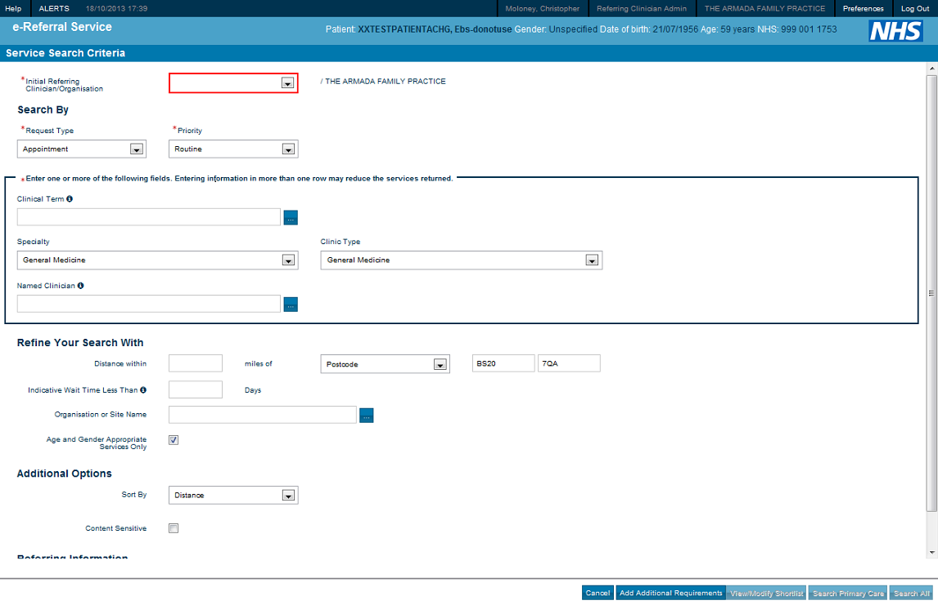

5. Select ‘Send for triage’ for the relevant West Hampshire Service that will be available to you

- To add referral letter or any attachments select ‘Add Attachment’

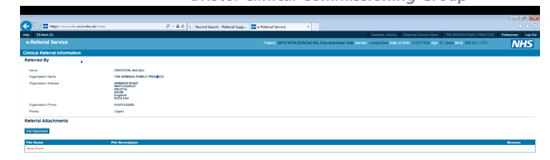

- Browse to location of referral letter and attach file

Select ‘submit’

- The next screen will confirm which attachments you have chosen select ‘Close’

Guidelines for checking worklists

Practices will need to undertake the following checks on worklists:

Advice and Guidance response worklist

This is where responses back from Advice and Guidance Services will be received:

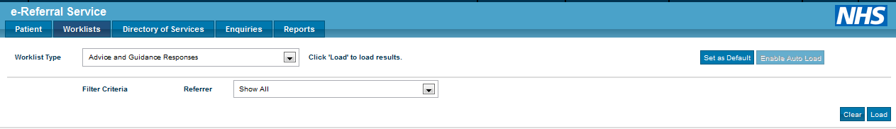

To view details of the response click on the UBRN and select ‘View Advice Request’

You will be able to view the response back from the Consultant and should follow the practice process for advising the referring GP and storing the detail of the response in the clinical record.

Once all necessary action has been taken the request for advice and guidance can be cancelled off the system. Click on the UBRN and select ‘Clear Advice Request’ and then confirm this action on the subsequent screen.

Referrer Action required worklist

This worklist will show any referrals that have been rejected or cancelled. To view details of the rejection or cancellation click on the UBRN and there will be a date of cancellation together with ‘Reason for cancellation’. For more details you can select ‘view history’ and from the list of the action within history click on the date of ‘Cancel Appointment and/or Cancel Request’ in the left side of the screen and more details will appear in the main body of the screen. This will indicate what action you may need to take.

Awaiting Booking Acceptance worklist

This worklist will show referrals that are still waiting to be booked. Please be mindful of 2WW referrals. Should they appear on this worklist, you may have to book them a dummy appointment so that the providers can view the contents of the referral on their systems.

Outstanding Referral Letters worklist

This worklist will list any referrals that have not been completed and sent to the Referral Service due to missing referral letters. Please do check this regularly as these will not be visible on e-Referral until you have completed the process by attaching the referral documents.

Nhs.net email addresses

Practices will need to regularly check the nhs.net e-mail address that they have provided to the West Hampshire Referral Support Service as this is where any queries regarding referrals will be sent.

When responding to any RSS queries, please make sure that you have included the patient’s name and UBRN/NHS number in your email to help us identify the original referral.

Awaiting booking/Acceptance worklist

The practice can check the progress of referrals sent to RSS using the Awaiting booking/Acceptance worklist.

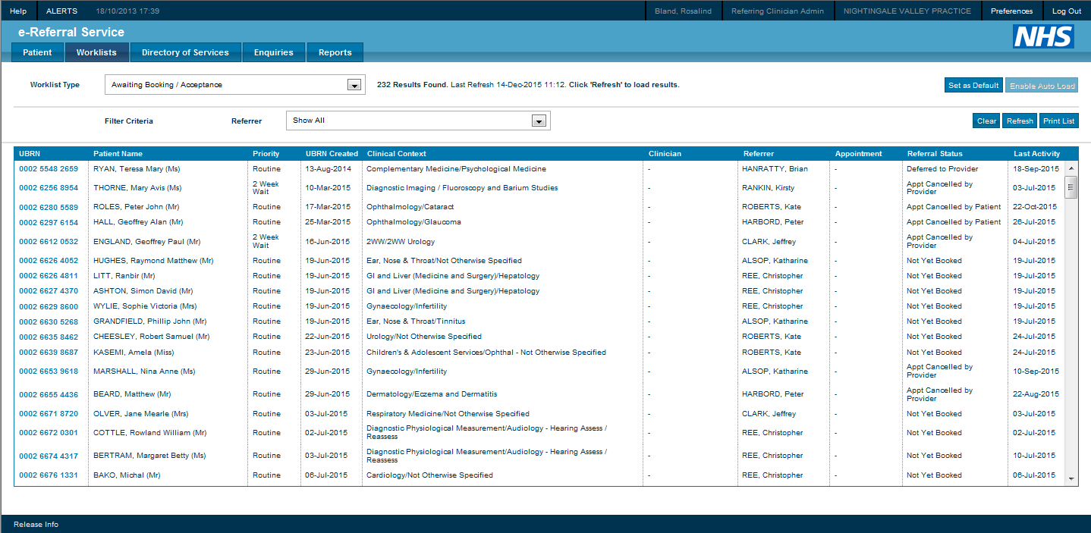

Status | Description | Action
Unbooked | RSS have sent the referral on to secondary care and issued the relevant details to the patient. More details can be accessed through the view history function within E-RS | To monitor this worklist daily to ensure patient book their appointments
Booked | Patient has made booking | No action required.
Cancelled | All UBRNs that get cancelled / rejected by hospitals/providers. | Practices must check their practice email inbox for any emails from RSS regarding their referrals which would give them instructions of any actions to take.

