# UHS ICE RADIOLOGY REQUESTING

GP surgery radiology referrals will be available through the surgery ICE pathology requesting system.

Access to ICE Radiology requesting is through the GP RADIOLOGY tab

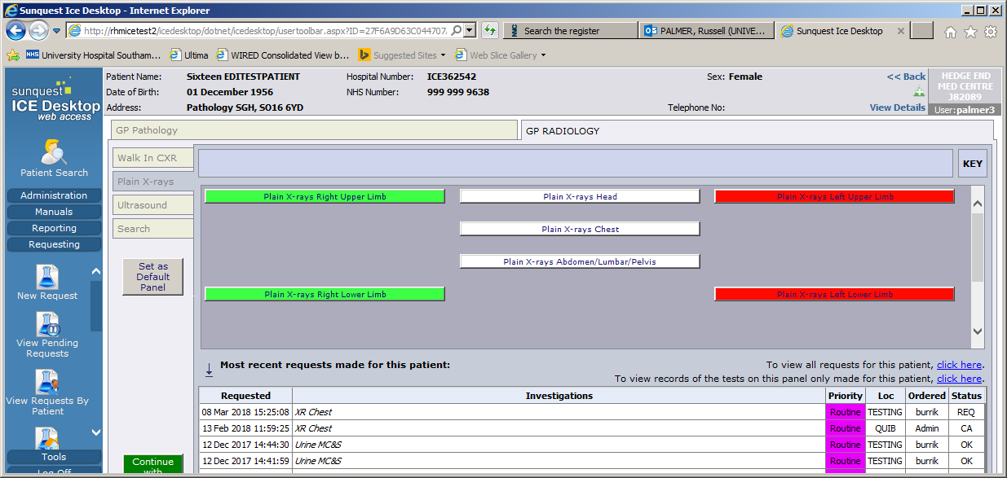

The GP Radiology requesting includes referrals for Planar X-rays and Ultrasound (USS) imaging to University Hospital Southampton NHS Foundation Trust (Southampton General Hospital, the Royal South Hants Hospital and Princess Anne Hospital). **Lymington Hospital, Romsey Hospital and Hythe Hospital are excluded. CT (except CT KUB), MR, Nuc Med and Vascular Ultrasound examinations are not included.**

Under the **GP RADIOLOGY** tab there are 7 options. For each option, your request for radiology imaging will be sent from your ICE application in exactly the same way as your pathology requests. There is no requirement to print a referral form. All the details of your request will be available on the UHS Radiology Information System.

**Option 1:** WALK IN CHEST X-RAY: This service is only available at the Royal South Hants Hospital for **adult** patients and is available immediately after your patient leaves the surgery. All other plain film and ultrasound examinations require an appointment. The Walk In Chest X-ray service is open from 09:00 to 16:30, Monday to Friday excluding Bank Holidays.

*NB For plain X-rays Patients under 17 years of age will be referred to the paediatric department. See* ***Bookings*** *below.*

**Option 2:** Plain X-RAYS. This includes all plain X-ray examinations of the Limbs, Spine, Pelvis, Abdomen, Chest and Head.

(Apart from the chest X-ray Walk In Service) All plain X-rays require an appointment. There are separate booking offices and processes for ADULT and PAEDIATRIC patients:

*NB For plain X-rays patients under* ***17*** *years of age will be referred to the Paediatric department. See* ***Bookings*** *below.*

**Option 3:** ULTRASOUND. This includes all general ultrasound examinations, specialist MSK ultrasound but **NOT** DVT ultrasound.

All ultrasound examinations require an appointment. There are separate booking offices and processes for **ADULT** and **PAEDIATRIC** referrals:

*NB For Ultrasound examinations patients under* ***16*** *years of age will be referred to the Paediatric department. See* ***Bookings*** *below.*

**Option 4:** Gynae U/S. This is a very restricted list of 2 examinations, Ultrasound of the Pelvis Trans abdominally and Ultrasound of the Pelvis Trans vaginally.

These patients will be sent an appointment. They do **NOT** need to contact the department to arrange an appointment.

**Option 5:** CT KUB. This is a single CT examination request for Urinary Tract (Kidneys, Ureters, Bladder). There are several extra prompting questions to reflect the higher radiation dose of this examination.

These patients will be sent an appointment. They do **NOT** need to contact the department to arrange an appointment. Cont…

**Option 6:** Barium Studies. This is a restricted list of 3 examinations. Barium Meal, Barium Swallow and Barium Swallow and Meal.

These patients will be sent an appointment. They do **NOT** need to contact the department to arrange an appointment.

**Option 7:** SEARCH. This searches all the radiological exams available to you in the system. Type the body part into the “Name” field and click ‘SEARCH’’

**BOOKINGS**

ADULT patients for X- RAY and GENERAL/MSK ULTRASOUND: Please ask the patient to ring the main radiology department to book a planar X-ray or Ultrasound appointment 48 hours after attending the GP appointment on: **023 8120 4015**

This office is open Mon – Fri 0900-1700 hrs (not open at weekends or Bank Holidays).

PAEDIATRIC patients for X- RAY and GENERAL ULTRASOUND: Please ask the patient or the patient’s parent / guardian to ring the paediatric radiology department to book a plain X-ray or Ultrasound appointment 48 hours after attending the GP appointment on: **023 8120 4191**

This office is open Mon – Fri 0900-1700 hrs (not open at weekends or Bank Holidays).

Cont…

**SELECTING AN EXAM**

**Walk In CXR** presents a single exam option to select a Chest X-ray.

Check the white box.

If the examination has been requested recently you will receive a warning message.

Follow the prompt to continue or abort the request.

Continuing will present the Radiology X-ray assumptions panel:

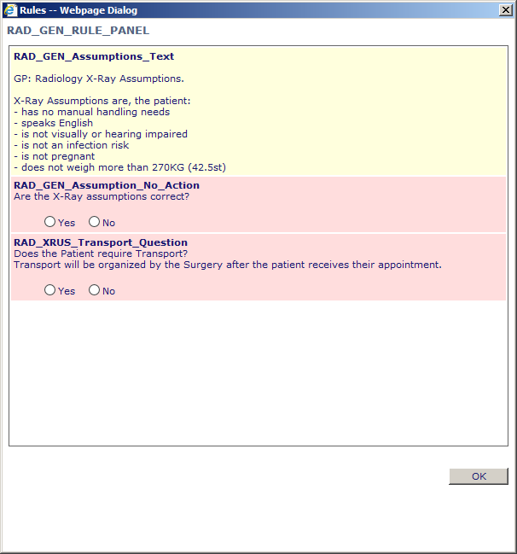

If one or more of the assumptions is incorrect select **No** and you will be presented with a free text box to provide details.

If the assumptions are correct select **Yes** and there is no further action to take.

If the patient requires transport select **Yes.** The transport will be arranged by the surgery and the patient will be given a morning appointment.

If the patient does not require transport select **No** and there is no further action to take.

Click OK

Click Continue with request

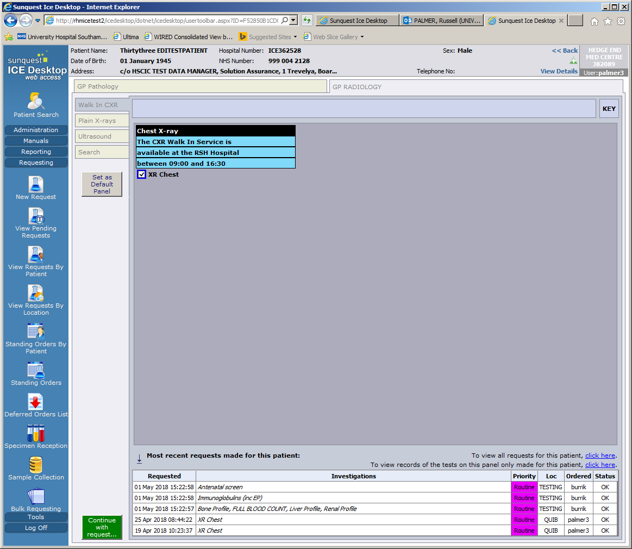

Your details as GP and Location will be auto filled unless you are a new GP (waiting for a GMP number), a locum or a registrar. If they are not contact your system administrator.

Enter the Cinical Details. There is a maximum of 240 characters.

Click **Accept Test.**

**The radiology order comm for a Chest X-ray is placed.**

Cont…

**Plain X-rays** presents all the body areas.

Select the appropriate area.

The examinations for this body area is presented. Select the examination/s by checking the white box/es.

If the examination has been requested recently you will receive a warning message.

Follow the prompt to continue or abort the request.

Continuing will present the Radiology X-ray assumptions panel:



If one or more of the assumptions is incorrect select **No** and you will be presented with a free text box to provide details of the incorrect assumption.

If the assumptions are correct select **Yes** and there is no further action to take.

If the patient requires transport select **Yes.** The transport will be arranged by the surgery and the patient will be given a morning appointment.

If the patient does not require transport select **No** and there is no further action to take.

Click OK

Click Continue with request



Your details as GP and Location will be auto filled unless you are a new GP (waiting for a GMP number), a locum or a registrar. If they are not contact your system administrator.

Enter the Cinical Details. There is a maximum of 240 characters.

Click **Accept Test.**

**The radiology order comm for a body part has been placed.**

Cont…

**Ultrasound** presents all the body areas.

Select the appropriate area.

The examinations for this body area is presented. Select the examination/s by checking the white box/es.

If the examination has been requested recently you will receive a warning message.

Follow the prompt to continue or abort the request.

Continuing will present the Radiology X-ray assumptions panel:



If one or more of the assumptions is incorrect select **No** and you will be presented with a free text box to provide details.

If the assumptions are correct select **Yes** and there is no further action to take.

If the patient requires transport select **Yes.** The transport will be arranged by the surgery and the patient will be given a morning appointment.

If the patient does not require transport select **No** and there is no further action to take.

Click OK

Click Continue with request



Your details as GP and Location will be auto filled unless you are a new GP (waiting for a GMP number), a locum or a registrar. If they are not contact your system administrator.

Enter the Cinical Details. There is a maximum of 240 characters.

Click **Accept Test.**

**The radiology order comm for a body part has been placed.**

Cont…

This service is available at the Royal South Hants Hospital, Brintons Terrace, Southampton. SO14 0YG

Monday – Friday 09:00 – 16:30

This service is not available at weekends or on Bank Holidays.

This service is not available for Paediatrics.

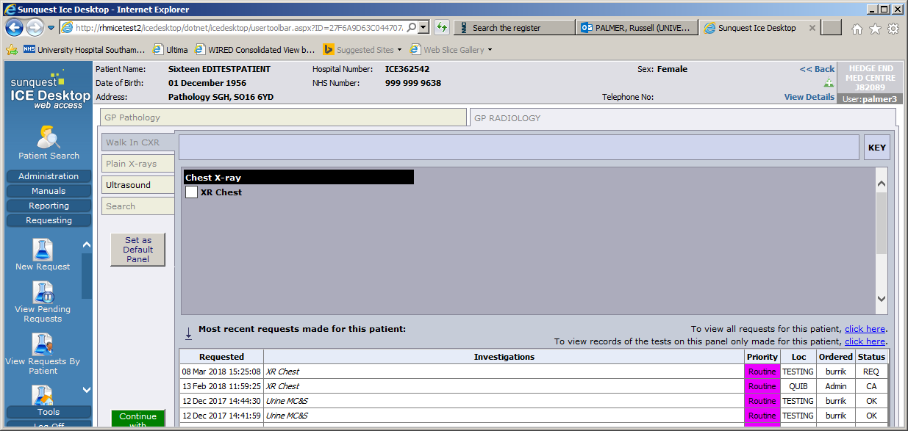



Plain X-ray and Ultrasound examinations require an appointment.

Please request the patient to ring the radiology department for a plain X-ray or Ultrasound examination after 48 hours of attending the GP appointment on:

**023 8120 4015**

For Paediatric radiology, Under 17 years for Plain X-rays and under 16 years for Ultrasound, please ask the patient, parent or guardian to ring:

**023 8120 4191**

48 hours after attending the GP appointment.

These lines are NOT open at weekends or on Bank Holidays.

Transport must be arranged by the surgery after the patient has booked their appointment.

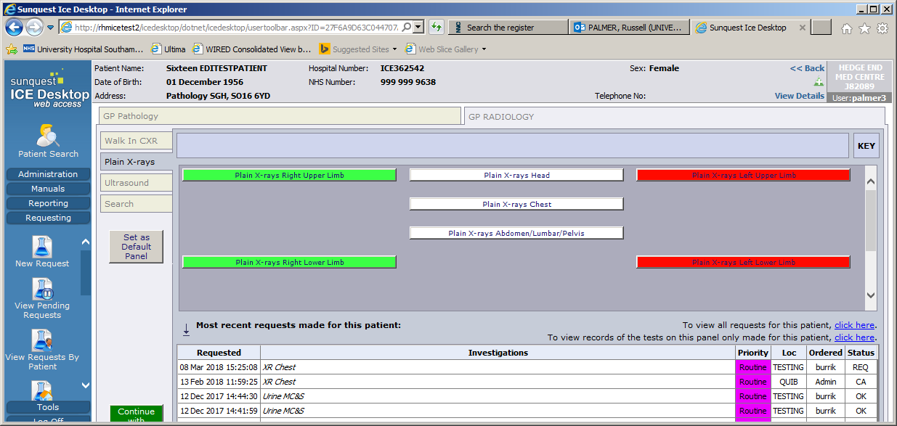



Plain X-ray, Ultrasound and CXRs that require an appointment

The CXR is undertaken when the patient attends the RSH.

CXR - Only

Use the Walk In Service at the RSH Hospital

Patient requires an X-ray

Cont…

**NEW GP/REGISTRAR/LOCUM ICE RADIOLOGY REFERRING**

Radiology referring via the ICE pathology system

New staff GP’s, Registrar GP’s and locums don’t have a GMP number that associates them with the GP surgery. This means that they are not registered on the Radiology Information System (CRIS) and radiology orders placed on ICE are received by CRIS but cannot be processed.

In order that New GP’s, GP registrars and locums can effectively make ICE radiology requests the process outlined below MUST be followed.

When the GP Radiology Tab is available to you select the examination/s you require.

The last page of the order process enables the registrar to enter the senior partner or their mentor as the Requesting Consultant / GP.

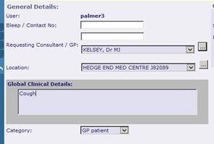

In this example, above, the user, palmer3, is the name of the new GP, or the registrar or the locum.

They should select the senior partner from the drop down or the search button. The Location should auto select.

Enter the clinical details and accept the request.

This will present the registered GP to CRIS and display the clinician as the registrar etc.

Cont…

**CANCELLATIONS**

In the event that the user wishes to cancel the request that they have just made.

Incoming Radiology Orders are constantly monitored. As soon as they are processed on CRIS it is not possible to alter them. If the GP/user wishes to cancel the examination please contact the PACS office on **023 8120 8587** to make cancellations.

If the order is cancelled by the patient or cancelled or rejected by the hospital a Staus Update message is sent and flagged on the surgery patient system TPP S1 or EMIS.

Status Update messages will reflect orders that are **NOT** performed. Attendances, appointments and re booking episodes will not be recorded.

The status messages that will be delivered are:

Cancelled by Radiologist*

DNA – Did Not Attend

Done as In Patient

Done at Private/Other Hospital

May be Pregnant

No longer required*

Patient Cancel*

Patient refused exam*

Unjustified examination*

*These status messages will have further text to explain the cancellation or request further information.

Cont…

**Contingency**

In the event that radiology orders do not reach the radiology information system we will accept requests into and monitor the email account [uhs.gpreferral@nhs.net](mailto:uhs.gpreferral@nhs.net) This will only be used for requesting radiology while the ICE OCS is down.

The information we will require to enable an email radiology request is

|  |  |
| --- | --- |
| Patient Surname |  |
| Given names |  |
| NHS Number |  |
| Date of Birth |  |
| Sex |  |
| 1st line of address |  |
| Postcode |  |
| GP Surgery/Code |  |
| GP Referrer |  |
| Clinical information |  |
| Examination/s |  |
| Urgency | Routine     Urgent |

Please do NOT save the completed form that you send to Southampton radiology as anything other than a Microsoft Word document.

Please remember that you may only send Patient Identifiable Data **FROM** an nhs.net account **TO** an nhs.net account.

Send the document to [uhs.gpreferral@nhs.net](mailto:uhs.gpreferral@nhs.net)

Cont…

**Patient Information**

The following information leaflets may be useful. Please print at will.

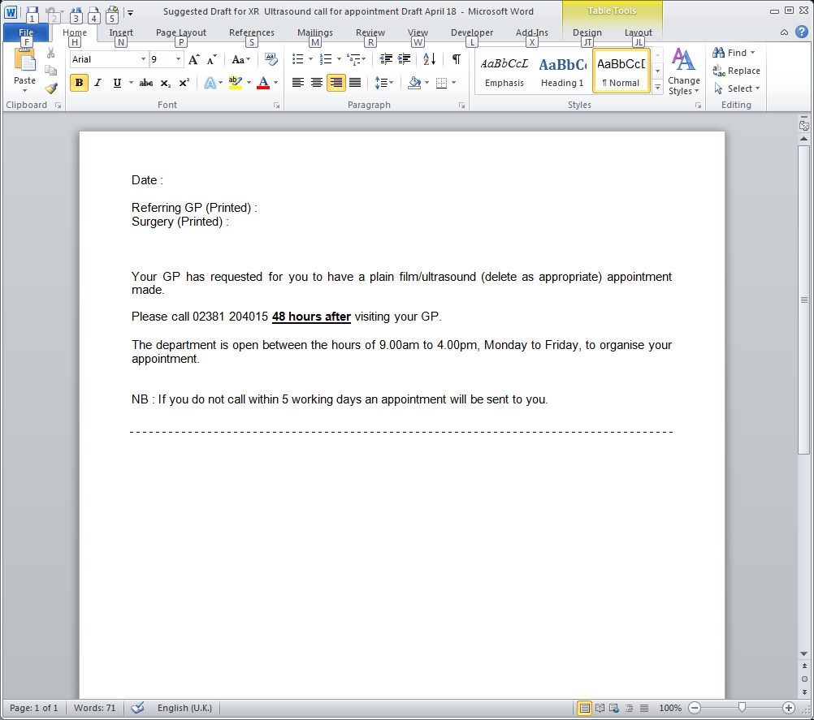

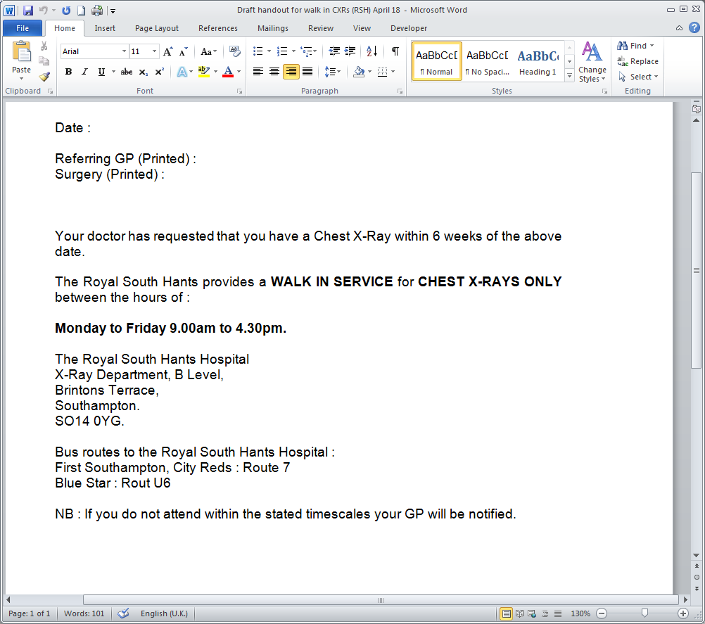

|  |  |
| --- | --- |
| **Glossary of Terms** | |
| CXR | Chest X-ray |
| USS | Ultrasound |
| CRIS | Computer Radiology Information System |
| PACS | Picture Archive Communication System |
| ICE | Integrated Clinical Environment |
| OCS | Order Comms |
| GMP | General Medical Practitioner |

**To contact the radiology ICE office**

**Queries and support**

**Pathology:**

[UHS.GPLinks@nhs.net](mailto:uhs.gplinks@nhs.net)

Tel  023 8120 3379, 4355 or 6705

**PACS (Radiology**):

[uhs.pacssupport@nhs.net](mailto:uhs.pacssupport@nhs.net)

Tel 023 8120 8575 & 023 8120 8196